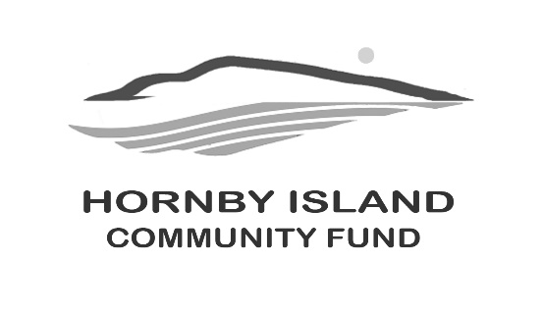
First Edition
February 2021
Report from the Community Fund

FEATURED PROJECTS SUPPORTED BY THE COMMUNITY FUND LAST YEAR:
NEW PLAYGROUND STRUCTURE FOR THE PRESCHOOL
The sandbox is the “heart” of our playground and is used daily by the children, rain or shine. The children can play happily under the roof, while the rain falls all around them, creating castles, digging for treasures, or sitting comfortably and listening quietly to favorite tales and stories. The original structure over the sandbox had deteriorated and needed renewal. Since the onset of Covid, it has become an essential facility for daily programming and minimizing transmission.
FOOD GROWS WHERE WATER FLOWS
In the last five years, The Fund has donated $8500. to the H.I. Farmland Trust Society (HIFTS) in response to their applications for development at the Donny Farris Community Garden. Projects have included fencing, irrigation, storage shed and water storage. These funds for “materials” have been leveraged into meaningful projects through labour from a large contingent of volunteers. “The Gardeners” are developing space to provide food for their own families; for the Community Kitchen/Food Bank; and for making available high quality, organic food products to the public. Thirty-five local gardeners currently have plots at the Farris Community Garden, and due to a waiting list, expansion is planned. In addition to the allotment plots there is also a fruit tree orchard site. Another project of the Farmland Trust is the Gleaning Program, offering volunteer pickers to Island home owners who have surplus fruit on their trees. This fruit is also used to feed local families, donated to local meal delivery programs, and provide ingredients for sale of value-added food products (such as juices and jams). Community Fund support for the HIFTS will help ensure food security on the Island for years to come.
THE RESTORATION OF BEULAH CREEK FOR FISH HABITAT
Historically, Beulah Creek was salmon-bearing but with the creation of roads and culvert systems, the creek had not been fish bearing for some time. In 2019, the B.C. MInistry of Transportation and Infrastructure reconstructed the crossing of Beulah Creek on Central Road. This resulted in the replacement of the 4’ culvert with a 5’ drop to 3 new culverts at stream-bed level, resolving the upstream spawning potential. The creek restoration, downstream from this earlier work, was sponsored by H.I. Conservancy, and included removal of a restrictive downstream culvert with a bridge, streambed and vegetation renewal, and creation of riffle pools to facilitate fish spawning. This second phase was completed in the Fall 2020 with
Wishing you all a wonderful 2021, filled with peace, happiness, and the fulfilment of philanthropy.

Community Fund Board: Anne Carney, Brenda Cha, JoAnn Harrison, April Lewis, Angie Read, Karen Ross and Eva Wetzel
www.hornbycommunityfund.org

