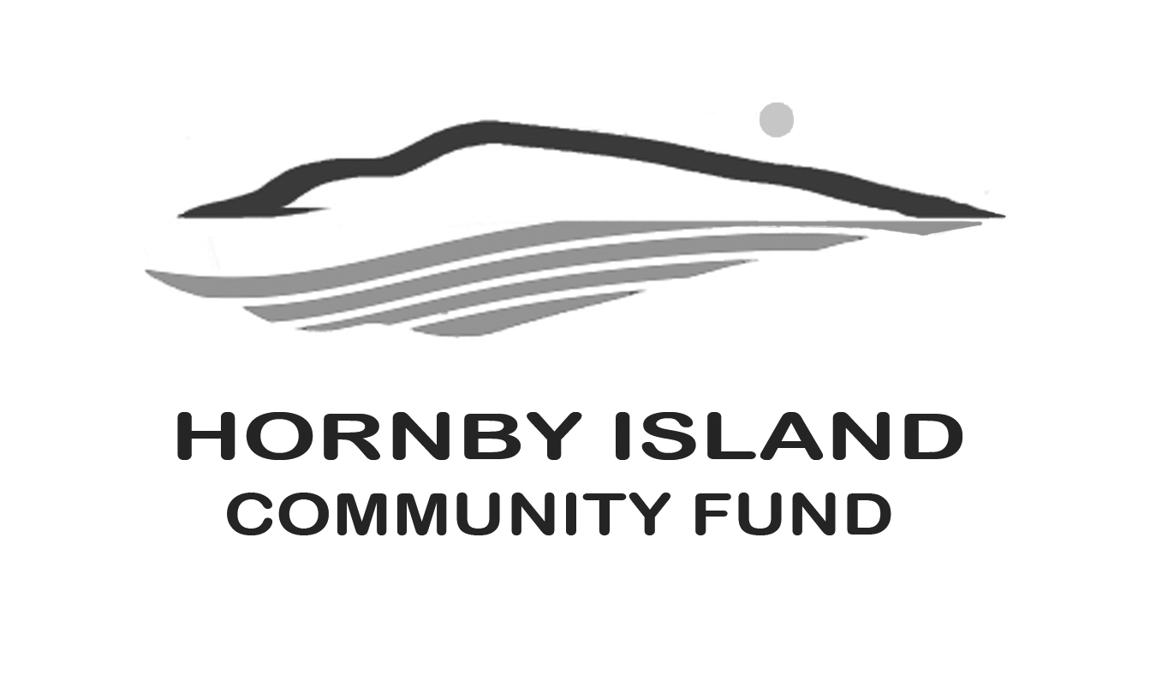
First Edition
Feb 22
Report from the Community Fund

In the U.S midwest, the second Thursday in February is NATIONAL GIVING HEARTS DAY.

You have to love it, their slogan is “Big hearts give big on National Giving Hearts Day!”

In this single 24-hour period, records are set
- In 2021, Giving Hearts Day celebrates its 14th year.
- Since 2008, tens of thousands of generous donors have given.
- In 2020, more than $19 million was donated in this region of the U.S.
- The average donor gave to 2.2 charities in 2020.
The advertising for the Event is so inclusive, with statements like:
- The celebration offers one of the best opportunities to donate to your favorite charity. So many hearts and so much to give!

- The money goes directly to the charities YOU love the most. Plus, you can give to as many charities you want. Give to one, or give to several.

- It doesn’t matter where you are on the planet. You can still give.

- It’s the best way to show your support and how giving your heart is. The minimum donation is $10, but how much is that really? Two cups of coffee?

The Registrar at National Day Calendar® proclaimed National Giving Hearts Day to be observed on the second Thursday in February, annually. Funny that this celebration hasn’t taken a foothold in Canada.
So here is a rousing endorsement, this Thursday, February 10th, you can join the movement............make a donation to your favourite Island charity, or two.
A lot of Hornby’s non-profits have a “giving portal” on www.canadahelps.org You can search them by name.
To donate to the Community Fund...........
After opening the website, in the box: Get Started, Find a Charity, type: Comox Valley Community Foundation
Click on the resulting box.
In the DONATE TO THIS CHARITY box, scroll down to the Hornby Island Community Fund, select, and make your donation.
We thank you for choosing the Community Fund and any of the worthy Hornby groups.
Cheques can also be mailed to Hornby Community Fund, c/o April Lewis, 5005 Arthurs Road, Hornby Island, B.C. V0R 1Z0
So ra ra ....remember, Thursday, February 10th, YOU CAN GIVE A LITTLE, OR YOU CAN GIVE ALOT!
Thank you to all the Friends of the Fund. Together we are making a difference in our community.
Please visit our website for more information: www.hornbycommunityfund.org
Submitted by: Community Fund Advisory Board Doug Bouey, Brenda Cha, April Lewis, Angie Read, and Karen Ross

