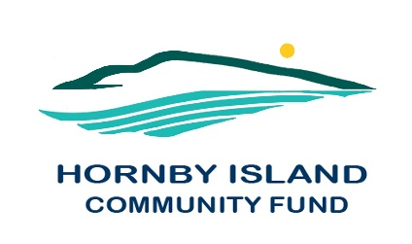
First Edition
June 2021
Report from the Community Fund

The Hornby Island Community Fund Board is in a reflective mode. Without personal contact, networking, and regular events, we have undertaken a strategic review, with the assistance of retired Management Consultant Jon Pascoe. Jon has specialized in strategic planning, governance and operational reviews, human resources, accreditation, bylaws, policies, and similar areas. As a Comox Valley resident, and regular visitor to Hornby island, Jon has generously come forward to facilitate this work with the Hornby Community Fund. The Board members are excited for this opportunity for re-evaluating their governance and role in the community.
As part of these reflections, we would like to warmly thank our outgoing members, Eva Wetzel and JoAnn Harrison, and gratefully acknowledge their years of service. They join the ranks of our honoured past members:
PAST ADVISORY BOARD MEMBERS:
- Charmaine Logan
- Robin de Lavis
- Bill Adams
- Dennis Anholt
- Moira Armour ·
- Joan Brears
- Lynne Carmichael
- John Farquhar
- Eleanora Laffin ·
- Linda Manzer ·
- Sheila McDonnell ·
- Arne Olsen
- Daniel Siegel
- Peter Wardle
- Chris Weixelbaumer
- Wayne Wiens
- Gary Duke
As can be read in this list, this grass roots organization strives to have a wide range of community members, and skill sets, represented on the Board. Sharing their love of the Island, the primary role of the HICF is to support building capacity in the community, through distribution of the earnings, from the perpetual capital fund, to applicant non-profit groups. In order to do this more effectively, the capital fund must grow and much work is done by the HICF Board in fund raising and providing information for bequests and donations. If you, or someone you know, might be interested in serving on the Board as a fund raiser, or a patron, please contact karenross@telus.net, or any Board member, for more information.

Hornby Community Fund Board: Anne Carney, Brenda Cha, April Lewis, Angie Read, and Karen Ross

