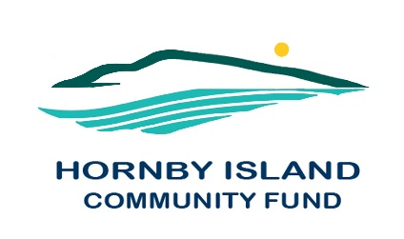
First Edition
September 2021
Report from the Community Fund

Attention all Island Charities
This year’s grant applications, for both the Hornby Community Fund and the Comox Valley Community Foundation, are opening August 24, 2020 and closing September 24, 2020. Go online: https://cvcfoundation.org/grants/grants-application-process/
Our appeal as we look to the future
The primary role of the HICF is to support building capacity in the community, through distribution of the earnings, from the perpetual capital fund, to applicant Island charitable groups. In order to do this more effectively, the capital fund must grow.
Please consider making a tax deductible donation to the Community Fund, to meet your philanthropic goals.
Who are We, and What are We Doing for our Community?
The Hornby Community fund is a local Community Society, whose Directors partner with, and advise, the Comox Valley Community Foundation re local granting. This Board of respected and dedicated volunteers are responsible for determining policy and direction, educating the community about the fund, soliciting donations, and developing and maintaining criteria for disbursement of the grants. The Directors are additionally charged with providing information on funding sources and fundraising techniques to support the fundraising efforts of community groups.
In 2019, fund members elected to form a non-profit society. The mandate is to provide funds, on a project application basis for Island charitable groups.
What Does Good Diversified Granting Look Like?

The money paid out is the earnings derived from an accumulated capital fund, and in more recent years, also proceeds from the Annual Book Sale. We are grateful for the management of the Fund, and an interest “bump”, provided by the Comox Valley Community Foundation.

Money for the capital fund has been accumulated from generous donations from members of our larger community. The Board has also tirelessly worked fund raising, including collecting fees at the Golf Gate; Vacation auctions; Art auctions; Gala dinners; and Collectibles sales. One long time summer resident significantly remembered the Fund in his will.

Volunteers on our Board, lead by Angie Read, also operate the community service of Party & Wedding Supplies Rentals, (view our website for a list of all the items & prices)

Thank you to all the Friends of the Fund
To all the civic minded donors, cadre of volunteers who help with events and fundraising, and to our host organization – the Comox Valley Community Foundation.

Together we are making a difference in our community.

Much work is done by the HICF Board in fund raising and providing information for bequests and donations. If you, or someone you know, might be interested in serving, as a fund raiser, or a patron, please contact karenross@telus.net, or any Board member, for a copy of our Board Recruitment Package.

Please check our website. www.hornbycommunityfund.org for more information.

Hornby Community Fund Board: Anne Carney, Brenda Cha, April Lewis, Angie Read, and Karen Ross

