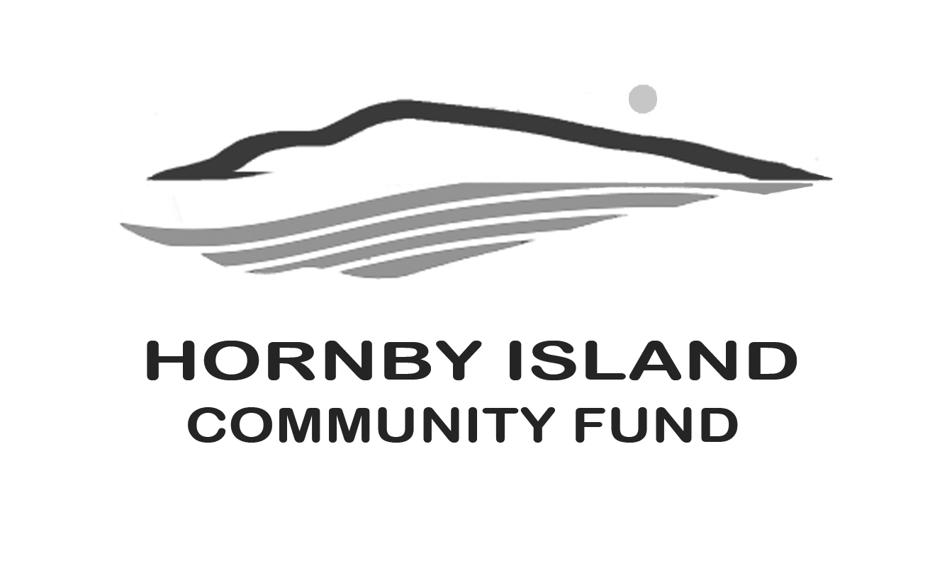
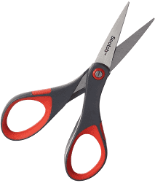 CLIP AND SAVE:
First Edition
July/August 22
Report from the Community Fund

Imagine
The love affair with Hornby Island starts on your very first visit. For those lucky enough to move to our little paradise it is life changing. Many more continue to come here loyally and want to keep a piece of this place in their heart year round. Some may remember the paintings of Brian Scott. They are exuberant playful captures of sunny summers many return to year after year. You could “buy a Brian”, or a piece from another Hornby creative, and have that in your home to remind you of more carefree times on these shores during the dark winter.
Your heart may feel at home here. Like anyone new to a community or visiting from time to time, you may not appreciate that there are a web of hard working volunteers who keep their sunny jewel ticking during the dreary times. A highly functioning community depends on many working parts for its smooth continuation that presents so well during the visitor season. The trials they go through to do that. Most of that ongoing maintenance is volunteer organized and staffed. As in any other activity, capital funds are required… Not that much of it is supplied by governments.
Can you imagine a world where a shortage of funding for local non-profits is the exception? Where Hornby organizations providing education, arts, recreation, culture, housing, health & well-being, environment, economic & social justice can turn to a local fund for sustaining their causes?
Many would like to help; see the need. But how to do it without concern their funds are being diluted or misapplied?
Since it’s inception in 2002, the Hornby Community Fund has granted over $200,000 to worthy Hornby groups. Recipients are carefully screened. As the Fund grows, so does the impact in the community, now and into the future.
The donations that you make to the fund, and the work that the non-profit groups on the Island do make this island’s easy and generous nature possible.
How can you help?
- Use a credit card by visiting our secure online donation portal:
  - Https://www.canadahelps.org/en/charities/the-comox-valley-community-foundation/
  - On the right side of the page, find the Hornby Island Community Fund
    - The page looks like this:
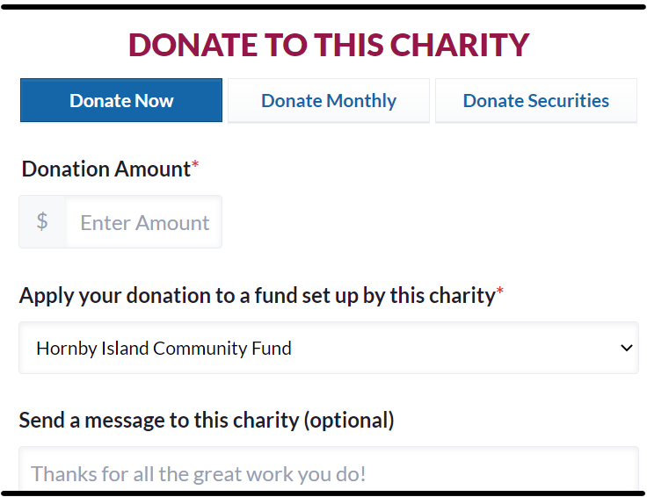
- Make a cheque payable to Comox Valley Community Foundation/Hornby Community Fund, and mail to:
Comox Valley Community Foundation
PO Box 1454
Comox, BC, V9M 7Z9
- Please include a note with your full name, address, phone number and instructions for the funds to go into the Hornby Fund
- Call Office: (250) 338-8444
Make your pride in your island “heart home” show. Join us. Your partnership and passion are critical to our progress.
With you, we are making a difference in our community. www.hornbycommunityfund.org

Submitted by: Community Fund Board: Doug Bouey, Brenda Cha, April Lewis, Angie Read, and Karen Ross

