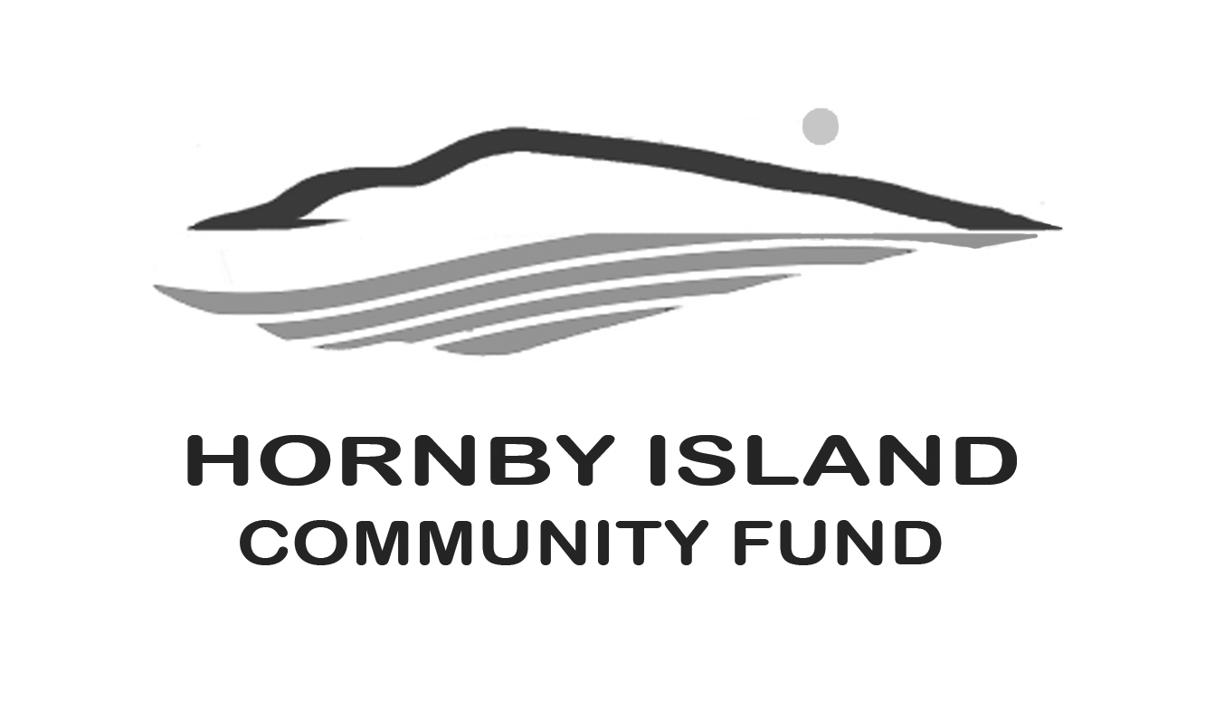
First Edition
October, 22
Report from the Community Fund

Great to see you
On Sept. 8, Sigourney and Susan, from the Comox Valley Community Foundation, came to support Hornby in getting information to the Island non-profits on the hows/whens/whys of the Foundations granting process.
Hornby Community Fund Board members and Directors and staff from other organizations appreciated the information.

Although this report will be past the 2022 granting application deadline, it is important for groups to know current changes to information moving forward.

The most significant changes are:
- A more simplified application process
- Clarity on non-profits that do not have charitable status being able to apply through a qualifying “sponsor” organization.
- An outline of how Hornby organizations are eligible to apply directly to the Comox Valley Community Foundation for grants (https://cvcfoundation.org/)
- Note: as in previous years, any unfunded or partially funded Hornby Island applications that also meet Comox Valley Community Foundation (CVCF) criteria will be included in the CVCF review.
- Hornby Island applications for things not eligible for funding by the Hornby fund, will automatically be considered by CVCF reviewers. (e.g. operations)

A refocusing of the Comox Valley Community Foundation has occurred, shifting in four ways.
- The Comox Valley Foundation now funds, capital projects, operations, and programs. This is a shift from singularly funding capital projects.
- Identifying specific sectors for eligibility. (not all sectors will qualify)
- CVCF is piloting multi-year funding and will consider applications for up to 2 years of funding,
- The adjudication of applications is now being done in two ways.
  - As traditional, by members of the CVCF organization/appointees, with recommendations from the Hornby Fund Board of Directors.
  - “At the table”, a grass roots evaluation of dedicated funds with distribution recommendations done by organizations in the specific field.

2022-2024 strategy CVCF Granting Program, by Adjudication method
For 2022:
- Community Enrichment Grants. $158,811
CVCF Sectors for Eligibility:
i. Food insecurity and food systems
ii. Mental heath and connection
iii. Indigenous led or benefiting projects/organizations
iv. Arts, culture, and heritage

- At The Table, $195,000.
  - Housing and homelessness supports $75,000
    - These grants are reviewed by the Comox Valley Coalition to End Homelessness. They are open to HI organizations, and coalition membership is not required. Applications will be in the CVCF Grants Portal.
  - Social and recreational programs for adults with diverse abilities. $50,000
    - Application process and decisions will be determined by a community table comprised of the organizations servicing this population.
  - Environmental protection and climate action. $50,000
    - Application process and decisions will be determined by a community table comprised of Valley wide organizations working in this field.
  - Charitable sector support and development. $20,000

These changes are seen as very favourable for some non-profit groups on Hornby, who will have access to applying for operational funding.

In addition to Hornby non-profits accessing the Foundations funds, they are also eligible for capital project funding with no sectoral limitations (i.e. all sectors are considered) from the Hornby Fund.

So, exciting times, as the Comox Valley Foundation has become larger, and had more funds to distribute, new opportunities open up in the whole Regional District.

The Hornby Community Fund local Board of Directors, play a strong role in liaising with the C.V. Foundation, working to help our local patrons achieve their philanthropic goals, and in supporting the full spectrum of Island non-profits’ to thrive.

For this year’s Hornby Fund capital raising efforts, we thank the Book Sale organizers, Angie and her party rentals team, the Arts sale patrons, and the generous cash/equivalent philanthropists. With you, we are making a difference in our community. www.hornbycommunityfund.org

Submitted by: Community Fund Board: Karen Ross, Brenda Cha, April Lewis, Angie Read, and Doug Bouey

