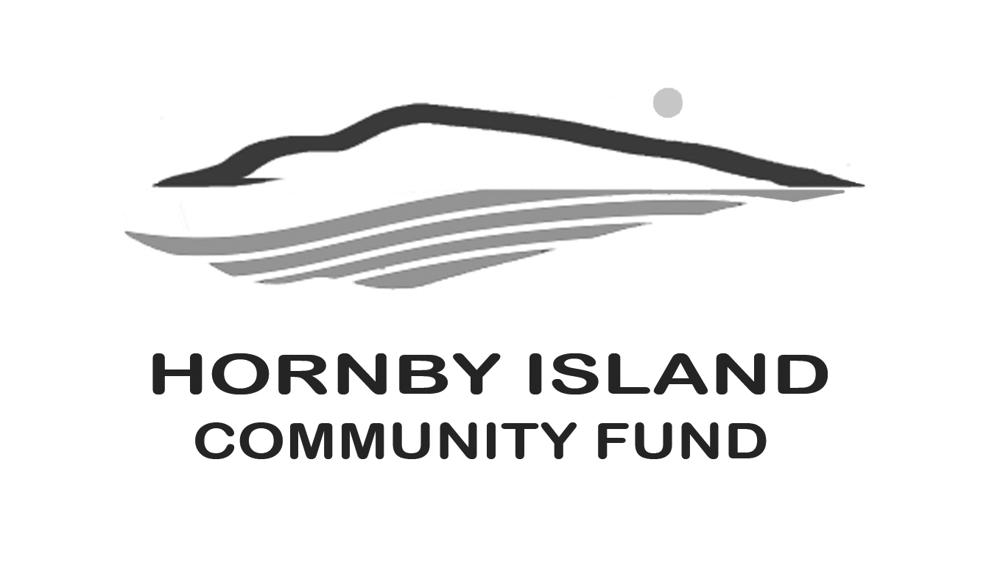
First Edition
July/August, 2020
Report from the Community Fund

Cautiously Optimistic
Congratulations to all British Columbians for their valiant fight to #plankthecurve and hold the flood of the pandemic at bay. So far so good. With cautious optimism we look forward to summer, and welcoming the many seasonal residents who share our love of Hornby, and are such great “friends of the fund”, back into our fold. While we have no plans in place to hold group events, we look forward to a friendly wave! Hopefully by 2021, Women’s Wednesdays, the annual Book Sale, the Home Décor & Collectibles Sale, and a Gala Dinner will all be back.
Not just as fund raising events to help support Hornby non-profit groups, but also as a
place for friends to join together in meaningful social interactions.

Time to Pivot
Thanks to the inspiration provided by photographer Sharron Milstein, with her generous donation of her and Gerald’s art collection (stepping up, by down sizing), the online auction looks possible. Probably later this summer, as we need time to assemble more donations -tentatively in these categories: collectibles, artworks, interesting books, local experiences, etc. If you are supportive of the idea, we invite you to contact one of our Board members to contribute items. More information on how the bidding, and viewing, will proceed will be announced soon.

A brief update
In the May First Edition paper, our report included a short introduction to our Board members.
This information has now been posted onto our website. www.hornbycommunityfund.org

Also, on the website is a breakdown, by recipient, of the $158,115. that has been granted by the Hornby Island Community Fund, between 2002 and 2019, (an additional $6300 for the Bruce Fairbairn Fund), to a wide cross section of Hornby non-profit organizations.

This money is the interest derived from an accumulated capital fund, and in more recent years, also proceeds from the Annual Book Sale. We are grateful for the management of the Fund, and an interest “bump”, provided by the Comox Valley Community Foundation.

We are pleased that the Foundation paid for half the cost of a new sanitizer for installation at the JoeKing Kitchen, during the pandemic, when meals uptake greatly increased.

Money for the capital fund has been accumulated from generous donations from members of our larger community. The Board has also tirelessly worked fund raising, including collecting fees at the Golf Gate; Vacation auctions; Art auctions; Gala dinners; and Collectibles sales. One long time summer resident significantly remembered the Fund in his will.

Volunteers on our Board also operate the community service of Party & Wedding Supplies Rentals, (view our website for a list of all the items & prices)

Thank you to all the Friends of the Fund.
To all the civic minded donors, cadre of volunteers who help with events and fundraising, and to our host organization – the Comox Valley Community Foundation. Stay safe and well.

Together we are making a difference in our community.

Submitted by: Community Fund Advisory Board: Anne Carney, Brenda Cha, Gary Duke, JoAnn Harrison, April Lewis, Angie Read, Karen Ross and Eva Wetzel

