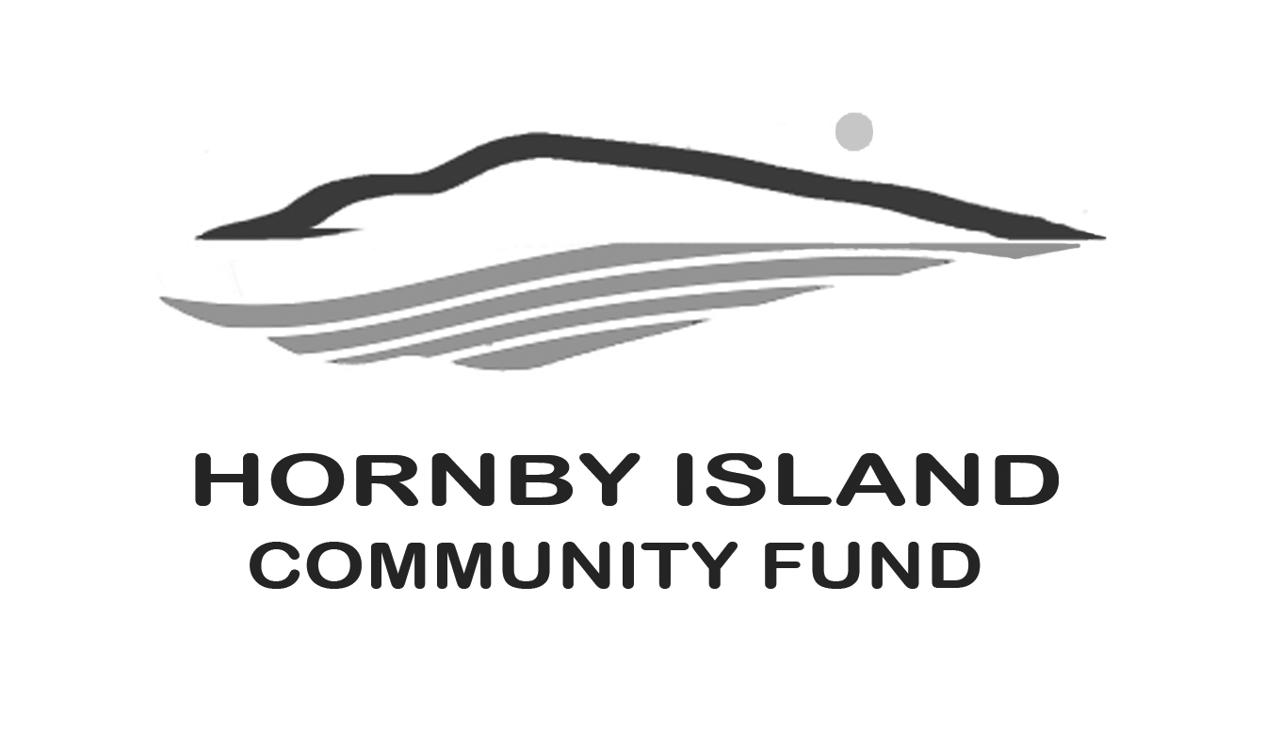
First Edition
June, 2020
Report from the Community Fund

COVID-19
What could be more disruptive to our community social order than a pandemic? At the time or writing, the Provincial Government order for “essential travel only” is still in force. As people stay in place, the effect on the fabric of our community is amplified as an important part of our population, our seasonal residents, stay away. We miss your support - Friends of the Fund, participants from Women’s Wednesdays, contributors to the annual Book Sale, browsers at the Collectibles Sale, and patrons at the Gala Dinners. But more importantly, we miss your friendships and we miss your company. We love you! There is some small comfort. In the words used by Queen Elizabeth II, in her stately address to the Brits, “until we meet again”.

A brief update
In last month’s paper, our report included a short introduction to our Board members.
This information has now been posted onto our website.

As reported in the April First Edition, $158,115. has been granted by the Hornby Island Community Fund, between 2002 and 2019, (an additional $6300 for the Bruce Fairbairn Fund), to a wide cross section of Hornby non-profit organizations.

This money is the interest derived from an accumulated capital fund, and in more recent years, also proceeds from the Annual Book Sale. We are grateful for the management of the Fund, and an interest “bump”, provided by the Comox Valley Community Foundation.

Money for the capital fund has been accumulated from generous donations from members of our larger community. The Board has also tirelessly worked fund raising, including collecting fees at the Golf Gate; Vacation auctions; Art auctions; Gala dinners; and Collectibles sales. One part-time resident remembered the Fund in his will.

Volunteers on our Board also operate the community service of Party & Wedding Supplies Rentals, (view our website for a list of all the items & prices)

Time to Innovate
The annual Book Sale is placed on “pause”, assembling and selling Collectibles requires much handling, the annual Gala Dinner involves a gathering of more than 50 people, and weddings and events cancellations have resulted in the Party Rental social enterprise losing clients.

So, what are a dedicated, energetic group of 8, blessed with loyal and generous patrons, do? Time to try something new! What would be the reaction to an online auction of collectibles, artworks, interesting books, local experience, etc. be? If you are supportive of the idea, we invite you to contact one of our Board members to contribute items. More information on how the bidding, and viewing, will proceed will be announced soon.

Thank you to all the Friends of the Fund.
To all the civic minded donors, cadre of volunteers who help with events and fundraising, and to our host organization – the Comox Valley Community Foundation. Stay safe and well.

Together we are making a difference in our community.

Submitted by: Community Fund Advisory Board: Anne Carney, Brenda Cha, Gary Duke, JoAnn Harrison, April Lewis, Angie Read, Karen Ross and Eva Wetzel

