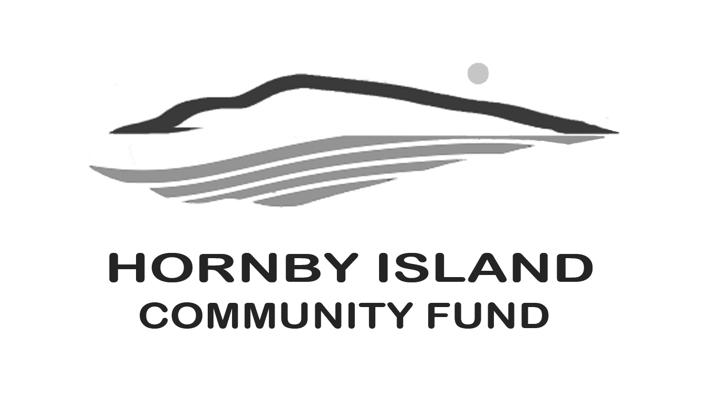

**First Edition**

**June 22**

**Report from the Community Fund**

**Group activity**

The gang is all here? How about taking them all for an afternoon of golfing? The Community Fund is working with Peter Wardle on a new fund-raising idea.

In exchange for making a donation to the Community Fund, your group can have a private golf afternoon at Little Tribune. (Shades of the Smith Family Classic). Please call Karen or Peter to discuss the details!

**Time for some thanks to those that give their time and energy:**

* The organizers of the annual Book Sale (for providing us all with fresh reading material, and for donating all the proceeds into the Community Fund’s annual granting pool for the benefit of others)
* New Horizons and Joe King for sharing your facilities
* Shelley Creelman for providing much needed storage for the Fund’s collectibles
* Eva Wetzel and Cal Read for assisting Angie with the Fund’s Party Rental business
* Past Board members for your continuing support of the Community Fund movement
* Paula Wardle for her design prowess in upgrading brochures, posters and invites
* The artists, craftspeople, accommodation owners, restaurants, and others who have donated auction items over the years

More time for thanks to those that make donations:

* There are so many, we give you heartfelt thanks for donating items, attending events, buying items at auctions and sales
* Those serious philanthropists who remember the Community Fund in their wills, while doing tax planning, and in their annual charitable donations.

And blanket kudos to the whole community who have helped build this Fund to over $500,000. The gift that keeps on giving!

To all the Friends of the Fund, together we are making a difference in our community. [www.hornbycommunityfund.org](http://www.hornbycommunityfund.org)

Submitted by: Community Fund Board: **Doug Bouey,** **Brenda Cha, April Lewis, Angie Read, and Karen Ross**