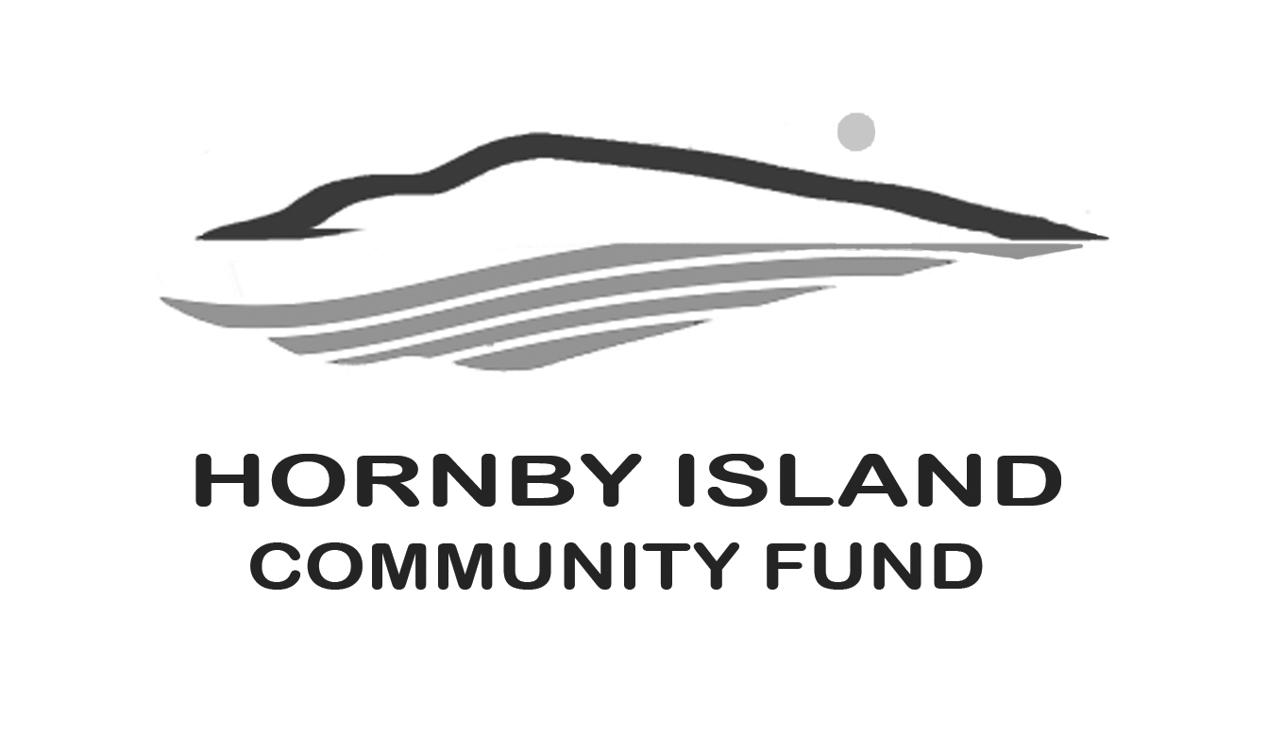

**First Edition**

**March, 2020**

**Report from the Community Fund**

**Donating makes you feel good!**

**ANYONE CAN GIVE, IN ANY AMOUNT**

The larger the pool of capital, the more income can be earned and the more good that can be done in our community.

There are a number of ways for individuals, families, organizations, private foundations and businesses to contribute to the Hornby Island Community Fund.

DIRECTLY TO ANY MEMBER OF OUR BOARD:

* cash or cheque
* pledges over a number of years
* stocks and bonds
* property bequests
* life insurance
* memorial gifts
* stock transfers

ONLINE WITH YOUR CREDIT CARD:

Please go to this website:

<https://www.canadahelps.org/en/charities/the-comox-valley-community-foundation/>

Scroll down to the drop down box:    "Apply your donation to a specific fund set up by this charity: "

From the list, choose: "Hornby Island Community Fund "

Below that is an open text box: "Include a message for this charity ":   Be sure to say hi, we love to hear from Friends of the Fund!

The Comox Valley Community Foundation also accepts donations for the Hornby Community Fund.

<https://cvcf.fcsuite.com/erp/donate/create?funit_id=1007>

This site will allow you to dedicate your donation to pay tribute to certain individuals.

WILLS & BEQUESTS:  An information sheet, with suggested wording, is provided on our website: hornbycommunityfund.org.  Please download the information and provide it to your lawyer for including the Fund in your Will.

STOCKS & SECURITIES:  Information, with suggested wording, is provided on our website: hornbycommunityfund.org.  Please download the information and seek independent financial adviser for making this transaction.

Charitable tax receipts will be issued for gifts of $50. and over.

OUR GOAL

A donation to the Community Fund is the gift that keeps on giving.

Annual interest paid our helps our community flourish in perpetuity.

Our long-term goal is to raise our capital balance to $1 million.

Together we can achieve these goals!

Discuss your options:

Email Board Chair: [k](mailto:hicommunityfund@gmail.com)[arenross@telus.net](mailto:arenross@telus.net)

Or talk to any Board member:

Advisory Board Members: **Anne Carney, Brenda Cha, Gary Duke, JoAnn Harrison, April Lewis, Angie Read, Karen Ross and Eva Wetzel**

**Thank you to all the Friends of the Fund.** Together we are making a difference in our community.