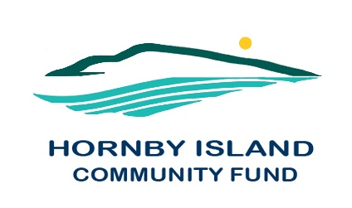
First Edition
March 2021
Report from the Community Fund

The Comox Valley Community Foundation (CVCF) held their annual Community Enrichment Awards Ceremony, in a well-organized Zoom presentation on January 27, 2021.
In 2020, CVCF distributed over $1 million, including significant emergency funding through the Government of Canada’s Emergency Community Support Fund.
Host and CVCF Executive Director, Susan Auchterlonie, introduced inspirational video vignettes featuring 5 of the recipient organizations, who radically pivoted their operations to keep offering their services. These heart-wrenching success stories came from the LUSH Valley Food Action Society, Comox Valley Transition Society, Comox Valley Children’s Daycare Society, the Cumberland Community School Society, and the Canadian Red Cross.

Two major business contributors were also recognized for their COVID response to assist local non-profits, health and emergency services keep safe. Last spring, with the critical shortage of hand sanitizer, Wayward Distillery partnered with CVCF to distribute free-of-charge $40,000 worth of sanitizer. This fall, Canadian Tire donated 2,400 litres of hand sanitizer, valued at $32,486.
The Hornby Island Community Fund (HICF) recipients were officially announced:
From general funds:
- HIES, new windows for Room to Grow, $8,000.
- HI Athletic Association, laundromat/shower, Wash House upgrade, $8,000.
- HI Housing Society, Elder Housing unit kitchen upgrade, $2,000.
- HI Natural History Centre, strategic planning for relocating, $1,200.
- HI Daycare Society, portable U.V. air purifier, $1,120.
For a total 2020 Islanders distribution from general funds, of $20,320.
ADDITIONALLY, from targeted funds:
- Bruce Fairbairn Bursary Fund:
$ 2000. to McKenzie McLeod for Art School tuition, to further her art career
- Arne Olsen Fund:
$ 680.00 to the Hornby Festival Society
- the Emergency Community Support Fund:
The Hornby Denman Community Health Care Society received $4,800. for “Transportation for Rural, Remote and Low-Income Seniors – inclusive of taxis, mileage reimbursement for volunteers, and grocery shopping and delivery”.
The 2020 granting, and emergency programs, represent the largest dollar amount ($ 1 million) and the most organizations (56), that the CVCF has supported in a single year.
Matt Beckett, President of the Comox Valley Community Foundation. “We are extremely grateful for the continued support we receive from our fund holders and donors who make this possible each and every year.”
2021 is the 25th anniversary of the Comox Valley Community Foundation. They have amassed $15 million in their Funds, and we wish them a very Happy Anniversary. The Hornby Fund will be celebrating 21 years of service to our Island.
On behalf of the Hornby Fund, we are very grateful, to our local donors and supporters, and to the Comox Valley Community Foundation for their generosity and for hosting our local Fund.
Hornby Community Fund Board: Anne Carney, Brenda Cha, JoAnn Harrison, April Lewis, Angie Read, Karen Ross and Eva Wetzel
www.hornbycommunityfund.org

