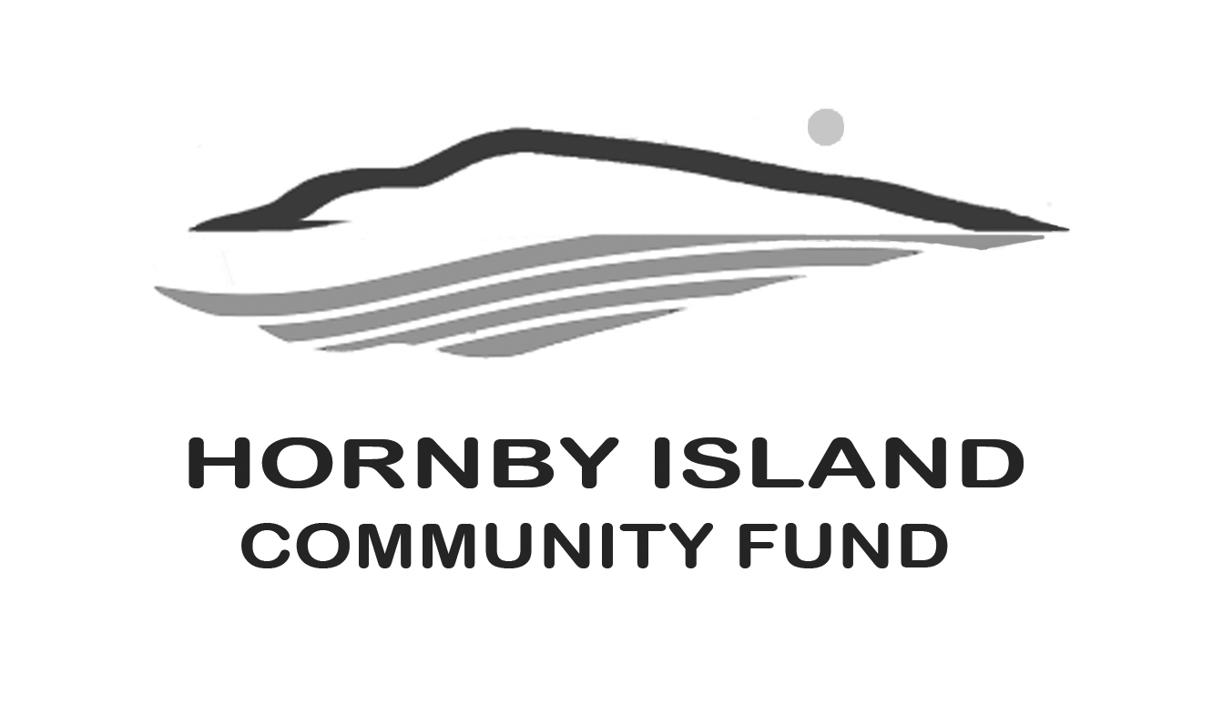
First Edition
March 22
Report from the Community Fund

Once of the best celebrations of the winter has been the 2022 Community Granting Celebration, held by the Comox Valley Community Foundation via Zoom on Thursday January 27.
The Foundation spread $375,000 of grant funds over 32 Valley organizations.
Several featured recipients spoke about their project, in depth, and included the two most heavily financed projects:
$100,000. was given to the Comox Valley Early Years Collaborative’s Building Connection for Valley Families Project. This program to improve social and supportive connections has its roots in early childhood development.
$109,930. was given to the “Walk with Me” project. Barb Whyte and Sharon Karsten presented a truly touching presentation. “Walk With Me” addresses the illicit toxic drug poisoning crisis in B.C. Since the B.C. emergency was declared in 2016 over 8000 people have lost their lives. The program works with people with lived experience, family members, front line workers and health professionals in training. North Island College, Island Health and the Comox Valley Community Health Network are partners in the program. Outreach relies heavily on the Coast Salish talking circles, where everyone has an opportunity to speak, and no one is left out. Talking moves around the circle to the left, representing people speaking from their heart side. Their website is www.walkwithme.ca
The Hornby Fund awards were announced in the Fall of 2021. However, Hornby organizations were still eligible to be funded from the larger Valley funds. From these general funds, Hornby recipients were:
- Hornby Island Housing Association, $2,500. for a Housing Needs Assessment
- Hornby Island Community Kitchen, program supports, $2,500
- Heron Rocks Friendship Centre Society, Hornby Groundwater Drought Signage $1,250
Of course, many of the Comox Valley networks, who received grants, do work that benefits residents of the Islands.
In addition to the regular grants, the CVCF also offers “neighbourhood grants”. This year they funded 36 projects, with $245-$600. provided/project. Projects ranged from block parties to gardening stimulators to environmental projects. There were no Hornby funded projects in this group. (Likely there were no applications.)
The featured presenter from the Neighbourhoods group was Vicky Brown, from Cumberland. The project was a “Pollinator Path” on Camp Road. The street is about 800 metres long, with about 60 homes. The organizers asked for funding to buy drought resistant plants, which the participating neighbours planted in their front yards to help the bees with pollination, and as beautification for the tightly packed neighbourhood. The plants to choose from were mock orange, Oregon grape, honey suckle or heather. In 2021 abut 16 houses participated, there is a Round 3 in 2022.
The liaison that the Hornby Fund enjoys with the Comox Valley Community Foundation has many benefits, which include access to funds, legal advice, and guidance in assisting with fundraising and granting.
But without YOU, our “Friends of the Fund”, nothing would happen. THANK YOU. Together we are making a difference in our community.
Please visit our website for more information: www.hornbycommunityfund.org
Submitted by: Community Fund Board: Doug Bouey, Brenda Cha, April Lewis, Angie Read, and Karen Ross

