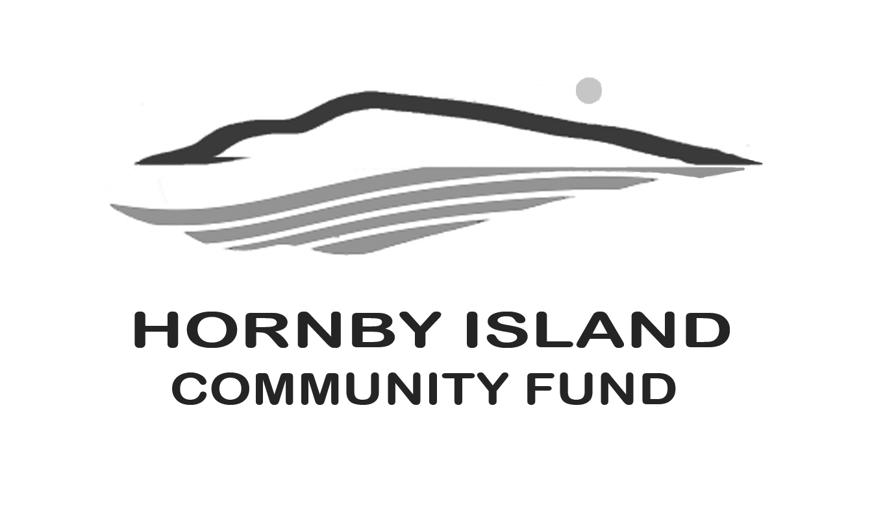

**First Edition**

**May, 2020**

**Report from the Community Fund**

As reported in the April First Edition, $158,115. has been granted by the Hornby Island Community Fund, between 2002 and 2019, (an additional $6300 for the Bruce Fairbairn Fund), to a wide cross section of Hornby non-profit organizations.

This money is the interest derived from an accumulated capital fund, and in more recent years, also proceeds from the Annual Book Sale. We are grateful for the management of the Fund, and an interest “bump”, provided by the Comox Valley Community Foundation.

Money for the capital fund has been accumulated from generous donations from members of our larger community. The Board has also tirelessly worked fund raising, including collecting fees at the Golf Gate; Vacation auctions; Art auctions; Gala dinners; and Collectibles sales. One part-time resident remembered the Fund in his will.

**Who are the members of the Community Fund Board?**

April Lewis is currently the Treasurer, and has been involved with the Fund since being the Executive Director of the Hornby Island Education Society. She has served both as a staff liaison with HIES and on the Board. April is known, and loved, by Hornby kids for her supervision at Teen Nights, working at the Preschool, and from being a constant visitor at the school with her HIES job.

Anne Carney is the Board Secretary. Anne is a relative ’new comer’ to the Board.

She and her husband, Owen (descendant of the Hornby Island Ford and Strachan Families) have been able to spend more of their time on the Island since retiring.

Anne from Nursing and Owen from the business world.

Both have been President and long-time members of the Rotary Club of Squamish and involved in many fund-raising ventures. Anne brings a high level of professionalism to the Board, and Owen continues to act philanthropically within the community. Both are held in high esteem in the communities they live, love and serve.

After retiring from being a nurse, Anne married long time Hornby resident Owen Carney (Owen is a descendant of the original Hornby Ford family). Anne is a former Chair of the Squamish Rotary Club and brings her Board professionalism to the Fund.

JoAnn Harrison, and husband Keith, moved to Hornby 24 years ago and instantly got involved with the community.  JoAnn provides strength and stability to our Board. JoAnn has also served for many years on the Elder Housing Board, and now is the President of the Hornby Island Housing Society.

Eva Wetzel is a tireless worker for the Community Fund. She and her husband, Kurt, retired here from Saskatchewan. For many years Eva headed up the Book Sale, the annual proceeds are passed each year to the Community Fund for distribution. Eva also assists with the Fund’s Party Rental business and anything else that needs doing.

Angie Read is a retired teacher, who has owned property on Hornby for many years. A well-loved Galleon resident, Angie takes on the huge job of Coordinator of the Party Rental business. This social enterprise was set up in response to the many local fund-raisers that needed tables and chairs and were having to rent them from Courtenay. The line expanded and now includes everything needed to put on a wedding. Fortunately, Angie’s husband, Cal, and Eva lend a hand when the going gets brisk.

Gary Duke is a member at large, and he and Peter Wardle were instrumental in helping establish the sub-fund in honour of Arne Olsen. This Arne Olsen Fund has now reached approx. $50,000., with the annual interest specifically targeted for the Hornby Festival Society. Gary is currently the president of the Festival Society.

Karen Ross is the current Chair, and has been on the Fund Board since the early days. She and John Ross moved to Hornby in 1984 as the new owners of the Thatch, then started a family, with two children – Jacquelin and Darren. Karen continues to live on Hornby and shares her family home as a short-term vacation rental, and works for HICEEC.

Brenda Cha, another long-time member of the Board is instrumental in raising awareness of the Fund. She, and partner Peter Wardle, have donated the golf gate to the Community Fund for years. Also, many times the proceeds of the Annual Gala Dinner. Brenda is the main force behind the Annual Collectibles Sale. She is also lead organizer of Women’s Wednesday, a summer networking group to help Friends of the Fund stay connected. Brenda is the Vice-Chair on the Board.

Over the years, other people have served. Special acknowledgement to:

* Sheila McDonnell
* Eleanor Laffin
* Moira Armour
* Peter Wardle

without whose service, the Fund, as we know it today, would not exist!

Other past Advisory Board members include: John Farquhar, Charmaine Logan, Robin de Lavis, Chris Weixelbaumer, Lynne Carmichael, Bill Adams, Dennis Anholt, Joan Brears, Linda Manzer, Wayne Wiens, Daniel Siegel, and Arne Olsen.

**Thank you to all the Friends of the Fund.**

The civic minded donors, cadre of volunteers who help with events and fundraising, and to our host organization – the Comox Valley Community Foundation.

Together we are making a difference in our community.

Submitted by: Community Fund Advisory Board: **Anne Carney, Brenda Cha, Gary Duke, JoAnn Harrison, April Lewis, Angie Read, Karen Ross and Eva Wetzel**