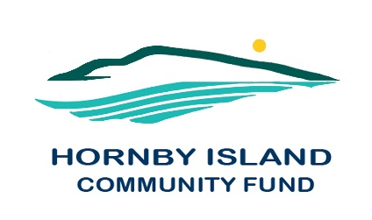

**First Edition**

**May 2021**

**Report from the Community Fund**

**The Hornby Island Community Fund has held it’s first AGM, on April 21st. One of the biggest highlights of 2020 was in forming a Society, independent of the HIES umbrella, for the Advisory Board. Excerpts from the President’s report, with other 2020 highlights:**

* **COVID PANDEMIC limited activities**
* **Book sale, collectibles sale, and most party rental reservations were all cancelled**
* **Summer of 2020, pivot to start collecting art for an online Art Auction, planning continues for this event** 
  + **Thanks to donors – Sharon Milstein, Catherine Ross, and others**
  + **Director Brenda Cha for the lead**
  + **Helpers – Jolayne Devente & Barb Biagi**
* **Shelley Creelman has continued to extend storage space for our expanding use**
* **Comox Valley Community Foundation took a lead role in accepting grant applications, people seemed to have adapted to the online system**
* **Gary Duke resigned as a Director**
* **Board secretary, Anne Carney, spearheaded a Board Strategic Planning Review**
* **Public presence retained through First Edition articles and website updates (**[**www.hornbycommunityfund.org**](http://www.hornbycommunityfund.org)**)**
* **Between 2002 and 2020, $181,481. has been granted** from General Funds.  (an additional $6300 for the Bruce Fairbairn Fund). A breakdown, by recipient, is on the website.
* THANKS to all the current, and former directors, for making this achievement possible. We particularly acknowledge the contribution of our retiring Directors

Hornby Community Fund Board, pre AGM: **Anne Carney, Brenda Cha, JoAnn Harrison, April Lewis, Angie Read, Karen Ross and Eva Wetzel**