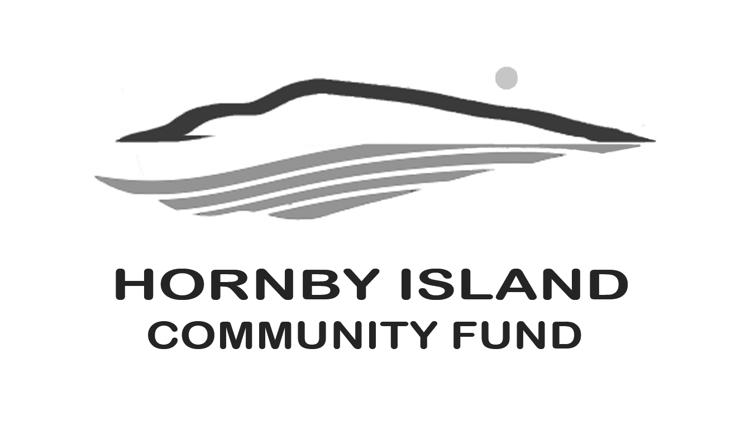

**First Edition**

**May 22**

**Report from the Community Fund**

**It’s Back - BUY A BOOK, READ A BOOK, DONATE A BOOK. REPEAT:**

The Annual Book Sale is back on the Summer Calendar. Dozens of people all over the Island have started gathering, sorting and packing books. The stalwart team welcomes books of all genres: the great, the almost great and the special interest great, any size, any age. Books that are excessively damaged or soiled should, however, go to the Free Store or Recycling Depot along with magazines and video/audio cassettes.

**Buy:** July 16 & 17th at the Community Hall

**Read**: At your leisure

**Donate**: Before 5 p.m., go to the “Big Tree”, follow the book signs to 4600 Chandler Road. Small amounts can also be left in the box, in the basement of the Coop.

Buy a book, read a book, donate a book – repeat – and grow a community. And it feels good.   Money from the proceeds of the sale are entrusted to the Board of the Community Fund for annual distribution, as part of their granting process. This infusion opens an opportunity for more loosely formed non-profits to access funds for worthy causes.

**Start the Conversation - The Joys of Philanthropy**

What would you identify as the joyful contribution of philanthropy.

Is it a favoured project that received vital funds due to the generosity of philanthropists? There are some wonderful examples on Hornby of this type of situation – the restoration of Beulah Creek, the building of the Hornby Medical Clinic, support for Elder Housing maintenance, contributions to the radio and emergency services, the list of work supported by the Hornby Community Fund is long and includes arts & culture, education, health & wellbeing, environment, economic & social justice, and recreation.. More information about the projects that have been supported on Hornby can be found on our website: <https://hornbycommunityfund.org/recipients>

Is it more personal, and that you leap out of bed and want to change the world, for the better? A philanthropist is a person who donates time, money, experience, skills or talent to help create a better world. Anyone can be a philanthropist, regardless of status or net worth.

Or perhaps it is as practical as advice from your financial adviser that a tax- deductible receipt would be beneficial for your annual return?

Definitely a conversation worth having. Where does inspiration lie?

Thank you to all the Friends of the Fund, together we are making a difference in our community. [www.hornbycommunityfund.org](http://www.hornbycommunityfund.org)

Submitted by: Community Fund Board: **Doug Bouey,** **Brenda Cha, April Lewis, Angie Read, and Karen Ross**