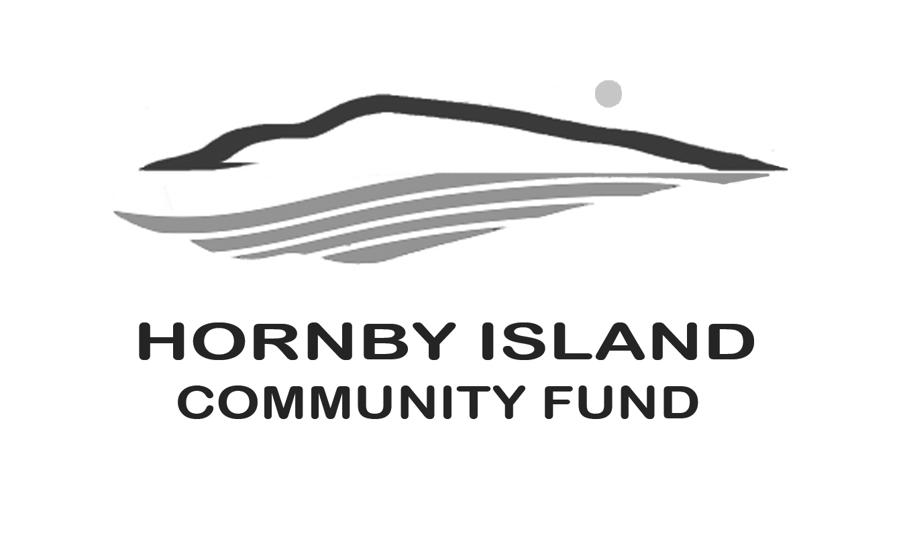
First Edition
November, 2020
Report from the Community Fund

Grant applications
The grant applications, for this year, are all in, and in progress of being evaluated, and categorized. This year, to recognize the devastation of the COVID-19 pandemic, our host organization, the Comox Valley Foundation, has added emergency funding for operations affected adversely. Three Hornby organizations have applied to be considered for some of that emergency money. According to the rules, one application/organization, this makes them ineligible to apply for the local funds

The regular annual Programs, Services or Projects applications come to the Hornby Fund Grant Evaluation Committee for adjudication. This year there are 5 registered charity applicants, with a total “ask” of $29,318. There is $12,066 available in the Hornby Island Community Fund to distribute this year.
In a normal year, the proceeds of the Book Sale are paid out, independently of the strict requirement for our local groups to have registered charitable status. (although registered charities are not excluded from receiving these funds). This year, without a Book Sale, this source of funding is not available for any of the Island groups. This leaves a big gap in the money available, and we thank those “Book Sale Volunteers” deeply for all they have contributed, over many years. (and look forward to it’s return in the future).

Be sure to watch next month’s First Edition for a list of the recipients, and identification of their funded projects.
A tip for access to grants in future years – get your organizational charity status, and watch for the grants’ opening, mid to late August, for one month.
If you have any questions regarding the application process, please contact the Comox Valley Foundation, be sure to specify HORNBY FUND, at 250-338-8444 or via email: office@cvcfoundation.org
Fewer faces
Volunteers on our Board also operate the community Party & Event Supplies Rentals, (view our website for a list of all the items & prices). This Island amenity has continued this year, with limited demand. Many thanks to Cal & Angie Read, Brenda Cha and Eva Wetzel, for their continuing commitment to this community service and for answering the call for service, despite the pandemic.

Online auction
Slow and sure would be the pace to describe our work on this year’s major fund-raising project, for the Fund, an online auction. The auction will be a collection of Collectibles, Artworks, Books, and Local Experiences. With a steady stream of donations to research, catalogue, photograph, store, and all, we are building an exciting inventory for the auction. Thank you to those who have come forward with their donations! More information on how the bidding, and viewing, will proceed will be announced soon.

Thinking of You
And hoping the many Friends of the Fund are happy and healthy during these unusual times. We have missed visiting with many of our key contributors this year, and look forward to seeing you all soon. Our sincere thanks to those that have reached, across the miles, and made a donation to the Fund in their effort to support their “heart home”.

Together we are making a difference in our community.
www.hornbycommunityfund.org

Submitted by: Community Fund Board: Anne Carney, Brenda Cha, Gary Duke, JoAnn Harrison, April Lewis, Angie Read, Karen Ross and Eva Wetzel

