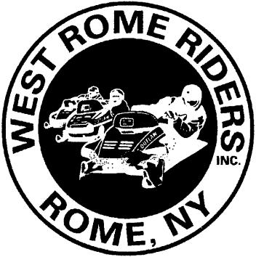
Membership Application www.westromeriders.com
West Rome Riders, Inc.
P.O. Box 962
Rome, NY 13442
*Please send check and fully completed form to address above *
Circle one: Renewal Address Change New Member

Please PRINT LEGIBLY (to ensure that info is able to be easily read at the DMV office)
* Please provide the following information exactly as it appears on your sled registration(s)* Member Name_____________________________________________Date:______________ NYSSA 6-digit I.D. # (if known)
E-mail address________________________________________(so your DMV Voucher, Club & NYSSA newsletters, & other private club communications can be e-mailed to you)
Street Address/P.O. Box________________________________________________________
City State Zip Code______________________ County
Phone #’s (____) (____) Spouse’s Name (or significant other’s) Children under 18 in household that intend to register a sled in their name
___________________________________________________________________________

☐ Check here if you are willing to help with trail work and/or other club functions

☐ Check here if you wish to receive occasional offers or promotions via U.S. Mail or email directly from NYSSA Sponsors and you are at least 18 years of age (default opt-out).

☐ Check here if you have already paid NYSSA dues this season to another club.
If yes, which Club (deduct $10.00 from your total due)
Yearly Club Membership Dues($40.00 Family or Individual):
$30.00 plus $10.00 NYSSA membership $ _40.00
+ NYSSA Trail Defender membership upgrade (additional $20.): + $
+ Donations for groomer fuel are accepted & appreciated: + $
TOTAL AMOUNT PAID to West Rome Riders $ _______

☐ Please check this box only if you wish to have 25 cents of your $10.00 NYSSA dues to go directly to the NYSSA
Snowmobile Political Action Committee (PAC). Please note, NYSSA dues remain $10.00.

*NOTE: WRR, Inc. reserves the right to refuse membership to anyone at the Board of Directors’ discretion and vote.

