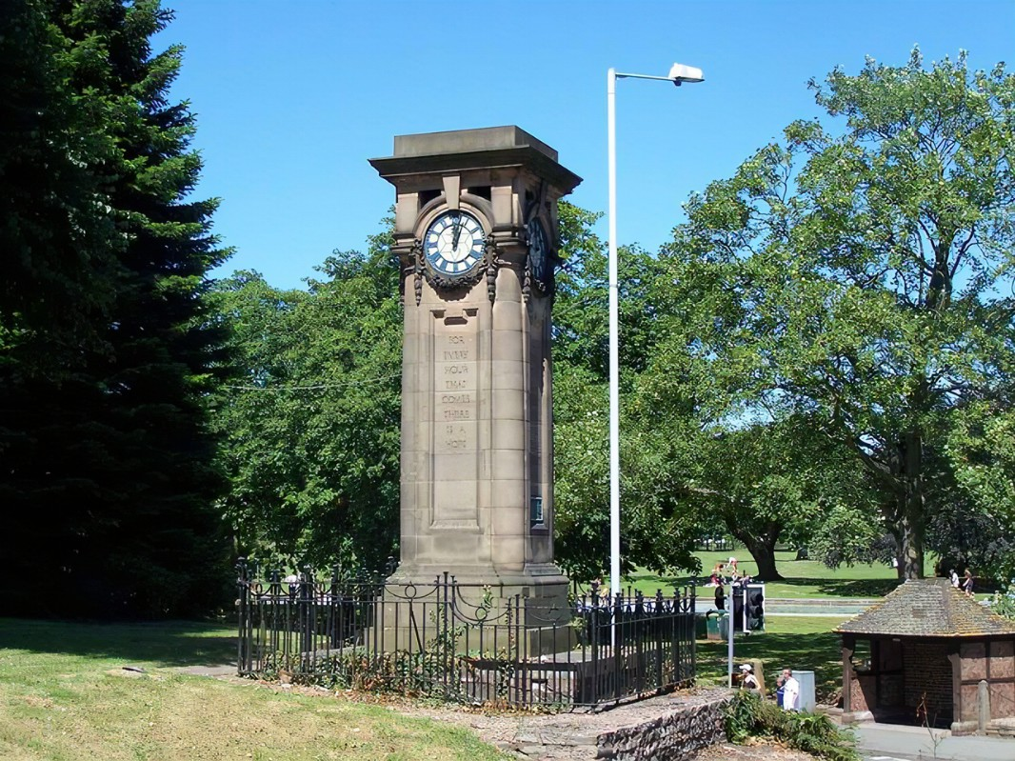
Tettenhall Community Forum
Case Study TNPLG-24-3

BROADBAND POLES COMPLAINT

Following a planning application by Openreach for the installation of a 9m wooden pole in Lower Green, Tettenhall Community Forum has issued an objection to the proposed telegraph pole on Lower Green. We have written to Openreach to insist on consultation with the Community Forum and Trust, under the Tettenhall Neighbourhood Plan policies.

This follows an article in The Times (16th March) which highlights the increasingly national opposition to the installation of obstructive telegraph poles that have been erected without appropriate consultation with the Local Communities.

There is a private members bill being proposed by Diana Johnson (Labour MP for Kingston), which was superseded by the letter sent by Julia Lopez, the current Minister for Data & Digital Infrastructure, warning broadband providers on this issue, Thursday 14th March.

Subject: Formal complaint by the Lower Green Resident’s Associations & the Tettenhall Community Forum against the proposed installation of a 9M wooden pole opposite 7 Lower Green

Following a planning application by Openreach for the installation of a 9m wooden pole in Lower Green, Tettenhall Community Forum has issued an objection to the proposed telegraph pole on Lower Green.

This complaint may be taken as a formal objection on behalf of the residents of Lower Green and Church Road and on behalf of Tettenhall District Neighbourhood Plan policies, as set by the Community Council (2014), referred to in this objection.

Attention is drawn to the following key points:

- Article 4 direction: Tettenhall Lower Green is covered by an existing Article 4 direction. It is a conservation area that includes a number of heritage assets (see below). We would like to confirm that you have submitted the relevant planning applications with the local council for the installation of this pole given the Article 4 direction.

- Tettenhall Neighbourhood Plan (TNP) 2014 – 2026: Under the approved TNP, the Mitre (TNP4(14)) is a protected heritage asset. The installation will materially impact the character and views of this asset alongside other listed properties (The Green House, The White House) on Lower Green. Under TNP12d setting and character must be preserved and important views must be protected. It should be noted that under the TNP 7 – all proposed developments should be consulted with the local community. We strongly refute that any consultation (aside from a lamppost posting) has been completed with the local residents and community, to whom Lower Green is an important asset.

- Telecommunications Developments: Under current permitted development legislation (2016), our understanding is that existing installations under permitted developments should be re-used before new installations. There is currently existing pole infrastructure in the footpath to the rear of residents on Lower Green that may be re-configured using existing rights.

- Wolverhampton County Council Digital Vision: We agree that Wolverhampton County Council has a clear digital vision. However, to date, all infrastructure providers have proceeded on either Church Road or Lower Green with trench and groundwork installations. We note that City Fibre has dug in infrastructure in the last 12 months in Church Road and Virgin Broadband has existing fibre infrastructure in the ducts in Lower Green. Both are in line with the heritage requirements of the Conservation Area and Article 4 direction. We suggest that BT Openreach review the existing groundwork infrastructure and ductwork and utilise what is currently available (see also 3 above).

- National opposition and the intervention of Julia Lopez: We note the article in The Times (16th March) which highlights the increasingly national opposition to the installation of obstructive telegraph poles that have been erected without appropriate consultation with the Local Communities. We draw your attention to the private members bill being proposed by Diana Johnson (Labour MP for Kingston), which was superseded last Thursday by the letter sent by Julia Lopez, the current Minister for Data & Digital Infrastructure, warning broadband providers on this issue, last Thursday. It is clearly not acceptable to simply erect poles without appropriate community consultation – particularly in what is a Conservation Area. We strongly object to this proposal.

In summary, we believe that the proposed pole should not be installed. Lower Green is an important green space for the local community and a Conservation Area. Existing infrastructure and ductwork should be utilised in line with other digital infrastructure providers. The local Resident’s Associations have not been consulted and strongly object to this proposal.

We suggest that you formally consult with the Tettenhall District Community Trust going forwards. Under the requirements of Tettenhall Neighbourhood Plan (2014-2026), policy TNP7 requires full and meaningful consultation, under the Gunning Principles, before planning application and we welcome the opportunity as a recognised body to be working with digital infrastructure providers to ensure that local communities in the Tettenhall wards are appropriately consulted going forwards.

Signed for on behalf of the Residents Associations & Tettenhall Community Forum

