**MINUTES OF THE TETTENHALL COMMUNITY FORUM**

**Spotted Cow Function Room, The Royal Oak, Tettenhall Wood at 6.30 pm**

**25th July 2024**

|  |  |  |
| --- | --- | --- |
| **APOLOGIES**  There were apologies from Sally Garner (SG) and Sally Hathaway and there were 12 local residents in attendance. | | |
| **STEERING GROUP UPDATE**  Neal Kelshaw (NK) reported that the application to the Council for registration was largely complete and would be submitted in the next 2 – 3 weeks. All properties in the 2 wards of Tettenhall district had now received the flyers which were delivered over a period of 6 weeks as a result of which there were now 44 new Trust members.  SG and Jonathan Crofts have confirmed that at least one of them is now available to attend Steering Group meetings following completion of election activity.  **ROCK JUNCTION**  There has still been no response from WCC regarding our petition recommending improvements to the Rock Junction and rejecting the Council’s original proposal.  It was recorded by Malcolm Rudge (MR) that tree foliage was now covering some of the traffic lights at the junction increasing the danger. NK informed the meeting that Nick Berriman and Steve Robinson had accepted an action to create a document which would allow us to consult with residents on particular issues to be discussed at a meeting with the Police and Crime Commissioner or their representatives. This should include speeding (eg Henwood Road and Stockwell End), traffic light violations and all matters of concern to residents.  **TREES**  Robin Hacking (RH) had not yet been able to agree a date for Paul Wilson (PW) to attend the Forum for a further discussion on trees. | | |
| **AETHELFLEAD STEERING GROUP**  Becky Cresswell (BC) is producing an outline plan for development of this arts project. Her plan will be presented at the meeting on 23rd August at the Parish Rooms, Tettenhall.  Actions prior to this meeting include, where possible, producing posters to encourage widespread attendance. After this meeting it was agreed at the following Steering Group meeting that RH and NK will seek a meeting with Catherine Perry of WCC who may be available to help with funding. Also SG agreed to contact Councillor Bateman to discuss possible ways of collaborating across the wards. | | |
| **PLANNING**  Three important items have come to the fore since the previous meeting - Proposed Codsall Road 5G mast, redevelopment at the former Chris Jewkes Fitness Centre on Danescourt Road and a pre planning application by Wolverhampton Cricket Club for a Masonic Lodge building as part of the Cricket Club.  FITNESS CENTRE  Residents are encouraged to examine this planning application in detail which at first appearance does not seem to inculde any items of concern. It was noted that pitches would be floodlit and some development to the existing buildings and boundaries with additional car parking. There was general support for appropriate facilities such as these to provide leisure and sporting activities.  MASONIC LODGE  It had recently become common knowledge following information to Cricket Club members that a pre planning application had been made by the Cricket Club concerning the provision of Masonic Lodge facilities on their site.  Since pre planning applications are confidential to the Applicant the Planning Department has been unwilling to provide any further details.  Discussion took place around the feasibility and appropriateness of this development with some concerns being expressed – increase in traffic volumes was a particular concern. It was also discussed whether the original gifting of the land by Mrs Swindley and the covenants it contained about the usage would allow for this development.  This item will be kept under consideration for when any further details become available.  CODSALL ROAD 5G MAST  Discussion on this contentious item took up a considerable proportion of the meeting. It was noted that the planning application had been rejected on more than one occasion by WCC and that a substantial number of objections had already been documented and raised by residents and council officers. Notwithstanding this the proposal has now been sent for Appeal to the Secretary of State in Bristol without any modificaitons which might have addressed the objecitons raised. A meeting at South Staffs Golf Club had been attended by a number of club members and Tettenhall residents to raise their concerns and a presentation was given identifying some of the issues associated with such a development so close to property. The attendees at the Forum were unanimous in their condemnation of this Appeal and the possibility of a leaflet drop along the Tyninghame Avenue, Knights Avenue, Lothians Road and Codsall Road, being the streets most significantly affected, was discussed in order to encourage as many specific objections being recorded with the Secretary of State as possible. Volunteers came forward for the delivery of these leaflets and Liz Hacking (LH) and RH agreed to produce the leaflets and deliver them to the volunteers. A copy of the leaflet is attached to these minutes.  Post meeting all these leaflets were produced and delivered. Additionally NK produced a formal objection on behalf of the Steering Group and Trust and RH submitted a formal objection on behalf of Tettenhall Community Forum. It is hoped that many other residents added their objections.  **CONTACT WITH MP**  Contact with our local MP is still outstanding. RH has agreed to contact them with a view to introducing the work being done on behalf of residents in Tettenhall via the Trust and Tettenhall Community Forum.  There being no other business the meeting closed at 8.20 pm.  **NOTE** – Rather than identify a formal agenda for the next meeting (see below) it is proposed to conduct a review of all matters outstanding and arising from previous meetings:- | | |
| Rock Junction  Registration of TDCT  Trees | Local MP  Contact with Councillor Bateman  Agenda for Police Commissioner | Aethelflead Project  Planning, Masonic Lodge  Planning, 5G mast |

**Next meeting 8th August 2024 at the Parish Rooms,Tettenhall at 6.30**



**TETTENHALL COMMUNITY FORUM**

With regard to the intention of Cornerstone to install a 20.6m high 5G telecommunications tower in a corner of South Staffordshire Golf Club adjacent to Codsall Road, Wolverhampton City Council has written to some residents local to the site as follows; “*I write to advise you that Cornerstone has submitted an appeal to the Secretary of State against the decision of the Council to refuse planning permission for* ***proposed 5G telecommunications equipment installation, comprising of a 20.6m high monopole mast with 12 antennas and 4 dishes together with 4 ground based cabinets, 1m cabinet and ancillary development thereto, including a 1.8m high closeboard fence compound at South Staffordshire Golf Club, Danescourt Road, Wolverhampton.***”

Tettenhall Community Forum (TCF) is providing this information to you in case you have not received it. The Forum, which has consultation rights on planning issues in the Tettenhall district, agrees with the Council’s decision to refuse planning permission and offers you the opportunity to add your objections by writing to the Planning Inspectorate at Temple Quay House, 2 The Square, Bristol BS1 6PN or to make any objections online at <https://acp.planninginspectorate.gov.uk/> . Your objection should be received before 6th August 2024 and quote reference **APP/D4635/W/24/3344491**.

Please note this installation has already been rejected by WCC three times and could easily be sited in a more appropriate location. Were it to be erected it would dominate and visually overwhelm the entire locality, many parts of which are in Conservation Areas.

**DON’T MISS YOUR LAST CHANCE TO OBJECT TO THIS APPEAL**

**tdct.org.uk**

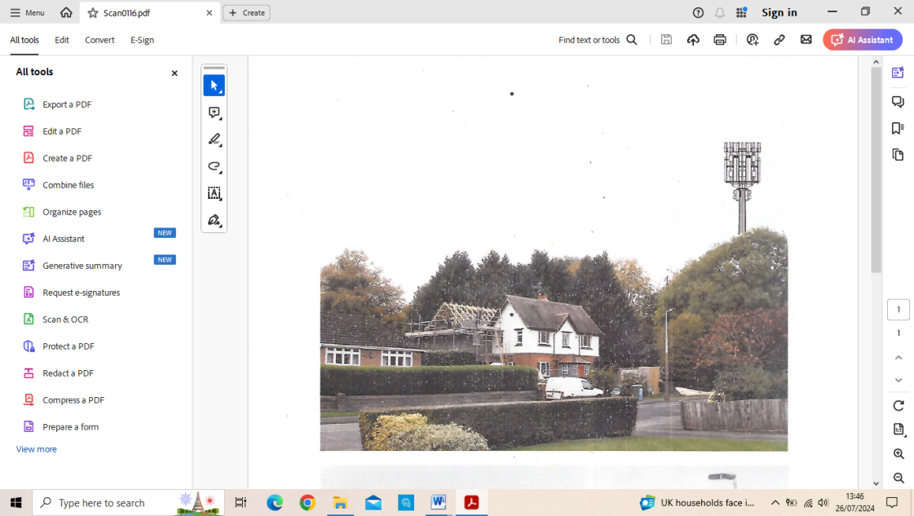

DON’T DELAY - OBJECT TODAY

OR THIS POLE IS COMING YOUR WAY!

