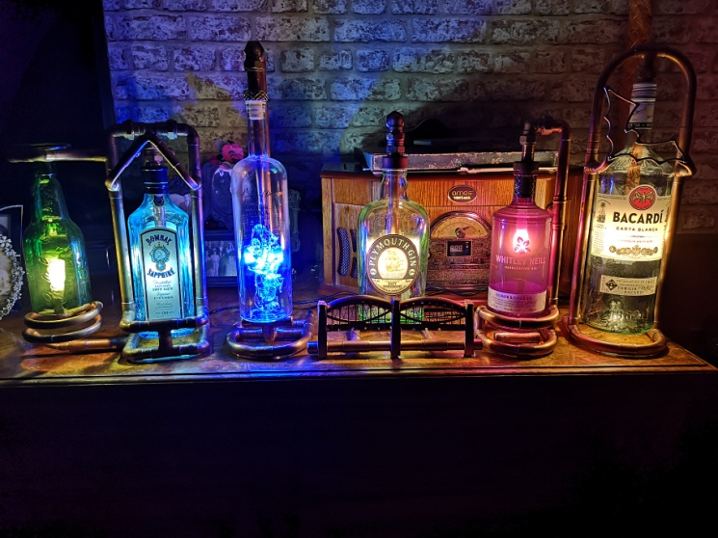

**Lighten Your Spirits**

These Lamps are a Low voltage (12 volt) type and should only be connected to an electrical socket using the 12 volt power supply that was supplied with the lamp (*or a similar 12volt equivalent*). **Do not under any circumstances connect this direct to a 230 volt supply, or use them with a standard 230 volt plug.**

**Lamp Bulb replacement**

To replace the bulb in your bottle Lamp, please make sure your lamp is unplugged from the electrical supply, and carefully follow the instructions below.

1. Slightly loosen the top nut on the joint attached to the bottle, where it joins the copper pipe (see *image 1*). This may require a spanner of large pliers, as this joint would have been tightened up to avoid movement when posted. After this hand tighten will suffice.

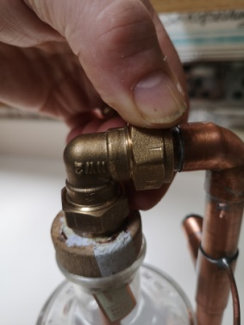

(*Image 1*)

1. Once nut in step one has been loosened so bottle can swivel. Swivel the bottle either backwards or sideways so it is clear of the surrounding pipe work (see *image 2*). The direction to swivel the bottle will depend on the pipe work design of your particular lamp.

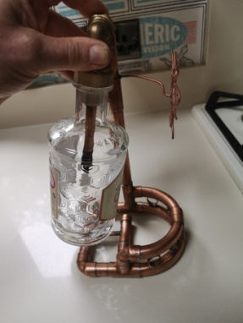

(*Image 2*)

1. Depending on your particular Bottle type Gently twist and slide the bottle off its cork, or rotate it to unscrew from its screw top (see image 3), and remove to expose bulb.

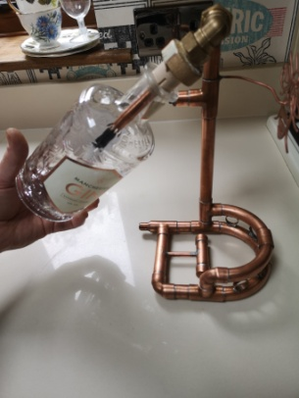

(*Image 3*)

1. Once bottle has been removed gently pull bulb to remove it. (see *Image 4*)

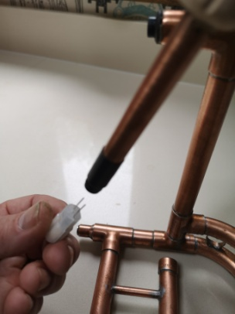

(*Image 4*)

Bulb type for replacement is a 12 volt G4 LED 1.5 watt to 2 watt maximum, install new bulb by lining up the 2 pins on the bulb with the 2 holes in the bulb holder, and gently push it in.

1. Once the new bulb in place, simply reverse steps 1 to 3 above to reassemble your lamp.