













1
WARRIOR ANGEL RIDERS NEWSLETTER

Contents:
- Words From The Board
- Who we are
- Featured Member of the Month
- New Member’s of W.A.R.
- Upcoming Events
- Last Months Rides/Events
- Safety Tips with Shawna
- Motorcycle Humor
- W.A.R. Contact Info


Words from the Board 2
Happy 2021 New Year!!!

Are you excited to say goodbye to 2020 and welcome 2021?!? Please, take a moment, say a prayer, and give
thanks for the blessings we had as we pass into the new year. Raise your helmet and give a loud shout…2020 is done, now on to 2021!!! I am not one to dwell in the past. I look forward to what today brings, hoping for tomorrow, and dreaming into the future. I’m sure you made a New Year’s Resolution sometime within your
lifetime, even maybe this New Year! Did you know the tradition of making New Year’s resolutions began during the reign of Caesar? At the time, New Year’s resolutions were of a moral nature, such as being kind to others.
Another fun fact, research shows that as many as 50 percent of adults in the United States make New Year’s
resolutions, but fewer than 10 percent actually keep them for more than a few months. Let’s be part of the 10% statistic! Sisters of Warrior Angel Riders, let’s make our first resolution this year, 2021, at our upcoming 1st 2021 Meet and Greet, Sunday, January 10th. Together, we will decide upon our resolution and hopefully at the end of the year congratulate ourselves for accomplishing our goal. Here is a recap of our accomplishments for 2020.
Without you, Warrior Angel Riders would not be on the map. COVID-19 caused us to cancel/postpone several events, but we will plan on them for this year!

Business Side:
- Logo trademarked
- Business License issued with State of Washington
- Established Employee Identification Number (EIN)
- Created By-Laws
- Appointed Board Members
- Established 501 C.3 with IRS

continued...Words from the Board 3
Rides/Events:
  - 1st Annual Spring/Summer Challenge Ride – Nusual to Pekuliar
  - 1st Annual Meet at the Beach Weekend Getaway
  - 1st Annual Bikes, Babes & BBQ Summer Bash
  - Crater Lake Coed Weekend Getaway Ride
  - 3rd W.A.R. Anniversary Ride
  - Wild Horse Coed Weekend Getaway Ride
  - Forks Coed Weekend Getaway Ride
  - 1st Annual Spring/Summer Luncheon
  - Trunk or Treat, 2nd year supporting
  - W.A.R. on the Range (Foxes and Firearms)

Ladies, 2020 may have taken some wind out of our plans but 2021 looks promising!

Remember that SOMETIMES not getting what you want is a wonderful stroke of luck. ~ Dalai Lama XIV

Be Safe, Ride Free Lilyann “Pixel”, Director Warrior Angel Riders


4

Who we are:
Warrior – is a woman whose strength has endured. Several of our gals are breast cancer survivors. Sadly, a few had to lay to rest their child, a spouse or a loved one. Something no one should ever have to experience alone. As women, we ALL fight our battles, support each other, struggle to survive and find the courage to live.
Angel – is a woman who looks after family, friends, co-workers, strangers. She is a loving and caring person who will make your day brighter just being there. She shows compassion; protecting and guiding, who is selfless.
Riders – as women riders, there is nothing more empowering than climbing onto your own bike and taking to the open road.

OUR COLOR CHOICE TO REPRESENT US: Purple and White.

Purple is associated with royalty. It symbolizes power, nobility, luxury, and ambition. It conveys wealth and extravagance. Purple is associated with wisdom, dignity, independence, creativity, mystery, and magic.

White, an inherently positive color, is associated with purity, virginity, innocence, light, goodness, safety, brilliance, illumination, understanding, cleanliness, faith, beginnings, sterility, spirituality, possibility, humility, sincerity, protection, softness, and perfection.

We believe in pursuing to be the BEST as women, through every aspect of life.

*Beauty* *Empowerment* *Strength* *Trust*

Who we are cont.


WAR is a group of dedicated and talented women who love to get together, have fun, and ride. We are a very diverse group of women coming from different backgrounds who pull together to make our events successful and fun. This is where lasting friendships and memories are made.

If you have any questions about Ladies of W.A.R. or want to know when we have our meetings and events, please feel free to call Lilyann @253-325-2405 or email at warriorangelriders@gmail.com.

History
In 2017, we were on a group ride with some experienced riders; the ride started at a respectful pace until we hit the backroads. The guys love the twisty roads and took off!

Understandably. And yes, there are gals who enjoy the spirited ride too. However, several gals were not at the same riding level and felt uncomfortable being pushed to ride faster than their guardian angel can fly.

Later several of us ladies got together for lunch, talked about the ride and asked ourselves, “what can we do to make sure we are riding within our
group’s level, leaving no rider
behind”. We discussed offering to be a mentor, helping to develop our riding skills, offering tips from our own riding experiences.

“Warrior Angel Riders (W.A.R.)” was
born!


W.A.R. Meetings
5

Meetings held monthly.
Socialization @ Elmer’s in Tacoma begins at 6:30 p.m. followed by the meeting at 7:00 p.m. You can simply attend the meeting or choose to eat and enjoy a beverage. The members of WAR run their own meetings and sponsor activities that ladies can participate in.

W.A.R. Upcoming Meeting Schedule

Feb. 7: 7pm via Zoom
March TBD April TBD



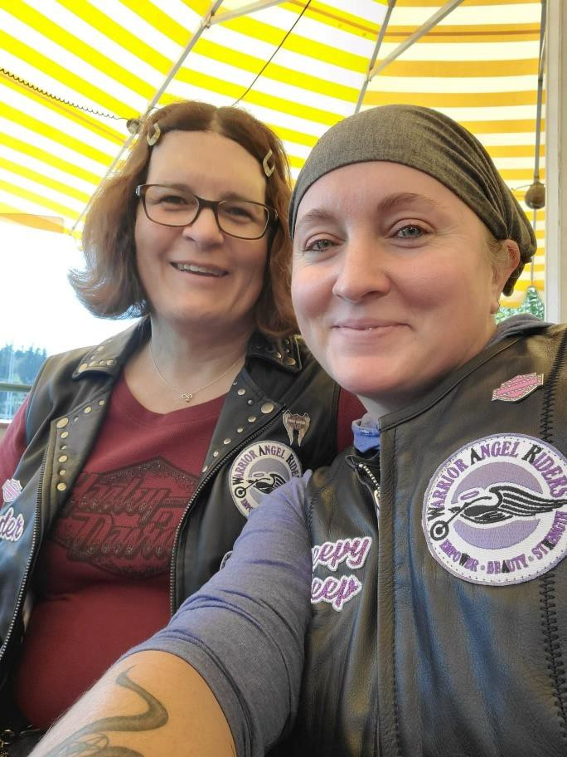

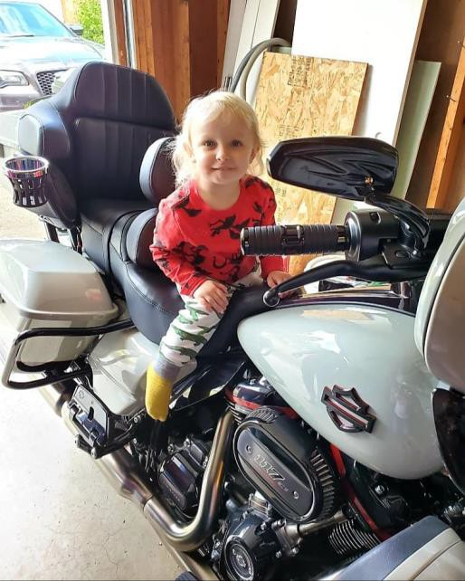
6
Sandy “Creepy Sheep” Purtlebaugh

I'm a full-time mom, and I love going on motorcycle adventures on the back of my love Shawna Chisholm aka Thunder's Harley. I took my first ride on the back of Thunder's Harley at age 41, and she took my motorcycle 🏍 virginity. Some day I would love to learn how to ride one of my own!!

Featured Rider


7

Upcoming Events:

- 1/16/2021 – 8AM-12PM – W.A.R. on the Range with Foxes and Firearms @ Marksman Gun Range
- 2/28/2021 – 1PM-3PM – Postponed..Calimoto & Cardo Class made simple @ Lilyann’s
- 11/5-11/7/2021 – 5PM Fri – 2nd Annual Meet at the Beach @ Pacific Beach/Ocean Shores
- 3-20/2021-9/22/2021 – 2nd Annual N’usual to
Pekuliar Ride
- 5/1/2021 – 9AM International Female Ride Day
- 6/21/2021 – National Ride to Work Day
- 7/4/2021 – 4th of July Parade @ Steilacoom, WA
- 7/8/2021-7/11/2021 – Hell’s Canyon Ride – Baker
City, OR
ATTENTION: Due to
COVID-19 virus situation please check that any event you plan to attend is still occurring. Thank you.
- 7/15/2021 – Pendleton Bike Rally @ Pendleton, OR
- 7/23/2021 – 4PM – HOG Wild Bike Rally @ Ocean Shores, WA
- 8/7/2021 – 9AM – W.A.R. Anniversary Ride
- 9/26/2021 – 9AM – 43rd Annual Oyster Run @ Anacortes, WA



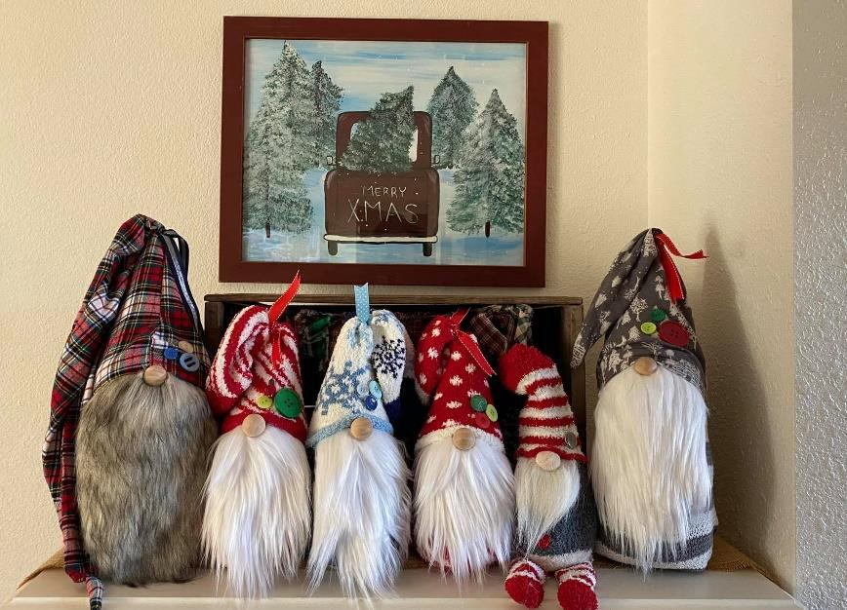
Comings and Goings for 2019 8

L
i l y s 2
0
2
0

Susan Fenwick
Tracy’s Gnomes
More comings and goings! 9

Jessie’s new home!

Stacy’s Diploma


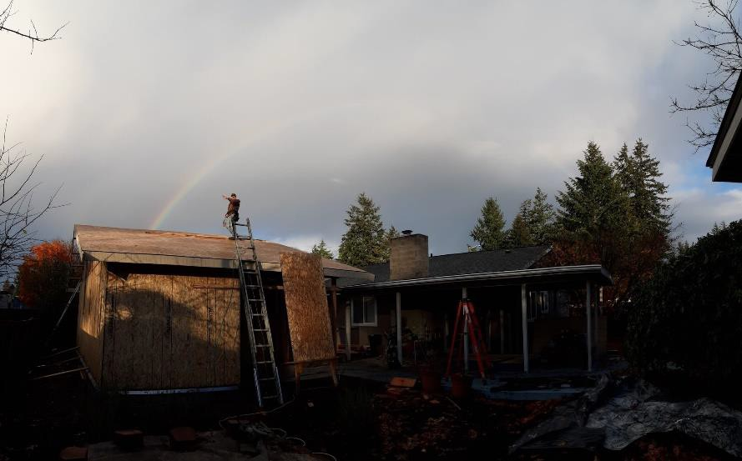
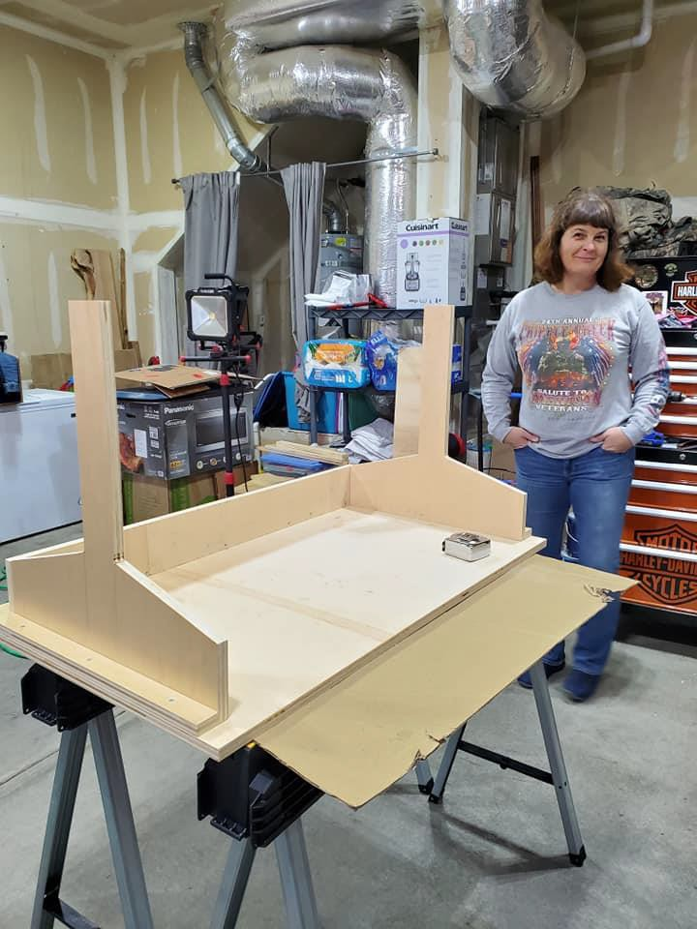
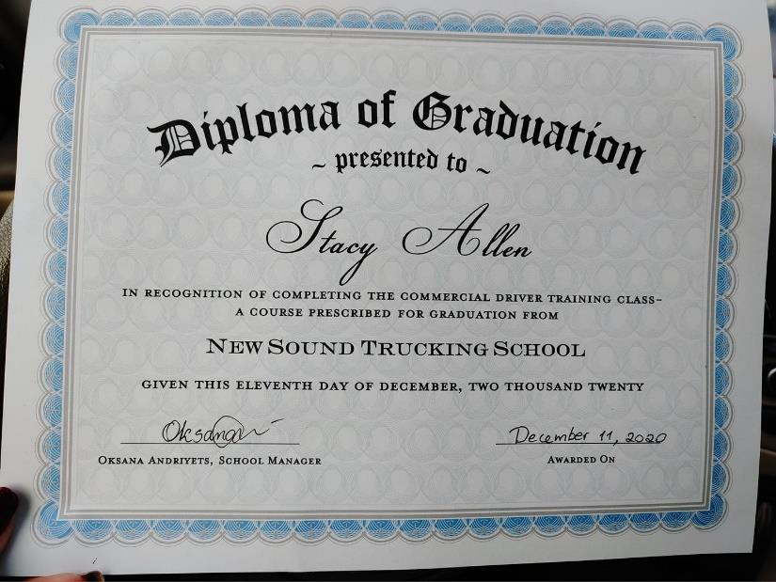
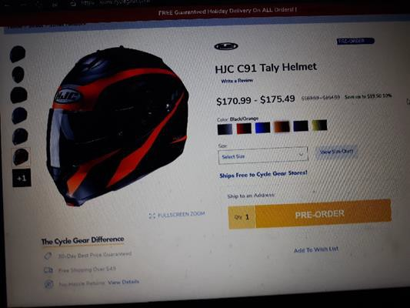
Cammie’s new helmet!
Shawna’s Project


Riding Tips from Shawna 9

Ten Steps to Winterize your Motorcycle
by BikeBandit | May 4, 2018 | Buyer’s Guide | 0 comments

If your idea of motorcycle storage in the winter is just throwing a cover over your bike, you may be in for some nasty surprises come spring-time. The last thing you want to find out when riding season starts is that your bike won’t, so use these tips to make sure your bike is as ready as you are when it’s time to ride! We may not want to admit it, but winter is just around the corner. And as the air cools off and the snow starts falling, most of us begrudgingly store our bikes and impatiently wait for spring to ride again. But storing your bike in the winter isn’t as simple and just throwing a cover over it and hopping in the car. In order to keep your motorcycle in top running condition, there is some work that needs to be done before storing it for several months (talk about adding insult to the injury of not being able to ride!)

However, if you properly get your bike ready for winter storage, it’ll make getting it running again when the riding season begins a whole lot easier, and prevent any unwanted surprises such as dead batteries, corrosion, and rust spots (or worse.)
Depending on what kind of motorcycle you ride there may be different things that will need to be addressed, but there is some general wisdom on how to get it ready to be stored for the winter. Your main enemy during winter storage is damage from moisture, so most of our winterizing efforts will be aimed at keeping that away from your bike. In addition, well give some love to your fuel system, battery, tires, and all your moving parts as well.
With just a little prep work using these ten simple steps, you’ll save yourself a lot of time and hassle come
spring time, and your bike will be ready to hit the road as soon as you are!
10
Riding Tips from Shawna – Cont’d.
Ten Simple Steps to Winterize Your Motorcycle

- Surface Prep
Washing your bike when nobody will see it for a few months anyway can be a drag, but giving your bike a thorough cleaning before storage is important; letting bug guts or water spots sit on your paint can corrode the finish permanently. Wash your bike and dry it completely to get all the moisture off the surfaces (an electric leaf blower is a great way to get all the nooks and crannies really dry.) Add a coat of wax, which will act as a barrier against moisture and rust. Finally, spray exposed metal surface with WD-40 to displace all moisture (fun fact: the WD in “WD-40” stands for water displacement) and to give them a protective coating against corrosion.

- Change Oil and Filter
Change your oil and filter. It’s better for your lubrication system to have fresh oil sitting in it for several months than to have used, broken down oil in it, not to mention the last thing you’ll want to do when riding season begins is change the oil before you can go ride. Using a winter weight oil like 5W30 can help it start up easier come spring time as well. If you’re going to be storing your bike for a long time (4-6 months or more) you will want to protect your
engine’s internals against moisture by coating them lightly with oil. You may not be able to see it with your naked eye, but the cold winter air is perfect for moisture to gather in your engine and cause rust to form on your pistons and cylinder walls. In order to do this, remove the spark plugs and put a little squirt (about a tablespoon) of engine oil into the holes, then turn your engine over a few times to coat the cylinder walls by spinning the rear wheel with the bike in gear. Once everything is coated, replace the spark plugs.

- Lube Moving Parts
Keeping moving parts lubed during the winter will help keep moisture from building up on them and causing any rusting or binding. Any part of your motorcycle that needs to be lubed at any point should be lubed again before storage. Some parts to check are: chain drive, cables, controls, fork surfaces, and any other pivot points.
11
Riding Tips from Shawna – Cont’d.

- Prep Fuel System
Gas tanks have a tendency to rust when not in use, and untreated pump gas breaks down and becomes gummy over time. To
prevent rusting and make sure your fuel is ready to run after a few months in storage, you’ll want to fill your tank completely with fuel treated with a product like Sta-Bil Fuel Stabilizer. On your last ride of the season, stop in at the gas station nearest to where you will be storing your bike and add the proper amount of fuel stabilizer, then top off the tank. A full tank will keep moisture from building up on the tank walls and adding the stabilizer before the short ride home will help mix the gas and stabilizer together and run it through your fuel system before storage.

Note: Another method that some advocate is to drain the tank and fuel system completely. This is more troublesome to do and requires that you treat the inside of the tank with fogging oil to prevent rusting. This method may be preferred for very long-term storage (6 months or more), but for winter storage, a full tank of treated fuel is easier and completely safe to do for both carbureted and fuel-injected bikes.

- Safeguard Battery
Batteries have a tendency to self-discharge when sitting over time, especially when they remain hooked up to the bike. The easiest way to combat this is to hook up a battery tender like the Battery Tender Super Smart Junior which uses smart technology to monitor the charge and keep the battery topped off without overcharging. Normally you should pull the battery from the bike for storage, but with a smart tender you can also connect the tender with the battery left in the bike. Before doing this, make sure the electrodes are clean and corrosion free; if necessary, clean them off and give them a light coating of grease.

- Protect Tires
If your tires are left to sit in the same position all winter long, they could develop flat spots. Keeping the tires off of the ground will prevent this, so if you have Motorcycle Stands, put the bike up on them for storage. If you don’t have stands, try to get at least the rear tire off the ground, or you can rotate your tires by rolling your motorcycle slightly every few weeks. If you need to leave your tires down on concrete, put a piece of carpet or plywood under them to keep any moisture from seeping into them.
12
Riding Tips from Shawna – Cont’d.

- Check Coolant/Anti-freeze
If you’ll be storing your bike somewhere that gets below freezing, make sure you have adequate levels of anti-freeze in your coolant system. This is very important; if you run straight water in your coolant system and it freezes, you could come back to a cracked head in the spring!

- Plug Out Pests
Mice and other rodents are notorious for hiding from the cold inside exhaust pipes and making homes out of air filters. If order to avoid any furry surprises when it’s time to ride again, plug up your pipes with an exhaust plug like the BikeMaster Rubber Muffler Plug. You can also simply stuff your air intake and the ends of your exhaust with some plastic bags – but do use bright colored bags or tie something to them so you don’t forget take them out when you fire up the bike!

- Keep it Covered
With your motorcycle fully prepped for winter, invest in a proper motorcycle cover. A quality motorcycle cover will not only keep dust off the bike but will keep the moisture out, so it doesn’t get trapped underneath it and create corrosion or rust. If you’re storing it outside, be sure to get a cover with tie downs to prevent it from blowing loose in wind. If you’re storing it inside, you’re in much better shape, but you should still use a cover to prevent dust from building up on it.

- Theft Protection
If you’re storing your bike outside, bear in mind that being parked unattended for months at a time makes it an easy target for theft. In addition to protecting your bike from weather, using a cover will conceal it from view, and securing it with a heavy lock and chain can give you some peace of mind. If youll be storing your bike anywhere it can be accessed by others, read our guide on How To Keep Your Motorcycle From Getting Stolen, and consider investing in some security measures.

With your bike fully prepared for a few months of hibernation, you’ll find that the winter is the perfect time to get done any
maintenance or upgrade projects that you’ve had on your mind. BikeBandit.com sells all kinds of upgrades that will make you feel like you’re hopping on a whole new motorcycle come springtime. You may not be able to ride in the snow, but nothing is stopping you from getting your hands a little greasy and actually starting one of those projects that you’ve been thinking about all season!




- Director - Lilyann “Pixel” Lear
warriorangelriders@gmail.com
- Assistant Director - Charlie “Angel” Houmes charlie.houmes@gmail.com
- Assistant Director - Gloria “Fireball” Padgett
organizer.gloria.war@gmail.com
- Treasurer – Sandy “Badass” Knab
slemerson35@comcast.net
- Secretary – Geneva “Blink” Laing
ramjet31@yahoo.com
- Head Road Captain - Tracy “Switchback” Cutler
roadcaptain.tracy.war@gmail.com
- Memberships - Michèle “Stitch” Courvoisier
membership.michele.war@gmail.com
- Ambassador – Hollie “Thumper” Imburgia hollieimb30@yahoo.com
- Editor - Cammie “Boots” Wood
editor.cammie.war@gmail.com
- Safety Officer - Shawna “Thunder” Chisholm
safetyofficer.Shawna.war@gmail.com
- Road Captain JessieLynn “Pipes” Sturizone msjessielynnesturzione@gmail.com
W.A.R. Contacts 13

