











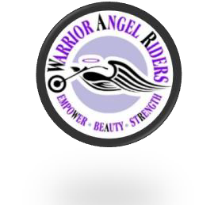


1
WARRIOR ANGEL RIDERS NEWSLETTER

Contents:

- Words From The Board
- Who we are
- Wing Sisters Mentor Program
- Featured Rider of the Month
- Upcoming Events
- NEW Members
- Wrench it up W/Jessie Lynne
- W.A.R. Contact Info



Words from the Board
June, I believe, is the most celebrated month for graduations, summer weddings (June 2
brides), Solstice and let us not forget “Father’s Day”, but also should be safety and wellness. June brings the warmth of that yellow ball in the sky, called “sunshine”!
We hosted a Motorcycle First Responder Awareness class in May. If you missed this class, we are planning to host it again next year in Spring. This class made me realize I can do something, even without medical training, and my actions could make a difference. Several pointers to keep in mind is stay CALM. I know easier said than done, but it will make all the difference for our brother or sister. S/he is relying on us to keep them safe and WARM. Regardless the temperature 60 degrees or 114 degrees, keep him/her warm with a blanket.
Another point, recognize when you need a break and take it! You have heard the “Smell the
Barn” effect. It means, to experience heightened anticipation or to act with renewed speed or energy as one approach a destination, goal, or other desired outcome, like a livestock animal at day's end returning to its barn. Regardless, do not place yourself in a position to challenge your senses. We have so many fun rides and events planned for the summer. Be sure to follow us on Facebook, MeetUp, and our WebSite.
Family is not always connected by blood...it's bonded with leather, lace and chrome rivets.

Lilyann “Pixel” Lear
Director
Warrior Angel Riders


3

Who we are:
Warrior – is a woman whose strength has endured. Several of our gals are breast cancer survivors. Sadly, a few had to lay to rest their child, a spouse or a loved one. Something no one should ever have to experience alone. As women, we ALL fight our battles, support each other, struggle to survive and find the courage to live.
Angel – is a woman who looks after family, friends, co-workers, strangers. She is a loving and caring person who will make your day brighter just being there. She shows compassion; protecting and guiding, who is selfless.
Riders – as women riders, there is nothing more empowering than climbing onto your own bike and taking to the open road.

OUR COLOR CHOICE TO REPRESENT US: Purple and White.

Purple is associated with royalty. It symbolizes power, nobility, luxury, and ambition. It conveys wealth and extravagance. Purple is associated with wisdom, dignity, independence, creativity, mystery, and magic.

White, an inherently positive color, is associated with purity, virginity, innocence, light, goodness, safety, brilliance, illumination, understanding, cleanliness, faith, beginnings, sterility, spirituality, possibility, humility, sincerity, protection, softness, and perfection.

We believe in pursuing to be the BEST as women, through every aspect of life.

*Beauty* *Empowerment* *Strength* *Trust*

Who we are cont.
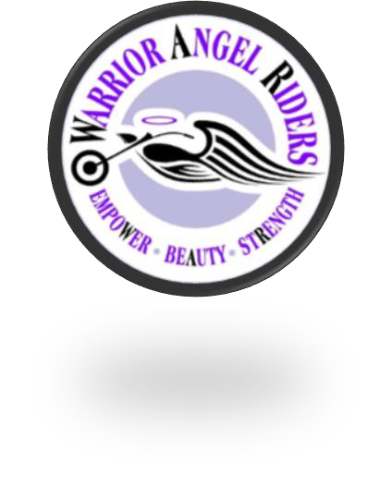

WAR is a group of dedicated and talented women who love to get together, have fun, and ride. We are a very diverse group of women coming from different backgrounds who pull together to make our events successful and fun. This is where lasting friendships and memories are made.

If you have any questions about Ladies of W.A.R. or want to know when we have our meetings and events, please feel free to call Lilyann @253-325-2405 or email at warriorangelriders@gmail.com.

History
In 2017, we were on a group ride with some experienced riders; the ride started at a respectful pace until we hit the backroads. The guys love the twisty roads and took off!

Understandably. And yes, there are gals who enjoy the spirited ride too. However, several gals were not at the same riding level and felt uncomfortable being pushed to ride faster than their guardian angel can fly.

Later several of us ladies got together for lunch, talked about the ride and asked ourselves, “what can we do to make sure we are riding within our
group’s level, leaving no rider
behind”. We discussed offering to be a mentor, helping to develop our riding skills, offering tips from our own riding experiences.

“Warrior Angel Riders (W.A.R.)” was
born!


W.A.R. Meetings
4

Meetings held monthly.
Socialization @ Elmer’s in Tacoma begins at 6:30 p.m. followed by the meeting at 7:00 p.m. You can simply attend the meeting or choose to eat and enjoy a beverage. The members of WAR run their own meetings and sponsor activities that ladies can participate in.

W.A.R. Upcoming Meeting Schedule

July 6, 2021

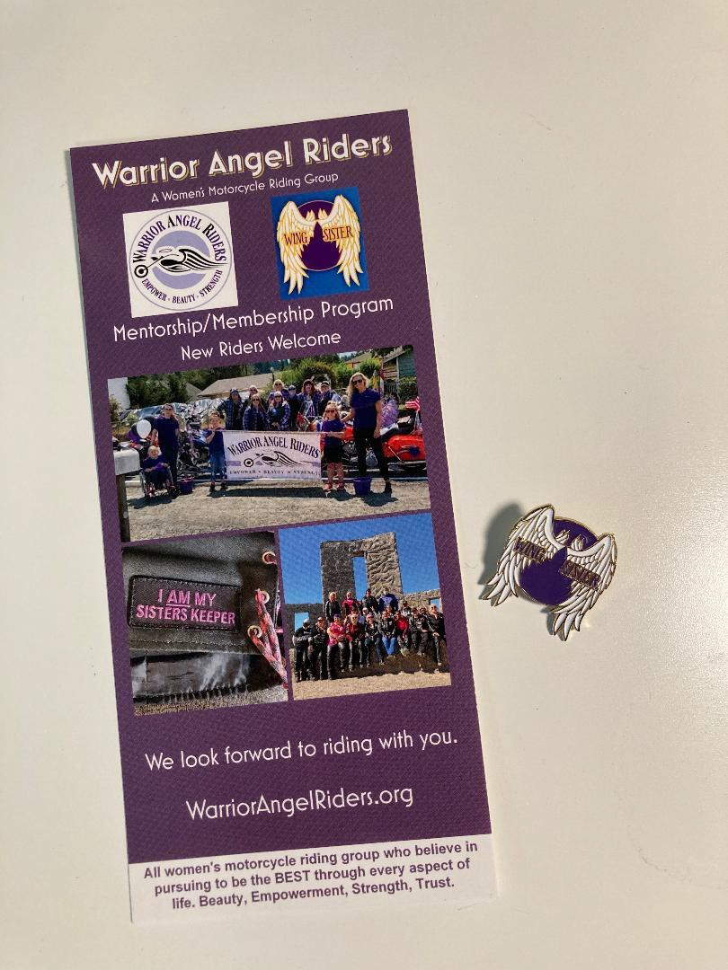
Wing Sister Mentorship Program 5
We are excited to announce our Mentorship Program known as
'Wing Sisters'.
Goal: The Wing Sister Program will serve as an opportunity for new riders to overcome barriers by building camaraderie with fellow motorcyclists in W.A.R. and pair riders together to foster safe motorcycle riding practices. We want to show new riders how fun riding can be and how to feel safe on the road; we will not be teaching ladies how to ride.
At this time, we have 9 amazing Wing Sisters ready to Mentor new riders; they will share their love of riding and adventure, as well as being a cheerleader, consultant, and counselor for new riders beginning their journey. We have begun outreach to local motorcycle shops, Motorcycle Safety Classes, and other locations to reach new riders. We have a few brochure displays in key locations to reach potential new lady riders. If you would like a brochure rack for a location you feel has good visibility to new riders let us know. We have extra brochures if you need a few.
Stop by Eagle Leather and take what you need; they are located on the counter by the backdoor. We will be refilling the brochure rack regularly.
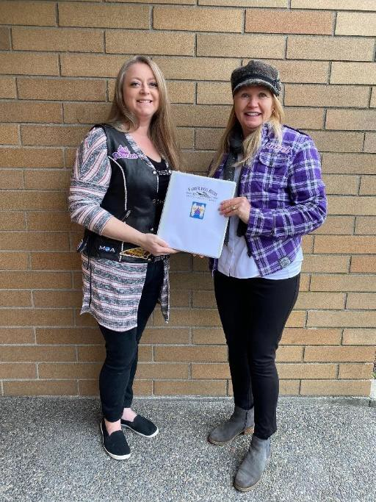
Wing Sisters mentorship program – pt. 2 6

What will a Mentor do for a new rider?
Call to check riding progress
Advice on safety gear
Go on rides with a mentee – escorting them home if needed Counsel to seek additional Safety Training
Bike purchase conferring
Encourage attendance at the W.A.R. monthly general membership meetings & social events
We could use your help; while we feel we have enough ladies volunteering to be Wing Sisters we would like to identify new riders - Mentees - who would like to join Warrior Angel Riders and take part in having a Big Sister to call on for their beginning riding experience. If you know of a new rider please let us know. We will be pairing them up with geographic location so their 'Wing Sister' will live in their general area.
NOW the most exciting part of this program: Elaine 'Earhart' Weaver has agreed to be the facilitator. We are thrilled she has agreed to run this program and we welcome her to the Leadership Team. Elaine can be reached at mentor.warriorangelriders@gmail.com.
Let us all reach out to new and beginner riders in our area and welcome them to the incredible world of riding motorcycles and the amazing camaraderie of Warrior Angel Riders.
Charlie ‘Angel’ Houmes - Assistant Director
Elaine ‘Earhart’ Weaver - Mentorship Facilitator

Featured Rider
Charlie “Angel” Houmes
7

“Tell them to get off, it’s my tuuurrrn!” my twelve-year-old self would whine to my mom and dad when my brothers failed to
give me my one-hour timeslot on our ancient, beat-up, Honda Trail 90. Brothers can be such bike hogs!

Fast forward 47 years as I am taking my motorcycle endorsement. It all came back to me as I zoomed past my Motorcycle Safety Instructor with a huge grin on my face which equaled the grin I had when I aced the course. He stated said grin had been on my face for two days! Even though I had not been on a motorcycle (other than pillion) since I was twelve some things you never forget; like riding a bike (sorry, bad pun) it all came back to me as the clutch was easy to do!

When my soon-to-be husband suggested it was time to shop for an engagement ring I responded, “I would rather have a motorcycle instead.” Like all good soon-to-be husbands he readily complied; I got both.

My bike journey: Honda Shadow 600, BMW F750GS, Indian Springfield (still in my garage -named Gussie), Indian Scout (also still in my garage – named Addy), and the latest edition: ’21 Cam-Am Spyder touring model (Lexie – short for Lexus). I love all three of my rides as they all serve a different riding purpose. (Yes, both of my Indians are named after the Van Buren
sisters.)

Now, at age 62 (motorcycles are my fountain of youth) after 3 summers of riding, I have discovered I LOVE long-distance riding. Last Summer I rode my beloved Springfield coast to coast and back, some 7,500 miles with good friends Hollie and Tracy for the 100th Anniversary of the 19th Amendment. Our route included Yellowstone National Park, Sturgis and the famous Tail of the Dragon.

I just completed a Four-Corners tour of the U.S., around 11,600 miles, with my amazing husband who encourages my riding journey 100%. We have another semi-long trip planned to Wisconsin this summer to participate in the Indian 3500 parade.

Although I have conceded my technical skills need work, I have devoted myself to being the safest rider possible. I read everything I can, learn from others, and take safety classes. I truly love our group: Warrior Angel Riders. Riding in a group helps us hone our skills in a safe, fun, and social atmosphere. The common love of our bikes and each other is unmatched by any other organization I have ever been a part of. I cherish the friendships I have made through W.A.R. Love you all bunches!

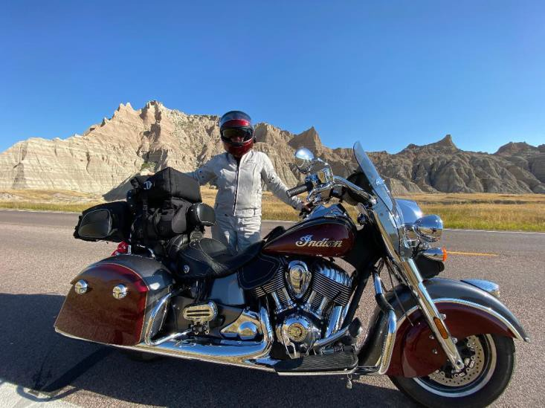
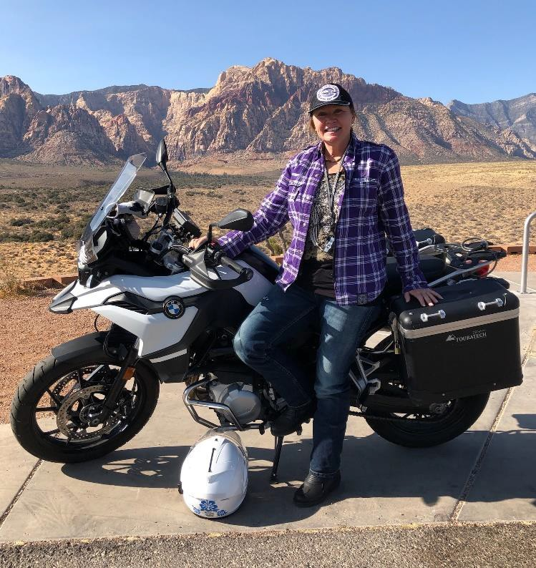
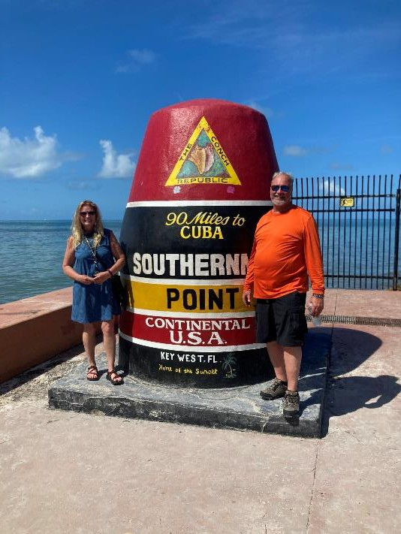
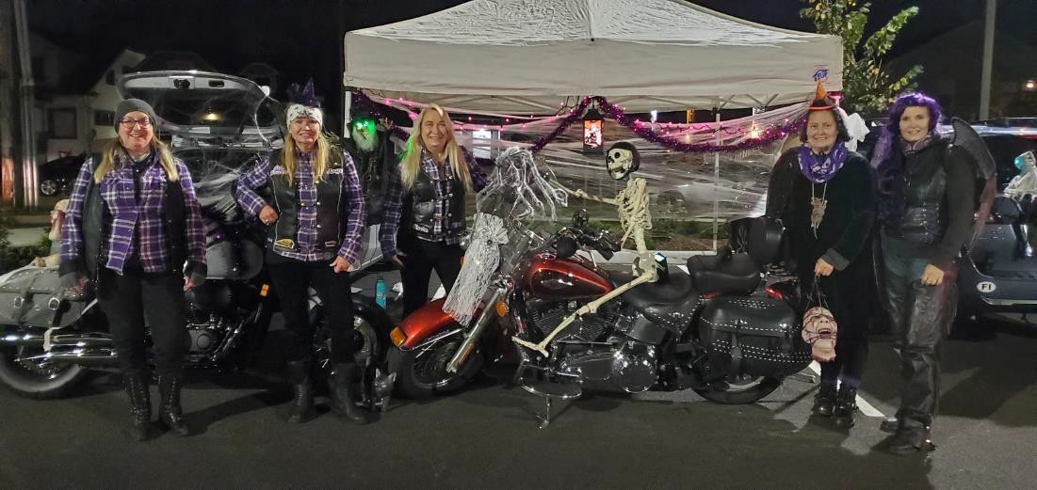
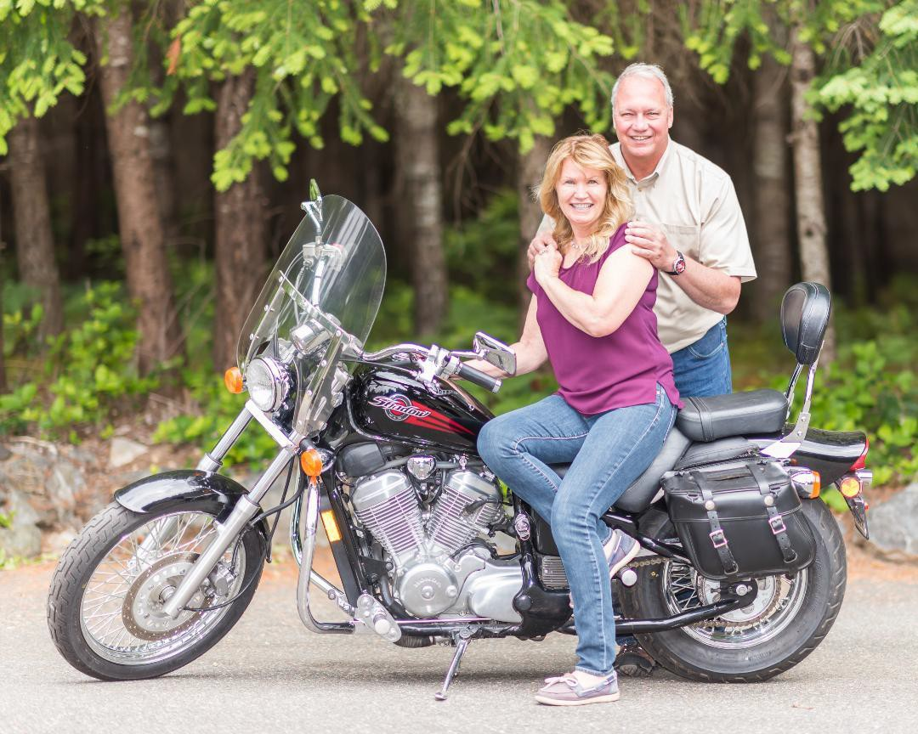
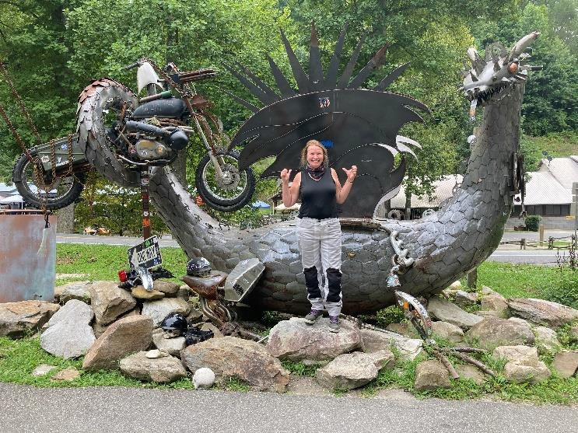
Featured Rider
8


9

Upcoming Events:

- 6/18/2021 through 6/21/2021 – 8AM - LOLO Pass Ride (both ways!) – Eagle Leather, Tacoma, WA (Hosted by Tracy)
- 6/21/2021 – National Ride to Work Day
- 6/26/2021 – 7:30AM – Wynoochee Dam – Eagle Leather, Tacoma
WA
- 7/4/2021 – 9:30AM to 3:00PM - 4th of July Parade – Enumclaw, WA – Meet at Puyallup Fred Meyers
- 7/10/2021 – 7:30AM – Annual 3 pass blast/Country Bobs BBQ (Co Ed Ride) – Denny’s, Auburn WA
- 7/17/2021 – 11AM – W.A.R. Pool Splash Party and BBQ - Puyallup
- 7/23/2021 – 6:00PM through 7/25/2021 3:00PM – Deception
Pass/Whidbey Island Weekend Getaway – Cenex, Auburn WA
- 8/7/2021 – 7:30AM – W.A.R. 4th Anniversary Ride and BBQ –
Location: TBD
- 8/21/2021 – 9:00AM – Bikers for Dogs Charity Poker Run –
Location: TBD
- 8/28/2021 – 10AM to 4PM – Warrior Brotherhood 2021 Poker
Run to help Veterans – Destination Harely Davidson, Tacoma WA
ATTENTION: Due to the COVID-19 virus situation please check that any event you plan to attend is still occurring.
- 9/12/2021 – 11AM to 3PM – Motorcycle swap Meet @American Legion Hall, Kent WA
- 9/23/2021 – 12PM – Street Vibrations Bike Rally – Reno, NV
- 10/23/2021 – Spring/Summer Luncheon – 11Am to 2 PM –
American Legion Hall Kent WA
- 11/5/2021 – 2nd Annual Meet at the Beach – Pacific Beach/Ocean Shores, WA
- 11/21/2021 – 4:30PM-?? Hoedown Holiday Party - American Legion Post 15 Memorial Hall – Kent, WA

New Members!!
Deb Butler

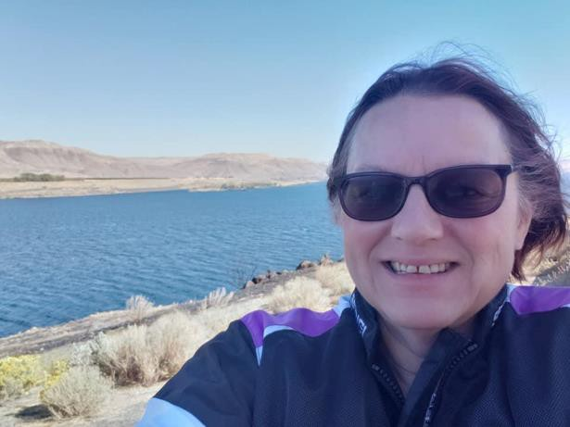
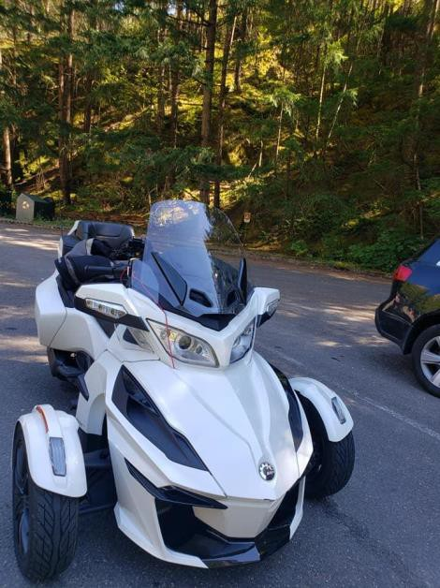
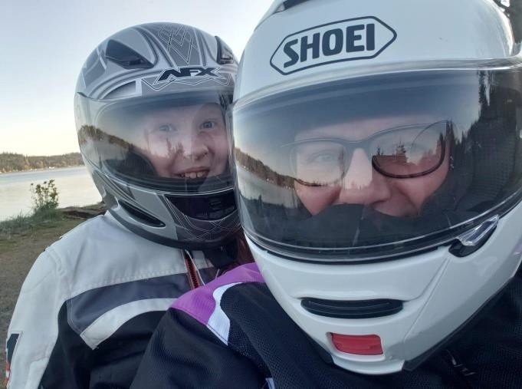
I am a full-time telecommuter for a large insurance company, a full-time student working 10
on my Associate's Degree in Accounting, and I opened my own bookkeeping company last year.

I have two grown children and an 11-yr-old granddaughter, who all live with me. We have 2 cats and a 6-month-old Texas Healer. I also have a daughter and grandson in Arizona.

I woke up one-day last year and decided I wanted to learn how to ride! I started researching and discovered that Can-Am was discounting lessons. And here I am the proud owner of a 2019 Can- Am Spyder RT, which I bought in July. I call her "Freedom" because she helps me escape and spend time outside. I put 3600 miles on her last year. I did the Cascade Loop twice, Hwy 12 to Yakima, and rode the Olympic Peninsula multiple times as it is one of my favorite rides. My granddaughter rides with me frequently. We made the ride to the Kangaroo Farm in the rain, even after it was canceled.

I don't have a road name yet but would love help in finding one. I look forward to getting to know everyone!

New Members
Kathleen Perrigo
11

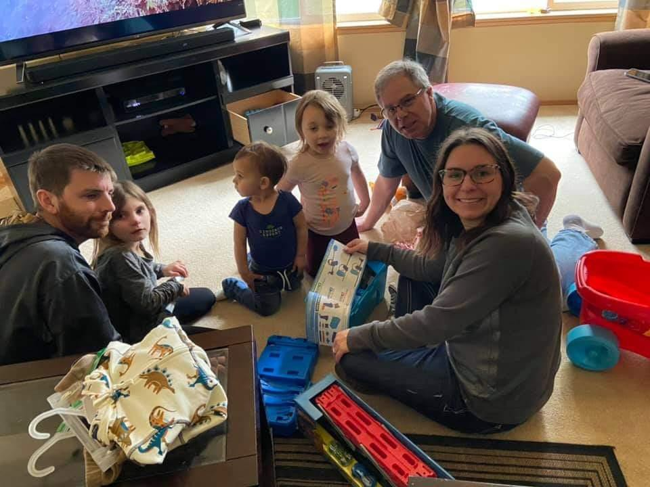
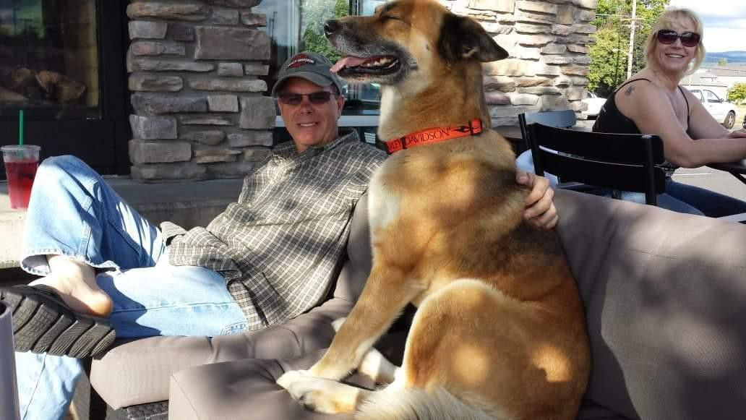
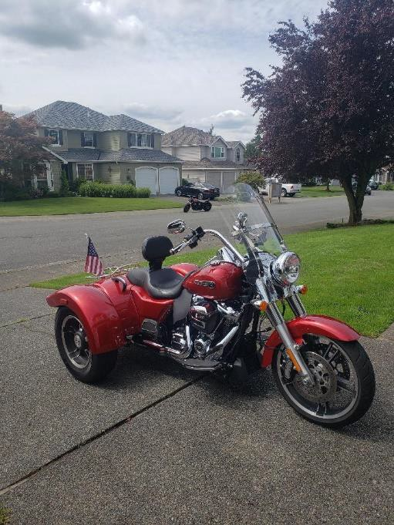
My Name Is Kathleen, I'm 69 years old and my husband is 59. I have 2 daughters, and 3 grandchildren, and I started riding in 1980. My first bike was a
Honda 400CMT and I called it slug, because it didn't have much power. I then
upgraded in 1986 to a Honda Magna 750, I put about 30,000 miles on both Hondas. Then in 1990, at 40 years old, I gave birth to Morgan, the mother of my grandchildren; bikes got sold and I didn't ride for 11 years. Then I bought a 1100 Virago, fast little bugger; I sold it and bought a Suzuki Boulevard. I put about 35,000 miles on each of those bikes. I love touring on motorcycles and traveled throughout the west coast, Nevada, Idaho, Montana, and Wyoming.
I Love motorcycling!


12
We have more new riders to feature, and you
will see them in upcoming editions!
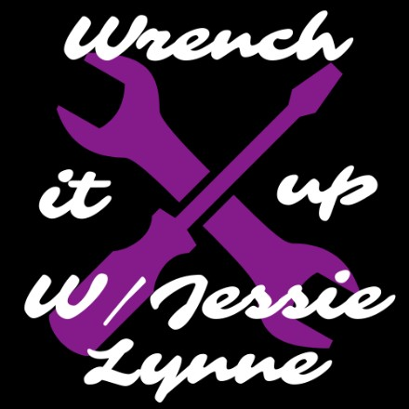
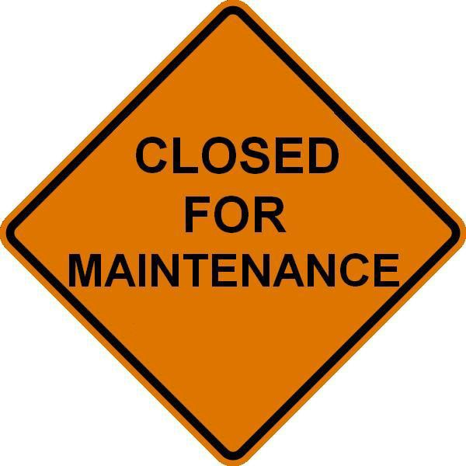
13
Due to foreseen and unforeseen circumstances, Jessie Lynne was
unable to deliver an article for wrench it up this month. She has had health challenges, a myriad of doctor's appointments trying to get well, she is currently in the process of moving, nevermind, she bought a "new" motorcycle.
Let's consider this downtime for wrench it up as a "down for maintenance time"




- Director - Lilyann “Pixel” Lear
warriorangelriders@gmail.com
- Assistant Director - Charlie “Angel” Houmes charlie.houmes@gmail.com
- Assistant Director - Gloria “Fireball” Padgett
organizer.gloria.war@gmail.com
- Treasurer – Sandy “Badass” Knab
slemerson35@comcast.net
- Secretary – Geneva “Blink” Laing
ramjet31@yahoo.com
- Head Road Captain - Tracy “Switchback” Cutler
roadcaptain.tracy.war@gmail.com
- Memberships – Pamela “Merlot” Nolan- Darlington membership.merlot.war@gmail.com
- Ambassador – Hollie “Thumper” Imburgia hollieimb30@yahoo.com
- Mentorship Facilitator - Elaine “Earhart” Weaver
mentor.warriorangelriders@gmail.com
- Editor - Cammie “Boots” Wood
editorcammie.war@yahoo.com
- Road Captain JessieLynn “Pipes” Sturizone wrentchitup.war@gmail.com
W.A.R. Contacts

¹⁴

