Chocolate covered date

night

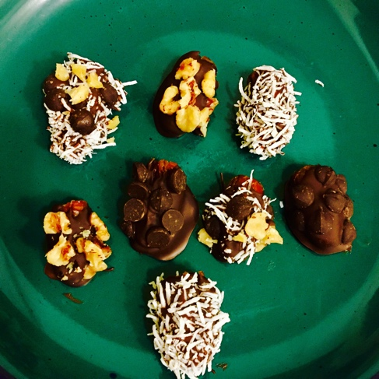

# Ingredients

8 Pitted Dates

1/3 of a bag of dark chocolate chips

2 Tbsp. Unsweetened shredded coconut for topping

1 Tbsp. Dark chocolate chips cut into smaller pieces or use mini ones for topping

1 Tbsp. Chopped Walnuts for topping

A fork or a wooden skewer

1 small bowl for melting the chocolate

A piece of parchment paper

1 plate

# Directions

Place your 1/3 of a bag of chocolate chips in the bowl and microwave for about a minute or less. Please check it after 30 seconds to ensure no burning takes place. Take it out and stir. Set it aside for a moment. Place your toppings in separate small bowls to dip the dates in. Place your parchment paper on the plate. Next take your fork or skewer and date by date place in the chocolate then desired topping. If it gets to messy you can sprinkle the toppings on. After you are finished with the last date you can place the plate in the freezer if eating in a few, or place in the refrigerator if you are not eating them soon. Trust me they are hard to resist! Take them out and have a fabulous “Date Night!”