Liver Shiver Cleanse Juice
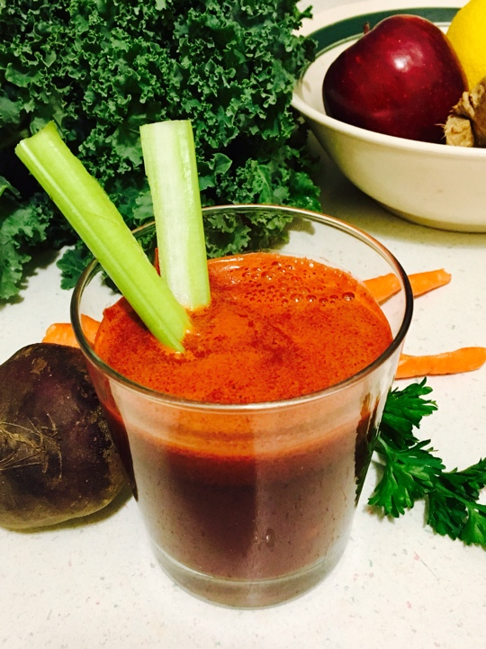

Ingredients
4 Organic carrots washed and peeled
1 Organic beet washed and peeled
1 Organic lemon washed and peeled
1 knob of organic fresh ginger washed and peeled
1 Organic red apple washed and cut in half
1 handful of organic kale washed
A few sprigs of fresh organic parsley washed

Directions
Place all of your ingredients in the juicer each item separately, being careful not to jam the juicer. You can add the carrots in together though. When you are finished you might want to strain out any thick pulp or leave it in the juice, it’s really up to you. My juicer yields a little over 8 oz. of juice. You can split it up and save some for the next day, or sip it all slowly in one setting. Juice like this is best when you drink it up to 30 minutes before eating a meal. Enjoy!

