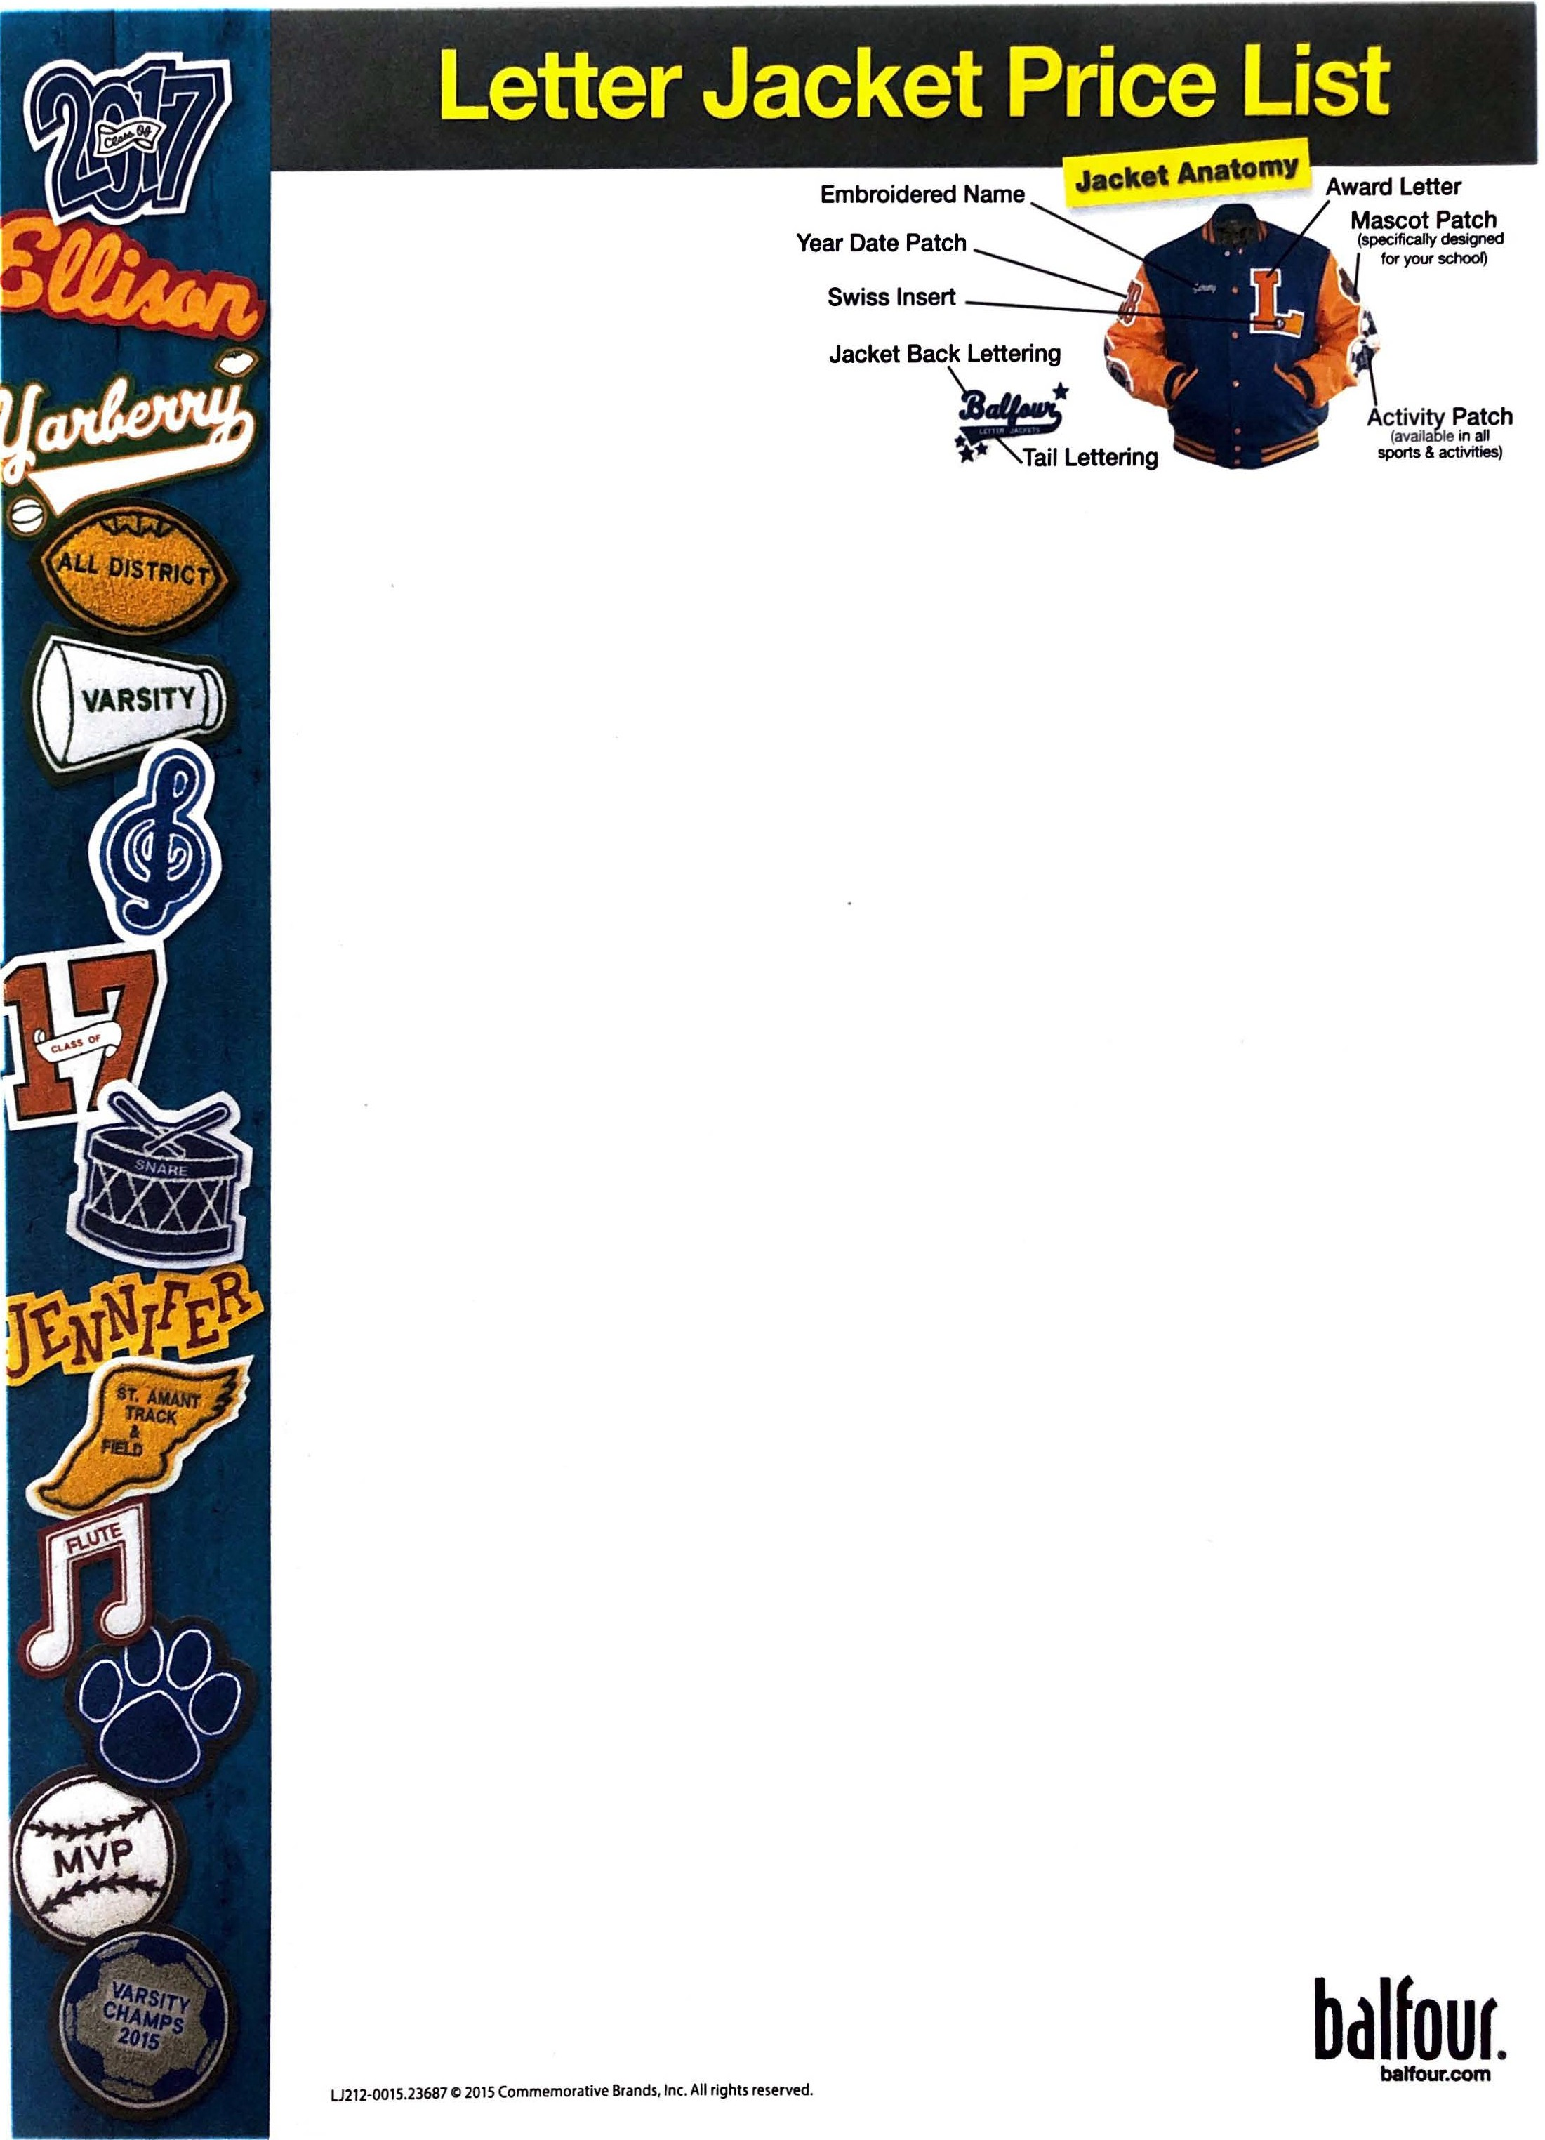

CONGRATULATIONS

Your Official School Jacket is
AVAILABLE NOW!!
Custom Jackets Starting at
$98.00!!
Package and Personalization options are as follows:
-Select a package of Custom Patches that Shows your Achievement
-All Patches are Color Coordinated to Match your Official School Jacket body and sleeves
-All Patches Ordered in a Package will be Sewn on FREE OF CHARGE!!
Sleeves, Body, Letter, Patches, snaps,
pockets, collar and trim will be produced in the appropriate School Colors.
Package D: boys vinyl sleeve………………… $142  boys leather sleeve……………. $183  girls w/sailor collar……………… $164  - Official Jacket with Your Letter sewn on  - Grad Year Patch  - Embroidered name on Front  Save $30  Package C: boys vinyl sleeve……………. $199  boys leather sleeve………… $240  girls w/sailor collar…………. $219  - Official Jacket with Your Letter sewn on  - Grad Year Patch  - Embroidered Name on Front  - Script Straight Name on Back  - Any Sleeve Activity Patch  Save $66  Package B: boys vinyl sleeve…………….. $219  boys leather sleeve………… $252  girls w/sailor collar…………. $237  - Official Jacket with Your Letter sewn on  - Grad Year Patch with “Class Of”  - Embroidered Name on Front  - Script Straight Name on Back  - Any 2 Sleeve Activity Patches  Save $93  Package A: boys vinyl sleeve…………….. $252  boys leather sleeve…………. $293  girls w/sailor collar…………. $274  - Official Jacket with Your Letter sewn on  - Grad Year Patch with “Class Of”  - Embroidered Name on Front  - Script Straight Name on Back  - Any 3 Sleeve Activity Patches  Save $96 | Individual & Add-On Items (if no pack chosen)  - Grad Year Patch -2 or 4 digit……………. $33  (add $5 for embroidered “Class Of’ sash)  - Script Name on Back Patch……..………. $40  (Up to 6 letters-each add’l letter add $5)  - Sleeve Activity Patches………….………… $39  - Mascot Patch (Sleeve 4”-6”)……………. $39  - Mascot Patch (Back 10”-12”)…………… $44  - Embroidered Name on Front…………… $17  - Sew on Charge per patch…………………. $9  - Official School Jacket-Blank boys, wool body-vinyl sleeve………………….………… $98  - Official School Jacket-Blank boys, wool body-leather sleeve………………………. $133  - Official School Jacket-Blank girls, wool body-wool sleeve, w/sailor collar…………… $104  Special Extras**  - Tail for Back Name……………………… $13  - Tail Lettering……………………………… $13  - Crazy Block Name………………………. $17  - Block Name…………………………………. $7  - Old English Name………………………. $17  - Shapes Added to Back Name………. $17  - Embroidered Name on Back………. $40  - Sailor Collar………………………………… $33  - Sailor Collar with Zipper…………….. $39  **These Options added to individual or package pricing  Regional Representative  Monte Reed  502 Red Fox Run  Arcadia, In 46030  317-606-8366  montereed-balfour@outlook.com

