Economic Moats Explained: What They Are & Why They Matter - Part I

The beginning of a multi-part deep dive into a foundational concept in quality investing
Jul 23, 2024

Flyover Stocks is approaching its first anniversary, and while we’ve discussed moats in several articles and analyzed them for each company profiled, I wanted to create a multi-part series that takes a deeper and more comprehensive look at this foundational topic for quality investors.
In the coming weeks, we’ll cover the following topics (I will add the links to this post as they become available):
- Part I: Why Care About Moats? (Today’s post)
- Part II: Moat Sources
- Part III: Moat Width
- Part IV: Moat Depth
- Part V: Moat Trend
- Part VI: How Management Impacts the Moat

Why Care About Moats?
In finance, we often use terms and assume the other person understands what we mean. “Economic moats” has become one of those terms, and having studied the topic for 15 years now, I’ve learned there’s an inconsistent understanding of what we mean when we talk about moats.
I want to return to first principles and illustrate why we should care about economic moats.
Companies invest in tangible and intangible assets using a mix of debt and equity, with the aim of generating profits from those assets. If the assets generate returns in excess of the cost of capital (a mix of debt and equity financing), the company creates shareholder value. If the financing costs outweigh the returns on invested capital (ROIC), the company destroys shareholder value and should stop investing.
In favorable years, some companies can temporarily generate ROIC above the cost of capital, but companies with durable competitive advantages - economic moats - can sustainably generate ROIC above the cost of capital.
To illustrate, consider the 20-year ROIC track records for Fastenal, Hermes, P&G, Jack Henry, and Copart. The black line below represents a generic 9% cost of capital.

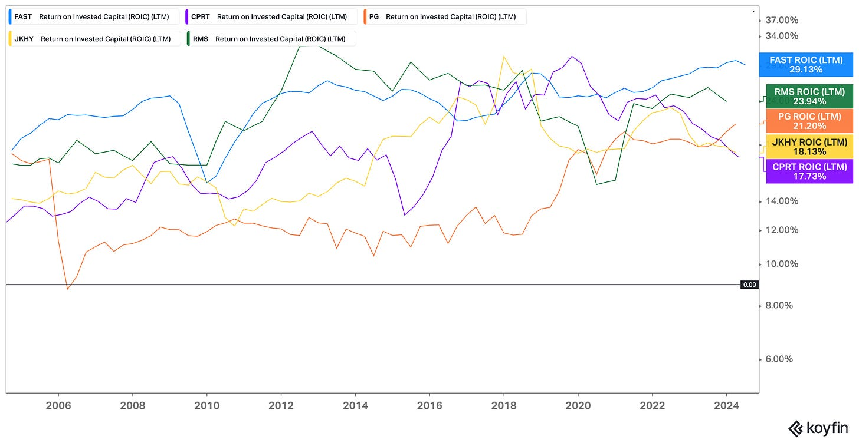
Source: Koyfin, as of July 20, 2024.
As Buffett keenly observed over 40 years ago when he coined the phrase “economic moat,” in a state of perfect competition, the magnitude and persistence of high ROICs would not be possible. Consequently, these companies must have unfair and durable advantages, which form a moat that prevents competition from closing in.

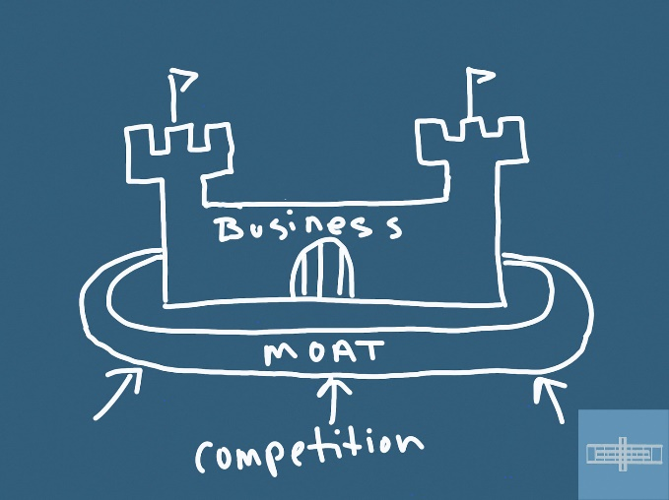

Importantly, a moat is not the economic engine of the business. Instead, a moat's value derives from the castle it's protecting. I'm sure a buggy whip company or two had moats in the early 20th century, but they were worthless once the Model T hit the streets.
Competitors don't attack castle ruins - they're after big, shiny castles. And the bigger and shinier the castle, the wider the moat must be to keep them at bay.
If we want to own quality businesses with superior economics, then we must understand the source of a company's moat, how wide the moat is, how long the moat might persist, if the moat is getting stronger or weaker, and how capable the knight behind the castle wall is at widening the moat. We'll cover these topics in this series in more detail.

Premium fare
Great franchises protected by economic moats naturally attract capital, and companies with persistently high ROIC should, all else equal, command premium multiples to lower ROIC peers.
Here’s why. Consider two peers—Company A generates 20% ROIC, and Company B 10%. If both companies can grow earnings at 10% per year, Company A only has to reinvest 50%, while Company B has to reinvest all of its earnings. This leaves Company A with remaining cash flow to return to shareholders via dividends, buybacks, and debt reduction. It’s a more attractive asset as it has more distributable cash flow.
To be sure, companies with economic moats are not always good investments. Market prices sometimes imply unreasonably high expectations, and returns can be diminished by contracting multiples, even if you’re right about the business’s fundamentals.

Subscribe

Risks and opportunities
Moats can also have risks. The most important one to watch for is complacency. Moats have a way of making those behind the castle walls a bit too comfortable.
As companies gain success and scale, bureaucratic fiefdoms have a way of popping up behind the moat, preventing necessary innovation and becoming culturally insular. Kodak is the classic example, as the company patented digital camera technology but didn’t want to kill its cash-cow film business.
Indeed, moat erosion starts behind the castle walls.
The upsides of owning companies with economic moats, however, far outweigh the risks. Among other things, companies with economic moats:
- Tend to attract talented employees who can better serve customers and further widen the moat.
- Provide management time to respond to challenges that weaker competitors don’t have.
- Can press their advantages in downturns, strengthening them at the start of the next cycle.
Finally, companies with moats better lend themselves to patient holding. Not only do they perform better as a group in downturns, but when they are acquired at a reasonable price, you can let the fundamental compounding do most of the legwork. By comparison, no-moat companies must be acquired at deep discounts and should be flipped when the valuation gap closes.

Bottom line
Not every investor or investment style needs to prioritize investing in companies with economic moats, but investors that prioritize owning quality businesses and holding them patiently should absolutely understand how to analyze moats and how management can enhance or destroy them.

Economic Moats Explained: What They Are & Why They Matter - Part II

Understanding sources of competitive advantage is the first task of evaluating a company's economic moat

For the second part of this series, we’ll explore the various economic moat sources.
- Part I: Why Care About Moats? (free)
- Part II: Moat Sources (today’s post)
- Part III: Moat Width
- Part IV: Moat Depth
- Part V: Moat Trend
- Part VI: How Management Impacts the Moat
Moats don’t make the company, the company makes the moat. In other words, moats are outputs rather than inputs.
As such, the first step of good moat research is understanding the business at a deep level. Even if you see a company has been able to consistently outearn its cost of capital, the sources of its advantage are not always immediately apparent.
Often, the less obvious the source of the moat, the wider or more durable the moat tends to be. Having a framework for evaluating moat sources can help you identify such exceptional companies more efficiently.
Morningstar’s five moat sources provide a good framework for discussion. They are:
- Intangible assets
- Switching costs
- Network effects
- Low-cost production
- Efficient scale
We’ll build upon these concepts in the subsequent posts in this series, which address moat width, moat depth, moat trend, and how management impacts the moat.

Intangible assets
Intangible assets is a catch-all for a number of moat sources such as patents, know-how, brands, trademarks, regulatory protection, intellectual property, and culture. Not all of these subgroups are equal in terms of moat value, so it’s important to discern what type of intangible asset moat we’re talking about.
A patent can support a wide moat, for example, but only until it expires and competition is free to create generic versions of the product. On the other hand, a luxury brand can support a wide moat indefinitely - and may even get stronger over time.


Source: Ferrari
Even within brands, you have Veblen goods and those that offer search cost advantages. Demand for Veblen goods increases as the price increase (e.g., luxury brands like Ferrari and Hermes), while demand for a search cost brand (e.g., known consumer brands such as Crest toothpaste or Starbucks) typically decreases as the price increases, albeit at a slower rate than an unbranded commodity product would.
One thing that makes intangible assets so valuable is that they are more likely to produce unexpected value than tangible assets. It’s unlikely, for example, that an industrial machine will yield a result that wasn’t previously considered. A brand, in contrast, can spawn new revenue and profit streams that could not have been considered ex ante and further widen the company’s moat.
Corporate culture hasn’t traditionally been considered in moat analysis, but it belongs in the intangible asset moat source category.
Like any moat source, culture passes the simple test:
- Is it difficult to replicate - or even unfair altogether? Yes.
- Does it make the company tougher to compete against? Yes.
Buffett touched on this in the 2005 letter to Berkshire Hathaway shareholders:
Every day, in countless ways, the competitive position of each of our businesses grows either weaker or stronger. If we are delighting customers, eliminating unnecessary costs and improving our products and services, we gain strength. But if we treat customers with indifference or tolerate bloat, our businesses will wither. On a daily basis, the effects of our actions are imperceptible; cumulatively, though, their consequences are enormous.
When our long-term competitive position improves as a result of these almost unnoticeable actions, we describe the phenomenon as “widening the moat.”
Delighting customers, eliminating unnecessary costs, and resisting bloat are all fruits of a healthy corporate culture. It’s true that a company with a poor corporate culture can reduce costs, but only for a time.
Indeed, when a great culture is paired with another moat source, good things tend to happen. Intangible assets in general are most valuable when they are paired with another economic moat source.
We’ll touch on that in Part III and IV of this series, but for now, consider how the Deere brand has been used for generations to reinforce and widen its switching cost advantage.

Subscribe

Switching costs
Think about the products and services you and your family use on a regular basis. Some of them - whether it’s Netflix, Spotify, or the Apple ecosystem - become so ingrained in our routines that someone would have to pay us a lot of money to swear them off for the rest of our lives.
This dependence enables the companies to charge higher prices while limiting the risk of customer loss.
And as strong as some business-to-consumer (B2C) switching costs can be, business-to-business (B2B) switching costs can be even stronger. If I’m inconvenienced as a customer, I might be annoyed for a brief period, but an inconvenience for a business could have rippling effects and impact many people.
One of the reasons that Paychex and ADP have been so successful, for example, is that they process payroll and the risk of screwing up employee paychecks during a provider transition is often not enough for a company to justify a switch.
It’s the same thing with Jack Henry, Fiserv, and Fidelity Information Services and core banking services. Deposit gathering is highly competitive and you don’t want to be the bank that upsets its customers during a core banking platform transition, lest you lose depositors that are expensive to acquire.
Service providers like Fastenal, Cintas, and Snap-On have their employees in their customers’ facilities often enough that cutting ties with the company would mean severing personal relationships and potentially disrupting workflows.
Razor-and-blade business models are built upon a desire for switching cost advantages. Gillette is the classic example of this principle - sell the “razor” at a loss to drive product adoption and then sell the blades, which are necessary to operate the razor, at a high margin.


Source: Gillette
Finally, companies that manufacture products that account for a small percentage of the customer’s costs but provide a mission-critical service have high switching cost advantages.
Rotork, for example, sells and services mission-critical flow control instruments and systems. Approximately 75% of Rotork’s sales come from orders below £100,000; 25% are below £10,000. These tickets are a low percentage of the cost of a massive energy or industrial project where the cost of failure is high. Rotork’s customers would be foolish to switch suppliers to save a few pounds.

Network effects
We discussed the downside of network effects in this post, but as long as the underlying product or service is relevant, network effects are the most difficult moat to attack.
As this research from Morningstar showed, companies that benefitted from the network effect advantage had the highest trailing 10-year return on equity and net margin.

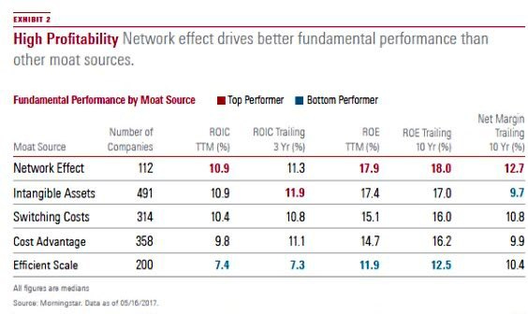

The reason why network effects are so valuable is that, with each incremental user, the platform builds momentum, becomes more valuable, and shuts out substitute offerings as it does. Once you had Facebook, there was no need to have MySpace as well.
Notice that the network effect moat source is also the rarest in the above table. Network effects are hard to establish, not every industry has network effect potential, and they tend to be winner-take-all or winner-take-most industries.

Low-cost production
I’ve found that companies with a relentless focus on lowering costs and diminishing waste tend to be doing something right elsewhere in the business.
My first job was with Vanguard and Jack Bogle’s frugality was at the heart of the company culture. There was a push to lower costs to pass the savings onto the funds’ shareholders.
Sam Walton was cut from the same cloth:
Every time Wal-Mart spends one dollar foolishly, it comes right out of our customers' pockets. Every time we save them a dollar, that puts us one more step ahead of the competition—which is where we always plan to be.
Such a perspective makes a company particularly hard to compete against. All else equal, the company with the lower cost structure can win business by lowering prices or generate higher margins than competitors selling products for the same price. Either way, the lower cost company has the upper hand.
Like any moat source, a low-cost advantage needs to be structural and durable to allow the company to consistently generate ROIC above cost of capital. A company can build a state of the art factory to lower costs, for instance, but if its competitors can do the same within a year or two, the cost advantages from the new factory are temporary and not an economic moat source.
Instead, it’s important to consider how the company might maintain the advantage over the next decade.
Some companies develop a low-cost advantage through deliberate operational practice, but others come by it as a matter of course.
To illustrate, rock quarries and metal beverage can facilities produce low value-to-weight ratio products and can only be transported economically within a certain radius. A rock quarry in California cannot compete with a rock quarry in Florida for a construction job in Georgia.

Efficient scale
The last, and most debatable, moat source is efficient scale. The principle of efficient scale is that a market generates ROICs high enough to attract competition, but low enough to prevent competition from actually entering the market. If the competitor did enter the market, it would drag ROIC below cost of capital for all participants, thus eliminating the incentive to enter the market.
Utilities, railroads, airports, beverage can makers, and other industries benefit from serving limited local markets where large investments in the infrastructure necessary to compete against them present barriers to entry and discourage competition.
Efficient scale can hold for a long time, but unexpected changes in the industry can quickly disrupt the status quo. During COVID, for example, beverage can demand skyrocketed as more people consumed drinks at home. The handful of major can makers like Ball and Crown didn’t have enough capacity to meet demand, so prices rose sharply, which boosted ROIC and made industry entry more attractive.
I wouldn’t want to own a company that showed evidence of efficient scale and no other economic moat sources.

Bottom line
When you boil it down, a good moat source is something that solves a customer’s problem - possibly one they don’t even know they have. Brands can help consumers make easier decisions and save time, switching costs can deepen relationships with customers, network effects more efficiently connect people, and low-cost advantages can save customers’ money.
A company with one economic moat source is already exceptional, but those with more than one moat source are capable of establishing wide moats that enable them to generate ROIC above cost of capital for more than ten years.
We’ll explore this further in the next installment in the series on moat width.
Stay patient, stay focused.
Todd

Economic Moats Explained: What They Are & Why They Matter - Part III

The sufficiency of a company’s moat width is dependent on the size of the castle it’s meant to protect.

Todd Wenning
Aug 24, 2024

Our managers of the businesses we run, I’ve got one message to them, which is to widen the moat. And we want to throw crocodiles and sharks and everything else, gators, I guess, into the moat to keep away competitors. – Warren Buffett
For the third part of this series, we’ll explore moat width.
I encourage you to read Parts I and II before reading this post.
- Part I: Why Care About Moats?
- Part II: Moat Sources
- Part III: Moat Width (today’s post)
- Part IV: Moat Depth
- Part V: Moat Trend
- Part VI: How Management Impacts the Moat

I’m fascinated by companies that have stood the test of time.
There’s a small roofing materials distributor near my house that’s been in business for 149 years. It’s managed by the fourth generation founding family.
As I’ve have travelled around the country with my family, I’ve noticed similarly long-lived independent distributors. The common denominator seems to be deep customer relationships and service track records built over decades.
Local advantages they may be, but they are durable.
Without seeing any of their financials, my guess is that their advantages yield high single-digit returns on invested capital, on average. That’s enough to reinvest in the business and pay the owners a tidy dividend, but not enough to expand regionally, and eventually, nationally.
These advantages haven’t been competed away because upstart local competitors lack the established relationships. Given tight margins in distribution, upstarts would need to take losses for years to compete on service. On the other hand, larger competitors are better off acquiring the company than competing on price and dragging down ROIC for both parties.
It's a nice position for the local incumbents. That said, local distributors can’t press their advantages too far in pursuit of higher margins and ROIC. If that were to happen, competitors would have enough incentive to enter the market.
In other words, their moats aren’t wide enough to support that strategy.

Moat and Castle
In the opening article in this series on economic moats, I wrote:
“Competitors don't attack castle ruins - they're after big, shiny castles. And the bigger and shinier the castle, the wider the moat must be to keep them at bay.”
For the local distributors, a skinny moat is sufficient to protect their impressive, but relatively modest, castles.
That’s not the case for the likes of Google, Visa, or Copart, however. Each of these businesses is a big, shiny castle coveted by competitors. They need wide imposing moats to maintain their position.
The sufficiency of a company’s moat width is dependent on the size of the castle it’s meant to protect.
Whether it’s a wide or narrow moat, the question to ask is, “Will competition size up the castle and say, ‘Eh, not worth the trouble.’?”
Pictures of Bodiam Castle in the U.K. are often used in articles on moats (including this one!) because of its wide moat and untouched castle. Indeed, most moated castles are in ruins, but that’s a story for another day.


Source: British Castles
Historians have debated whether Bodiam’s moat served ornamental or military purposes, but it could be both. It’s situated on the River Rother in East Sussex and it stands to reason that its strategic location could have been attacked, particularly during the War of the Roses.
Yet it wasn’t.
The catch is that as wide as Bodiam’s moat is, it is not particularly deep - about five feet in most parts and could have been besieged with some effort, but if you were a general sizing it up, why would you want to deal with a moat like that in the first place? Your advance would at least have been dramatically slowed.
You can think of moat width as a deterrent of sorts.
Moat depth, which we’ll explore in the next post, considers how durable the moat is to withstand an attack. In other words, how likely is it that the moat will be at least as wide in a decade?
But here, we want to understand how formidable the company’s current advantages are and if they are sufficient to deter competition.

The crown jewels
The attractiveness of the castle depends on the strength of the underlying business. As we discussed in this post on The Warren Buffett Way, a business franchise “possesses the economic goodwill necessary to raise prices in all environments without commensurate capital expenditures, particularly during inflationary ones.”
It's the dream of every business to become a franchise and raise prices as necessary without having to “hold a prayer session” beforehand. Such franchises are natural targets for competitors who want to wear the crown themselves.
As a result of their advantages, wide moat companies tend to have higher and/or more persistent returns on invested capital.

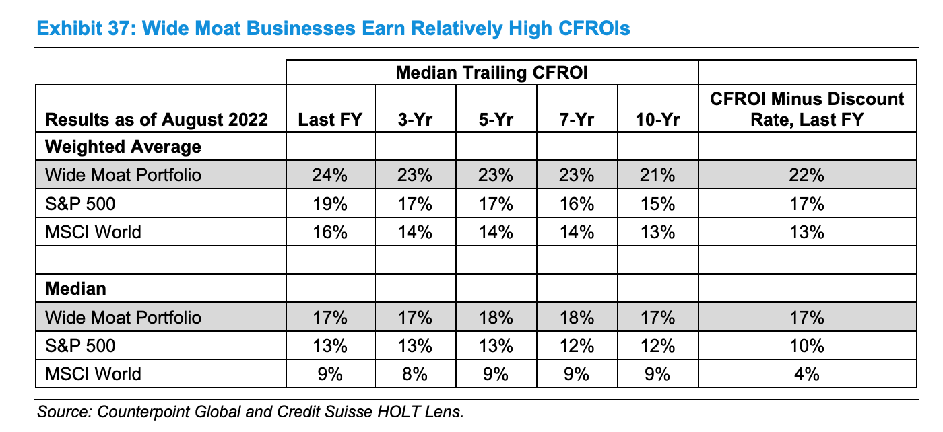

Without a wide moat, the franchise is vulnerable to competition. Raising prices gets harder, more investment is required to keep pace, and returns on invested capital naturally decline.

Moat source matters
The nature of the moat source can also tell us something about moat width.
As the below chart from Morningstar shows, network effects are more often found in companies they’ve rated “wide moat” than efficient scale advantages.

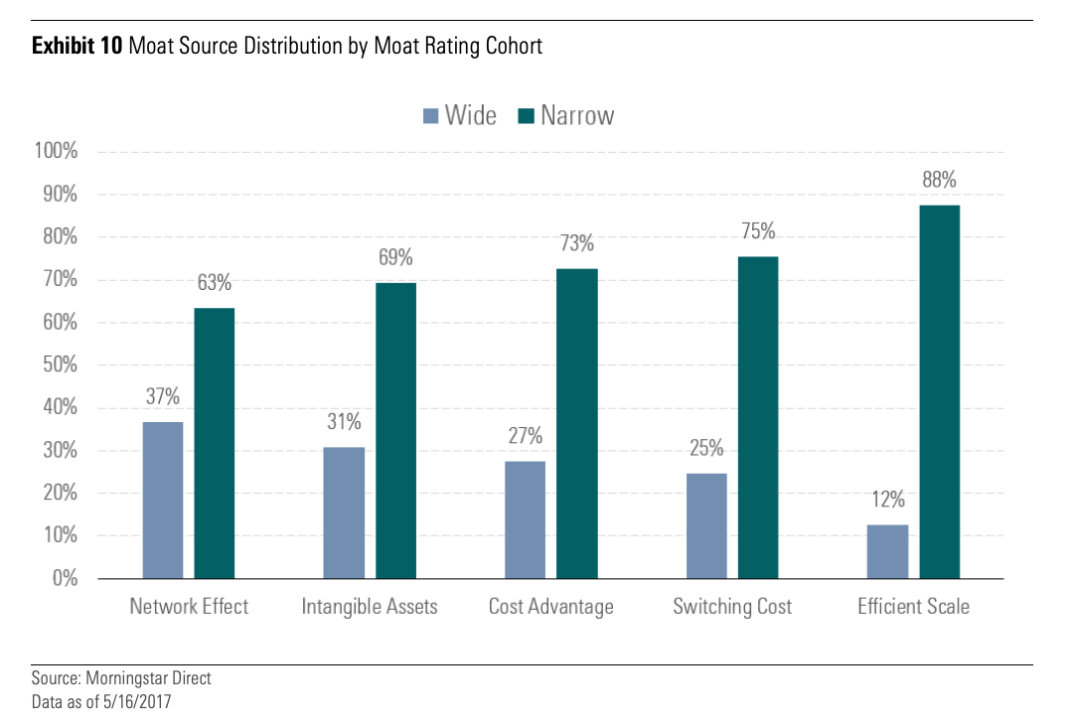

That makes sense. Network effects tend to produce “winner take all” or “winner-take-most” industries that result in concentration and little competition.
While network effects can unravel more quickly than other moat sources, when they are supporting a highly-relevant product or service, they are near-impossible to overcome as a competitor.
Efficient scale, in contrast, relies on rational competition to work. If an irrational competitor enters the market and cuts prices to win business, the returns on invested capital and the efficient scale moat source itself dissolve for all participants.

Multiple moat sources
Companies with wide moats also tend to have multiple moat sources.
To illustrate, Copart, which is a global automobile auctioning and remarketing platform, has a number of moat sources behind its wide moat. For one, it has both physical and digital network effects. Its physical network effects come from its storage yards scattered across the country, where it collects damaged cars for auction. The more locations it has, the easier it is for sellers (like insurance companies) to get cars into the Copart system. Copart’s digital network effects are built upon this physical network advantage. As Copart’s inventory grows, the more attractive its online auction platform becomes to both sellers and buyers.



In addition to these network effects, Copart has some intangible asset advantages related to its deep relationships with insurance companies who rely on Copart to help them sell damaged vehicles and minimize their losses.
Because Copart owns rather than leases most of its land, and held much of it for decades, it also has a cost advantage versus competitors just starting out or legacy competitors like IAA who have historically leased their land and are subject to lease negotiations.
Each of Copart’s moat sources are robust on their own and are even more formidable when combined. It has considerable bargaining power with both customers and suppliers and has become an integral part of how the auto insurance industry operates in the United States.

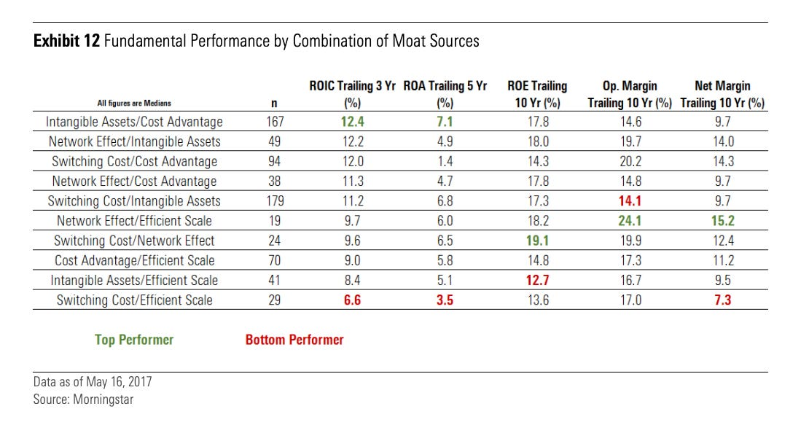

By comparison, Toro has a weaker franchise than Copart; however, a less impressive set of moat sources is sufficient to protect its more modest castle.



Flyover Stock: The Toro Company (TTC)
Todd Wenning
·
Apr 21

Read full story

Toro’s moat relies on its extensive dealer network that offers professional customers like golf courses, landscapers, and municipalities superior sales and service. For these customers, equipment downtime is lost money and having local service is worth paying a premium for the Toro brand relative to a cheaper brand that doesn’t have a local presence.

Bottom line
Once you’ve determined the quality of the underlying business, you can better understand the width of the moat necessary to defend the company’s position.
Wide moats are as rare as exceptional companies. There might be a few dozen - maybe 100 - in the world. If you’re only looking for wide moats and exceptional companies, your universe may be too restricted. There are great businesses worth considering that are just as well protected by narrow moats. What matters is that the width of the moat matches the attractiveness of the castle it’s defending.
Stay patient, stay focused.
Todd

Economic Moats Explained: What They Are & Why They Matter - Part IV

Moat depth measures how well a company can defend itself when a competitor decides to attack
Todd Wenning

Sep 22

For the fourth part of this series, we’ll explore moat depth.
I encourage you to read Parts I-III before reading this post.
- Part I: Why Care About Moats?
- Part II: Moat Sources
- Part III: Moat Width
- Part IV: Moat Depth (today’s post)
- Part V: Moat Trend
- Part VI: How Management Impacts the Moat
In Part III of this series on economic moats, we discussed how moat width serves as a deterrent to competition. The adequacy of a company’s moat width depends on the size of the castle it’s meant to defend.
A nice little business can do quite well with a narrow moat, for instance, but a fast-growing, high-return on invested capital (ROIC) business that everyone wants a piece of needs a wide moat to keep envious competitors at bay.

AI generated image: “knights attacking castle with moat”
That said, the economy and companies are complex adaptive systems. Companies do not operate in static environments. Over the course of a decade, even a wide moat business will face at least one serious challenge as consumer tastes change, new technologies emerge, and the availability of cheap capital ebbs and flows.
A company’s ability to withstand such changes - and have the chance to get stronger on the other side - depends on its moat depth. Moat depth is about sustaining product and service relevance over time – no small feat! – and the power to fend off competition that’s trying to siphon off some of its profitability.

Failed moat attacks
The most recent company profiled here at Flyover Stocks, Simpson Manufacturing, contains a good example of the difference between moat width and moat depth.

  Flyover Stock: Simpson Manufacturing (SSD)
   |  | Sep 3
    Todd Wenning |  | ·
  Read full story
In 2012, Lowe’s pulled Simpson’s dominant Simpson Strong-Tie brand of structural connectors off its shelves and promoted its own private-label brand.
At face value, it made sense for Lowe’s to try the strategy. The reasoning might have went something like this: Simpson enjoys 40%-plus gross margins on its products – a considerable markup for what appears to be simple metal connectors - and professional contractors regularly need connectors to build sturdy structures like houses and decks. Lowe’s could offer a lower markup through private label, which would delight Pro customers and drive more Pro traffic to its stores.
In practice, however, it was a poor decision. Contractors went to Lowe’s for Simpson Strong-Tie and didn’t buy Simpson Strong-Tie because Lowe’s carried it. Because Simpson is often specified by name by architects and engineers in building plans, if contractors choose an alternative brand, the liability rests with them if the structure fails.

Source: Simpson
When contractors couldn’t find Simpson Strong-Tie at Lowe’s, they went somewhere else. By 2020, Lowe’s restocked Simpson Strong-Tie to win back more Pro business. In fact, Lowe’s named Simpson one of its vendors of the year in 2023.
A failed moat attack, like the Lowe’s-Simpson example, is usually a good sign that a company’s moat is deeper than it appears. Companies with deep moats often provide their customers with some solution beyond the obvious utility of their products. In the case of Simpson, its reputation for quality and rigorous testing provides architects, engineers, and contractors with peace of mind that structures built with Simpson connectors will hold.

New wine in old wineskins
Another example is found in the streaming wars where the traditional media companies took on Netflix. A few years ago, there was reasonable and genuine concern that when the likes of Disney, NBC, and Paramount took their IP off the Netflix platform, it was game over for Netflix.
That has not proven to be the case.
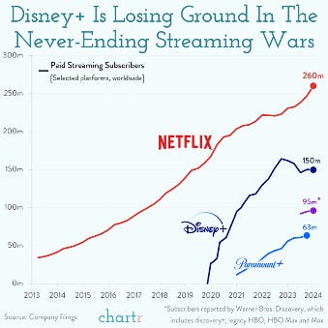
To Netflix’s credit, it launched original programming in 2013 - well in advance of the threat of big media pulling their content from the platform. By the time Disney+ launched in late 2019, for instance, Netflix had a number of popular original series like Orange is the New Black and Stranger Things.
Despite traditional media companies having the cash, content, and intention to take on Netflix, they have yet to catch up with its technology lead. Here’s Disney CEO Bob Iger in March of this year:
What we didn't have was the technology that we needed to basically lower customer acquisition and retention costs to increase engagement to essentially grow our margins by reducing marketing expenses. We're now in the process of creating all and developing all of that technology. And obviously, the gold standard there is Netflix, we need to be at their level in terms of technology capability.
And one of the reasons why their margins are so much more significant than ours is because they have that technology. So our marketing expenses are significantly higher, our churn rates are higher than they need to be.
Traditional media companies underestimated Netflix’s moat, which from the outside appeared to be built around licensing their IP. Just pull the IP, the thinking went, and Netflix will crumble. They found out there was more to the story once they attacked Netflix’s moat.

Behind the scenes
One thing Simpson and Netflix had in common was nimble and thoughtful management and distinct and robust corporate cultures. (We’ll discuss the role of management and moats in greater detail in Part VI.)
These attributes are critical when considering moat depth and durability. Moats first erode behind the castle walls due to cultural rigidity, myopia, bad capital allocation, and inertia (“This is how we’ve always done it.”) Only then is the company vulnerable to an attack.
Pivoting thousands of employees toward a new strategy is not easy, especially when many of them may have been hired to do a job related to the old strategy. It requires cultural dexterity and buy-in from employees. Indeed, Netflix pivoted multiple times, shifting from DVD-by-mail, to digital streaming, and to original programming.

Recognizability vs. Relevance
The desired outcome of moat depth is to at least maintain product or service relevance over a decade and beyond. It is relevance that commands pricing power and pricing power begets superior economics.
"The single-most important decision in evaluating a business is pricing power. If you've got the power to raise prices without losing business to a competitor, you've got a very good business. And if you have to have a prayer session before raising the price by a tenth of a cent, then you've got a terrible business. I've been in both, and I know the difference."
- Warren Buffett
There’s a critical difference between relevance and recognizability. A company’s brand might be recognizable but not relevant, in which case the brand cannot command pricing power.
To illustrate, consider the Hanna-Barbera universe of cartoon characters like The Flintstones, Yogi Bear, and Scooby-Doo. Those of a certain age will recall how popular and relevant those franchises were in the 1980s and earlier. When I was a kid, my local amusement park featured Hanna-Barbera characters and many Saturday mornings were spent watching their cartoons.
While the Hanna-Barbera franchises remain recognizable, due to a variety of factors, few of them remain relevant to today’s audiences.
Meanwhile, millions of children remain delighted to see the likes of Mickey, Cinderella, and Belle when they visit Disney theme parks each year - and parents fork over small fortunes for the opportunity.
Both Hanna-Barbera and Disney characters are recognizable, but only Disney characters remain relevant.

Evaluating moat depth
As you’re evaluating a company’s moat depth, consider the following questions:
- Has the company’s moat been threatened before? If so, what was the outcome?
- If the company disappeared tomorrow, why would their customers be in mourning?
- In what ways is the company culturally and operationally agile enough to respond to unexpected changes and threats?
- How much more could the company charge for its products before customers would balk at the prices?
- What is the competitive intensity in the industry? Does management have time to deepen its moat or is it preoccupied with fighting off new challengers?
These aren’t easy questions to find answers to, but the best questions always take time to research, otherwise everyone would ask them.
Moat width and depth are often lumped into the same category, but I find it helpful to split them into separate analyses as they serve separate purposes. Moat width is concerned with how the economic moat sources deter competition and moat depth focuses on what resources a company has when an attack actually occurs.
In Part V of the series, we’ll explore moat trend, which considers if the company’s competitive position is getting stronger or weaker in the next few years and how that can be a primary determinant of medium-term stock performance.
Thank you for your continued interest in this series and in Flyover Stocks. Please feel free to add your questions and comments below or contact me directly.
Forwarded this email? Subscribe here for more

You can find a list of all the companies profiled at Flyover Stocks by clicking here. Paid subscribers get full analysis of the company’s moat, management, and valuation.
Upgrade to paid
Flyover Stocks posts are now in audio format! You can listen to Flyover Stocks content on Spotify, Apple, or wherever you get your podcasts. Please rate, like, and share the podcast so that more thoughtful investors can join our community.

Economic Moats Explained: What They Are & Why They Matter - Part V

How to assess whether a company's moat is getting wider or narrower
Todd Wenning

Nov 4

READ IN APP

For the fifth part of this series, we’ll explore moat trend.
I encourage you to read Parts I-IV before reading this post.
- Part I: Why Care About Moats?
- Part II: Moat Sources
- Part III: Moat Width
- Part IV: Moat Depth
- Part V: Moat Trend (today’s post)
- Part VI: How Management Impacts the Moat
Upgrade to paid

Companies are not static assets. Unlike gold or artwork, companies are always changing. Future cash flows are unknown.
It’s true that some companies change slower than others, but eventually, every current employee will retire or leave and a new crop will take over. Every asset will break down or become obsolete and need to be replaced or refreshed. A company you invested in 10 or 20 years ago is not the same company today.
What’s more, companies are in a constant battle against entropy: the natural tendency toward disorder and decay. Just staying in place takes effort.
Given the constant state of change and the weight of entropy, it’s remarkable that some companies are able to dig a moat in the first place. Those that are able sustain it - and even widen it - are in a special class indeed.
The direction of a company’s moat - widening or narrowing - is a product of daily decisions by both managers and employees. Buffett touches on this point in one of my favorite passages from his letters. This from the 2005 shareholder letter:
“Every day, in countless ways, the competitive position of each of our businesses grows either weaker or stronger. If we are delighting customers, eliminating unnecessary costs and improving our products and services, we gain strength. But if we treat customers with indifference or tolerate bloat, our businesses will wither. On a daily basis, the effects of our actions are imperceptible; cumulatively, though, their consequences are enormous.
When our long-term competitive position improves as a result of these almost unnoticeable actions, we describe the phenomenon as “widening the moat.” And doing that is essential if we are to have the kind of business we want a decade or two from now. We always, of course, hope to earn more money in the short-term. But when short-term and long-term conflict, widening the moat must take precedence.” (my emphasis)
As outside investors, it’s hard for us to notice these daily micro actions. (Once in a while, though, we might pick up on something.)
Heck, it’s even hard for board members and executives to notice them, especially when a company is spread out over many geographies.
But, as Buffett observed, the cumulative effects of these daily actions have enormous consequences to the moat. At a minimum, we should be on the lookout for discernable trends.
The effects eventually show up in the form of stronger pricing power, lower costs, or ideally both. As a result, returns on incremental invested capital (ROIIC) improve, and the business grows intrinsic value at a faster pace. In turn, the market typically rewards the company with a higher share price.
Upgrade to paid

Chutes and ladders
Of course, this works in both directions. In Michael Mauboussin and Dan Callahan’s excellent 2023 paper called “ROIC and the Investment Process”, the authors show how over rolling three-year periods from 1990 to 2022, cohorts of companies that moved up ROIC quintiles exhibited more positive total shareholder returns. In contrast, those that slipped quintiles posted relatively poor returns.
Fortunately, as the accompanying table shows, companies in the highest ROIC quintile tend to stay in the highest quintile, but if a company falls out of the highest quintile, it is more likely to have poor subsequent performance. We discussed this at more length in this video on quality traps.
Given the tendency of companies to perform better when ROIC meaningfully improves and perform worse when ROIC meaningfully declines, it pays to understand how moat trend can impact changes in ROIC.

Evaluating moat trend
Ultimately, what we’re trying to determine with moat trend analysis is “Are the company’s identifiable competitive advantages getting stronger or weaker over the next three to five years?”
Before evaluating moat trend, we need to understand the sources of the company’s moat, such as low-cost production, network effects, switching costs, intangible assets, or efficient scale. (We explored each of these moat sources in Part II of this series.)
Once you’ve identified the source of the company’s advantage, you can better evaluate its direction.
This is, in fact, what Buffett did when describing GEICO in the 1986 letter to Berkshire Hathaway shareholders:
“The difference between GEICO’s costs and those of its competitors is a kind of moat that protects a valuable and much-sought-after business castle. No one understands this moat-around-the-castle concept better than Bill Snyder, Chairman of GEICO. He continually widens the moat by driving down costs still more, thereby defending and strengthening the economic franchise.”
Buffett identified the moat source (low costs) and tracked GEICO’s moat trend by evaluating GEICO’s costs (in insurance terms, the expense ratio) relative to those of its competitors.
You’ll note that Buffett ties this relationship to actions taken by then-chairman/CEO Bill Snyder. In the final segment in this series, we’ll explore how management’s actions impact all aspects of the moat.
Upgrade to paid
Having a metric to track helps a great deal in moat trend evaluation. It doesn’t have to be a traditional metric like insurance expense ratio, but the data must be relevant and available.
Two of the metrics I watch at Costco, for example, are Change in Annual Executive Membership and Executive Members as a % of Total Members.
Source: Company filings, author estimates
These two metrics provide a regular update on how relevant Costco is to its customers. Here’s why.
You can shop at a Costco with the basic Gold Star Membership (currently $65 per year in the US). The Gold Star Membership gives you access to just about everything Costco has to offer.
Therefore, to justify an upgrade to Executive Membership (currently $130 per year in the US) in which you get a 2% reward on purchases, you need to spend at least $3,250 annually - or $270 per month on average - at Costco to break even with the Gold Star Membership.
With few exceptions, $270 a month implies that shopping at Costco is part of your routine. And as research suggests, once a store is ingrained in your routine, it usually takes a major life event like having a baby or a global pandemic to disrupt it.
The more members spend at Costco, the more bargaining power Costco has with its suppliers, the lower prices it can offer its members, the more members join Costco. As this process plays out, Costco’s moat gets wider and ROIC drifts higher. It shouldn’t be a surprise that Costco’s stock price has followed suit.
Source: Koyfin, as of November 3, 2024. Flyover Stocks readers can get a special offer from Koyfin by clicking here!
Upgrade to paid

What moat trend isn’t
Companies - and particularly cyclical companies - tend to get a ROIC boost in favorable markets. These natural ebbs and flows may impact the stock price, but they do not represent moat trend as they are outside or “systematic” forces.
What we’re after with moat trend is instead company-specific. Indeed, a company’s moat trend can improve in a downswing if its competitors weren’t prepared and the company gains market share.
Growth can be indicative of a moat trend if the growth is adding intrinsic value, but growth alone is not a moat trend, as companies can grow while investing in projects that destroy value.
Changes in business mix are also not in themselves indicative of moat trend. For example, if a company has a wide-moat segment and a no-moat segment and spins off its no-moat segment, the company’s moat trend does not turn positive because only the wide-moat segment remains. What’s more important to understand is if that wide-moat segment is itself building upon its advantages or not.

Moat trend process
As you’re thinking about moat trend at a company, consider the following steps:
- Identify the moat source: What’s the source of the company’s competitive advantage? Why does the company benefit from the moat source and why don’t its competitors equally benefit from it?
- Find or build metrics to track moat source strength: If the company has a low-cost advantage, are costs per unit declining? If the company benefits from switching cost advantages, is the retention rate or spending per customer moving higher?
- Consider medium-term relevance of product or service: Do you expect the company’s offerings to be at least as relevant in five years as they are today? eBay has long been used as a classic example of a network effect moat, but the relevance of online auction platforms declined as local classifieds (Facebook Marketplace, Craigslist) and direct e-commerce (Amazon, Walmart) became more ubiquitous and easier to use.
- Cultural impact: Does the company’s corporate culture support or detract from the company’s moat? A company with a weak corporate culture (e.g. revolving door management, multiple private equity owners over the last decade) will be less likely to correct a negative moat trend.
Correctly identifying positive moat trends can lead to strong returns, but if your investment universe is already whittled down to quality, high ROIC businesses, then moat trend analysis is most useful as a way to avoid negative moat trends. As Mauboussin and Callahan’s table above suggests, the companies that start with a top quintile ROIC and drop out of that cohort often have the furthest to fall. These are the aforementioned “quality traps.”
On the other hand, positive moat trends are most useful if you’re looking for companies to move up from lower ROIC cohorts. As discussed in the Hawkins profile from February 2024, the company’s growing competitive strength in water treatment alongside increased relevance of its services pointed toward improving segment margins.
As Hawkins acquires new water treatment facilities and integrates the company into the Hawkins’ way of doing business, I expect segment margins to improve back to the mid-teens and support the company’s overall margin expansion.
Supporting this trend is increased attention being paid toward removing water contaminants like lead and PFAS from municipal water. In addition, reshoring of manufacturing will lead to greater industrial demand.
Thus far, that seems to be playing out in Hawkins’ water segment, and the stock has followed alongside this progress.
Sources: Hawkins company filings, author estimates

Bottom line
Moat trend analysis is a helpful way of framing and tracking the momentum of a company’s competitive advantages. These changes can’t be screened for and require qualitative effort to understand the company at a deep level.
How do you think about moat trend? Please let me know in the comments below.
I’ll conclude this series in a few weeks with Part VI, which looks at the intersection of moat and management. Stay tuned!
Forwarded this email? Subscribe here for more


You can find a list of all the companies profiled at Flyover Stocks by clicking here. Paid subscribers get full analysis of the company’s moat, management, and valuation.
Upgrade to paid
Flyover Stocks posts are now in audio format! You can listen to Flyover Stocks content on Spotify, Apple, or wherever you get your podcasts. Please rate, like, and share the podcast so that more thoughtful investors can join our community.

Economic Moats Explained: What They Are & Why They Matter - Part VI

The conclusion of a six-part series on economic moats
  Todd Wenning
  Dec 6
  

    
    
    
    
  READ IN APP

For the final part of this series, we’ll explore how management impacts moats.
I hope you’ve enjoyed this series. Please subscribe below to stay up to date on the latest Flyover Stocks content.
- Part I: Why Care About Moats?
- Part II: Moat Sources
- Part III: Moat Width
- Part IV: Moat Depth
- Part V: Moat Trend
- Part VI: How Management Impacts the Moat (today’s post)
Flyover Stocks is a reader-supported publication. To receive new posts and support my work, consider becoming a free or paid subscriber.
Upgrade to paid

If you have a castle in capitalism, people are going to try to capture it. You need two things – a moat around the castle, and you need a knight in the castle who is trying to widen the moat around the castle. - Warren Buffett
Ten years ago, I served as Morningstar’s head of equity stewardship, which meant it was my job to think about the confluence of moat and management.
Prior to taking the role, most of my management research was focused on governance. I asked questions like “Is the board independent?” and “Are the chairman and CEO roles held by the same person?”

medieval knight watching over moat around castle
Governance is important, of course, but long-term investors are primarily concerned with how management allocates capital and sets the business’s cultural tone.
In other words, is management acting as good stewards of shareholder capital?
Having a stewardship mentality means setting the company up for success beyond your tenure. In turn, this means widening the company’s economic moat while you’re in charge.

Understanding
Naturally, widening the moat first requires management to understand the sources of the company’s economic moat.
After many conversations with company management, I can tell you that this is not always a given.
As such, it’s our job as investors to look for signs that management “gets it.”
Here are a few examples:
Fastenal, July 2008 earnings call (then-CFO, now CEO Daniel Florness speaking):
Where we can straighten out the line of where that product flows, everybody knows the shortest distance is a straight line. We can lower our costs and have a competitive advantage and improve our margin and improve the value we provide to our customer…
Because when you get down to it we’re hauling a gob of steel at relatively low value per pound product around a very large continent and we can do it more cost effectively than anybody. Getting back to that whole concept of alternative A or alternative B, alternative B, which is Fastenal trucking, has a 10-to-1 cost advantage. I can’t make that point enough.
Netflix, July 2009 earnings call (Reed Hastings speaking):
The streaming initiative, we get a couple of wins out of that in terms of retention, acquisition, DVD usage substitution. And strategically, when you think of low price as a great competitive weapon, if we can -- competitive moat, if we can get a very large subscriber base with aggressive price, it's harder to attack our franchise. So we're continuing to look for ways of which we can grow the subscriber base even faster, on the lower prices by, for example, emphasizing our lower-price plans.
Meta (then-Facebook), July 2012 (Mark Zuckerberg speaking):
Growing the network of people who use Facebook and expanding the social experiences available to them remains the foundation of our efforts and the key to our future success.
Additional sources for evaluating management’s moat aptitude are direct conversations (ideally more than one and in different settings), speaking with former employees, and perusing third-party interviews.

Actions
Once we know that management understands the moat at a deep level, then the question becomes, “What actions are they taking to widen it?”
There are two primary ways that management impacts the moat: capital and culture. When both are done well, the moat widens; when they’re not done well, the moat narrows.
Capital is the more externally recognizable factor to research. We can, for instance, observe how management allocates capital expenditures to different segments, track unit economics, and review M&A decisions.
Ideally, management will direct capital toward strategies that will make the company harder to compete against. Using one of the examples above - in fact, shortly after the comment was made in the earnings call - Fastenal launched its on-site industrial vending machines program in 2009.
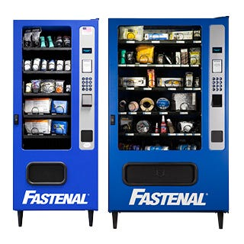
Source: Fastenal
This program, which today counts over 100,000 installed units, extended Fastenal’s transportation cost advantage by putting inventory closer to the customer - literally on the shop floor - and reducing the need for just-in-time and emergency deliveries.
Good luck to any would-be competitor trying to compete with Fastenal on delivery costs.
As an outside investor, culture can be more challenging to monitor. Every human organization has a belief system: what it stands for, how it operates, what it won’t tolerate, etc..
Management - specifically the CEO - is the standard bearer of this belief system at a corporation, and the more closely linked the company’s culture is to the economic moat, the more important it is for investors to understand it.
When I started my career at Vanguard, for example, every employee knew that the company’s founder, Jack Bogle, flew coach when he traveled. It set the cultural tone that every cost mattered if Vanguard was to deliver the lowest costs to its funds’ shareholders. If you were a middle manager, the thought of upgrading to business class wouldn’t have even crossed your mind.
Legend has it that a Costco merchandise buyer once presented co-founder and CEO Jim Sinegal with an opportunity to take a larger markup than the company’s standard 14% on some discounted jeans. Sinegal refused, saying, "I let you do it this time, you will do it again.”
Costco’s moat is rooted in the “scale economies shared” concept as labeled by investor Nick Sleep. Costco offers members a flat markup on bulk items, which in turn drives traffic and membership sales, which in turn strengthens Costco’s bargaining power with suppliers, which creates lower inventory costs, which results in better prices for Costco members, and the cycle repeats.
Sinegal’s quote set a cultural tone that at Costco short-term gains are not to be made at the expense of member trust. Otherwise, the entire system will begin to unwind and eventually fail.
Upgrade to paid

Castle walls
A great civilization is not conquered from without until it has destroyed itself from within.
– Ariel Durant
Having studied the confluence of moat and management for some time, one of the conclusions I’ve reached is that moat erosion usually starts behind the castle walls.
This might seem counterintuitive, as most research around competitive advantage evaluates external threats. We’ve all learned the classic broken moat examples like Blackberry and Kodak where technological disruption led to their undoing.
Looking beneath the surface, however, broken moat stories usually have existing internal cultural rot - complacency, departure from core values, etc. - that enabled the moat attack to be successful in the first place.
For example, in the 2010s, Time Warner had an opportunity to take on Netflix as the latter ramped up its spending on streaming video and technology. However, that would have required Time Warner to change its generous dividend and share repurchase practices and reinvest the capital. Instead, between 2015 and 2017, Time Warner returned $9.6 billion to shareholders in the form of dividends and buybacks.
Unsurprisingly, a few years earlier, Time Warner’s CEO quipped about the upstart Netflix: “It’s a little bit like, is the Albanian army going to take over the world?”
AT&T would acquire Time Warner in 2018 only to spin it back out a few years later for a fresh - and now late - attempt to battle Netflix.
To be sure, Netflix was a formidable and innovative competitor in the 2010s, but Time Warner’s cultural dismissiveness and unwillingness to change only hastened its ascendancy.
As discussed in this video post, quality traps - where quality company fundamentals deteriorate, creating a double whammy of slowing earnings growth and multiple compression - lead to impaired capital. Consequently, investors in quality businesses must always be on the lookout for signs of internal rot as it can lead to an opportunity for a successful moat attack from a competitor.

Bottom line
Thought management itself cannot be an economic moat source, management’s capital allocation decisions and cultural tone can have a material impact on the company’s economic moat.
As much as I enjoy quotes like Buffett’s “a ham sandwich could run Coca-Cola” or Peter Lynch’s “Go for a business any idiot can run - because sooner or later, any idiot is probably going to run it,” and understand what they mean (and don’t mean), no company is immune from the effects of poor allocation and cultural rot.
As you think about a company’s moat, then, pay attention to the ways in which management is supporting or undermining it.
Stay patient, stay focused.
Todd

Flyover Stocks is a reader-supported publication. To receive new posts and support my work, consider becoming a free or paid subscriber.
Upgrade to paid
Todd Wenning is the founder of KNA Capital Management, LLC, an Ohio-registered investment advisor that manages a concentrated equity strategy and provides other investment-related services.
At the time of publication, Todd, his immediate family, and/or KNA Capital Management, LLC own shares of Costco.
Please see important disclaimers.
Disclaimer:
Todd is the President and CIO of KNA Capital Management, LLC, an investment management firm based in Cincinnati, Ohio that is currently pending state registration. The information contained on this site as well as kna-capital.com is for informational purposes only and should not be considered as investment advice or as a recommendation of any particular strategy or investment product. This blog should not be considered as a solicitation for services.
This material on FlyoverStocks.com is published by W8 Group, LLC and is for informational, entertainment, and educational purposes only and is not financial advice or a solicitation to deal in any of the securities mentioned. All investments carry risks, including the risk of losing all your investment. Investors should carefully consider the risks involved before making any investment decision. Be sure to do your own due diligence before making an investment of any kind.
At time of publication, the author, his family, or KNA Capital Management clients may have an interest in the securities mentioned or discussed. Any ownership of this kind will be disclosed at the time of publication, but may not be updated if ownership of a particular security changes after publication.
This newsletter does not provide buy or sell recommendations and articles should not be interpreted this way.
Information presented may be sourced from third parties and public filings. Unless otherwise specified, any links to these sources are included for convenience only and are not endorsements, sponsorships, or recommendations of any opinions expressed or services offered by those third parties.
Flyover Stocks has partnered with Koyfin to provide a discount to Koyfin’s services for Flyover Stocks readers. The W8 Group, LLC, which publishes Flyover Stocks, may receive a commission from a reader’s purchase of products linked from this page as part of an affiliate program.

