- Animal News  September 21, 2018  Busy work!  Find out all the things we have completed, what we have in the works, what we have planned and how we will achieve them all. In this newsletter you will find information about the rescues we have already taken in, our properties, and how you can help. | 4 Hope Animal Sanctuary Newsletter  Our First!  This Newsletter will give everyone the insight into our plans, our work, and how we are accomplishing everything.  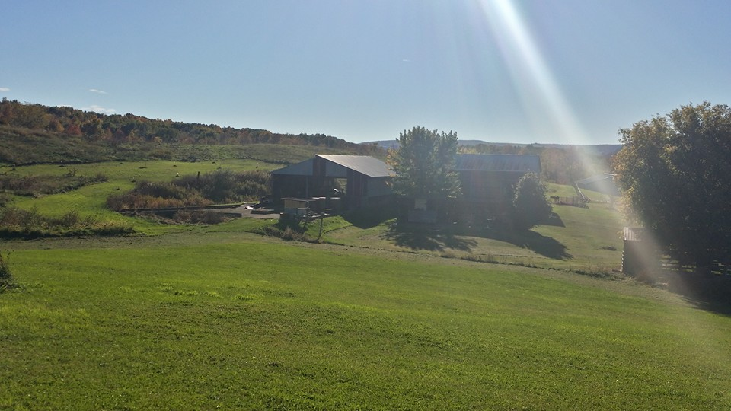  Caption Here  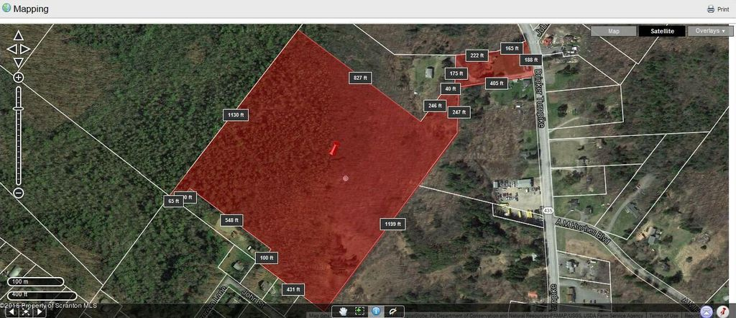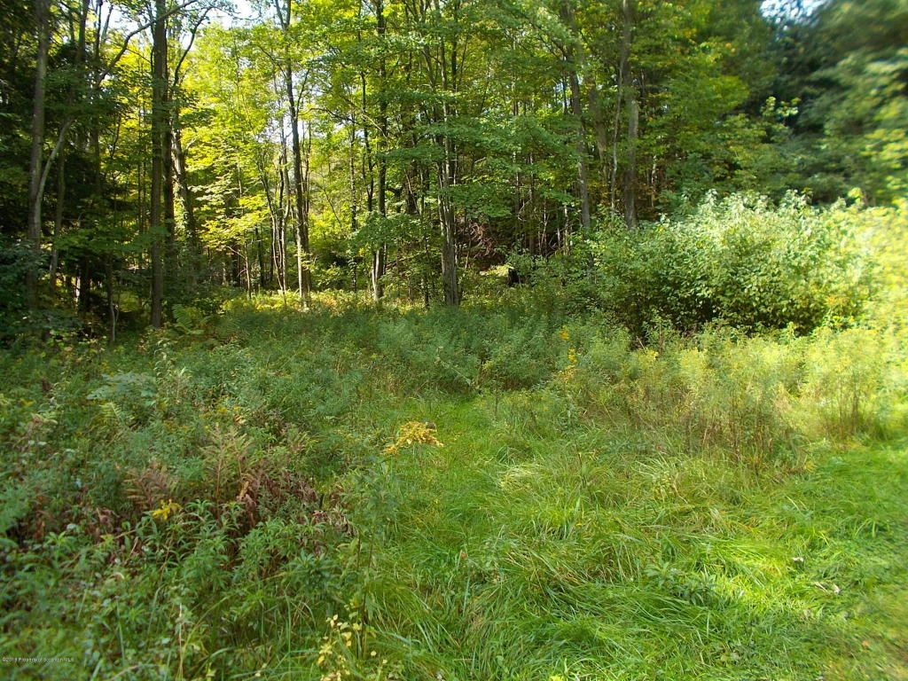  Caption Here  The first picture is from the hill looking from the side of our Dansville, NY property with two very large barns that come together to form an L shape. There are several other small buildings on the property that can be used to make a nice sized kennel with runs for dogs that are aggressive and need to be trained before placing them in the bigger area with the other dogs. The second picture is an outline of our 27.4 acres in Covington Township, PA with the third picture of the open field in the center of the land – it is mostly woods and will need to be excavated to build the sanctuary at this location. Our plan right now? Enclose and insulate both sides of the Dansville barn with the biggest area for dogs and the other for cats – large windows for cats to sit in and dogs to look out, but the dogs will have access to areas around their side of the barn out to the largest part of the 6.7 acres and will not have access to the cat area. The plan will be to excavate and build large barns on the Pennsylvania land.
- Contact Us  4 Hope Animal Sanctuary  4 Hope Drive  Covington Township, PA 18424  570-848-7276  4hopeanimalsanctuary@gmail.com  4hopeanimalsanctuary.com  1116 Lemen Road  Dansville, NY 14437 | What have we accomplished so far?  We have filed with the state of Pennsylvania to get our nonprofit organization registered. With the assistance of Legalzoom.com we have our 501c3 application all set and ready to go, however, a newsletter and brochure should accompany it, so here is our first newsletter! More will come every month after this to keep everyone informed of our plans and accomplishments.  We have opened a business bank account, received our customized checks, return labels, and business cards. We have created our website, 4hopeanimalsanctuary.com, through godaddy.com and even though we are still updating it and working on it daily, we still have plenty to do to make it look perfect. We have created a Facebook page and working to promote the page to get others to like the page, so we can get the word out.  We are continuously working on some fundraising ideas! There are so many! For now, we have the planet fundraiser application – the online portion can provide us with small donations if you go through the app to order from places like Walmart, Macy’s, Barnes and Noble to name a few. Download the app today and take a look. When choosing a charity, pick 4 Hope Animal Sanctuary. Nothing comes out of your money – the store you make a purchase from provides the donation.  I am creating a Schwann’s fundraising page and will make a blast on Facebook but will also share the page on our website so everyone that would like to participate can.  I have created a Shop with Scrip account – you can purchase gift cards and a percentage of the purchase goes to the sanctuary. I will also post information on Facebook about this and our website. Christmas is coming, and this is a great site to purchase those gift cards you give as gifts and donate to a good cause. I do have to provide a code and then you must set up an account and provide bank information. You will have to verify the bank account information before making a purchase so start early if you would like to do this. Everything is very secure – you can check it out by going to their website – shopwithscrip.com.  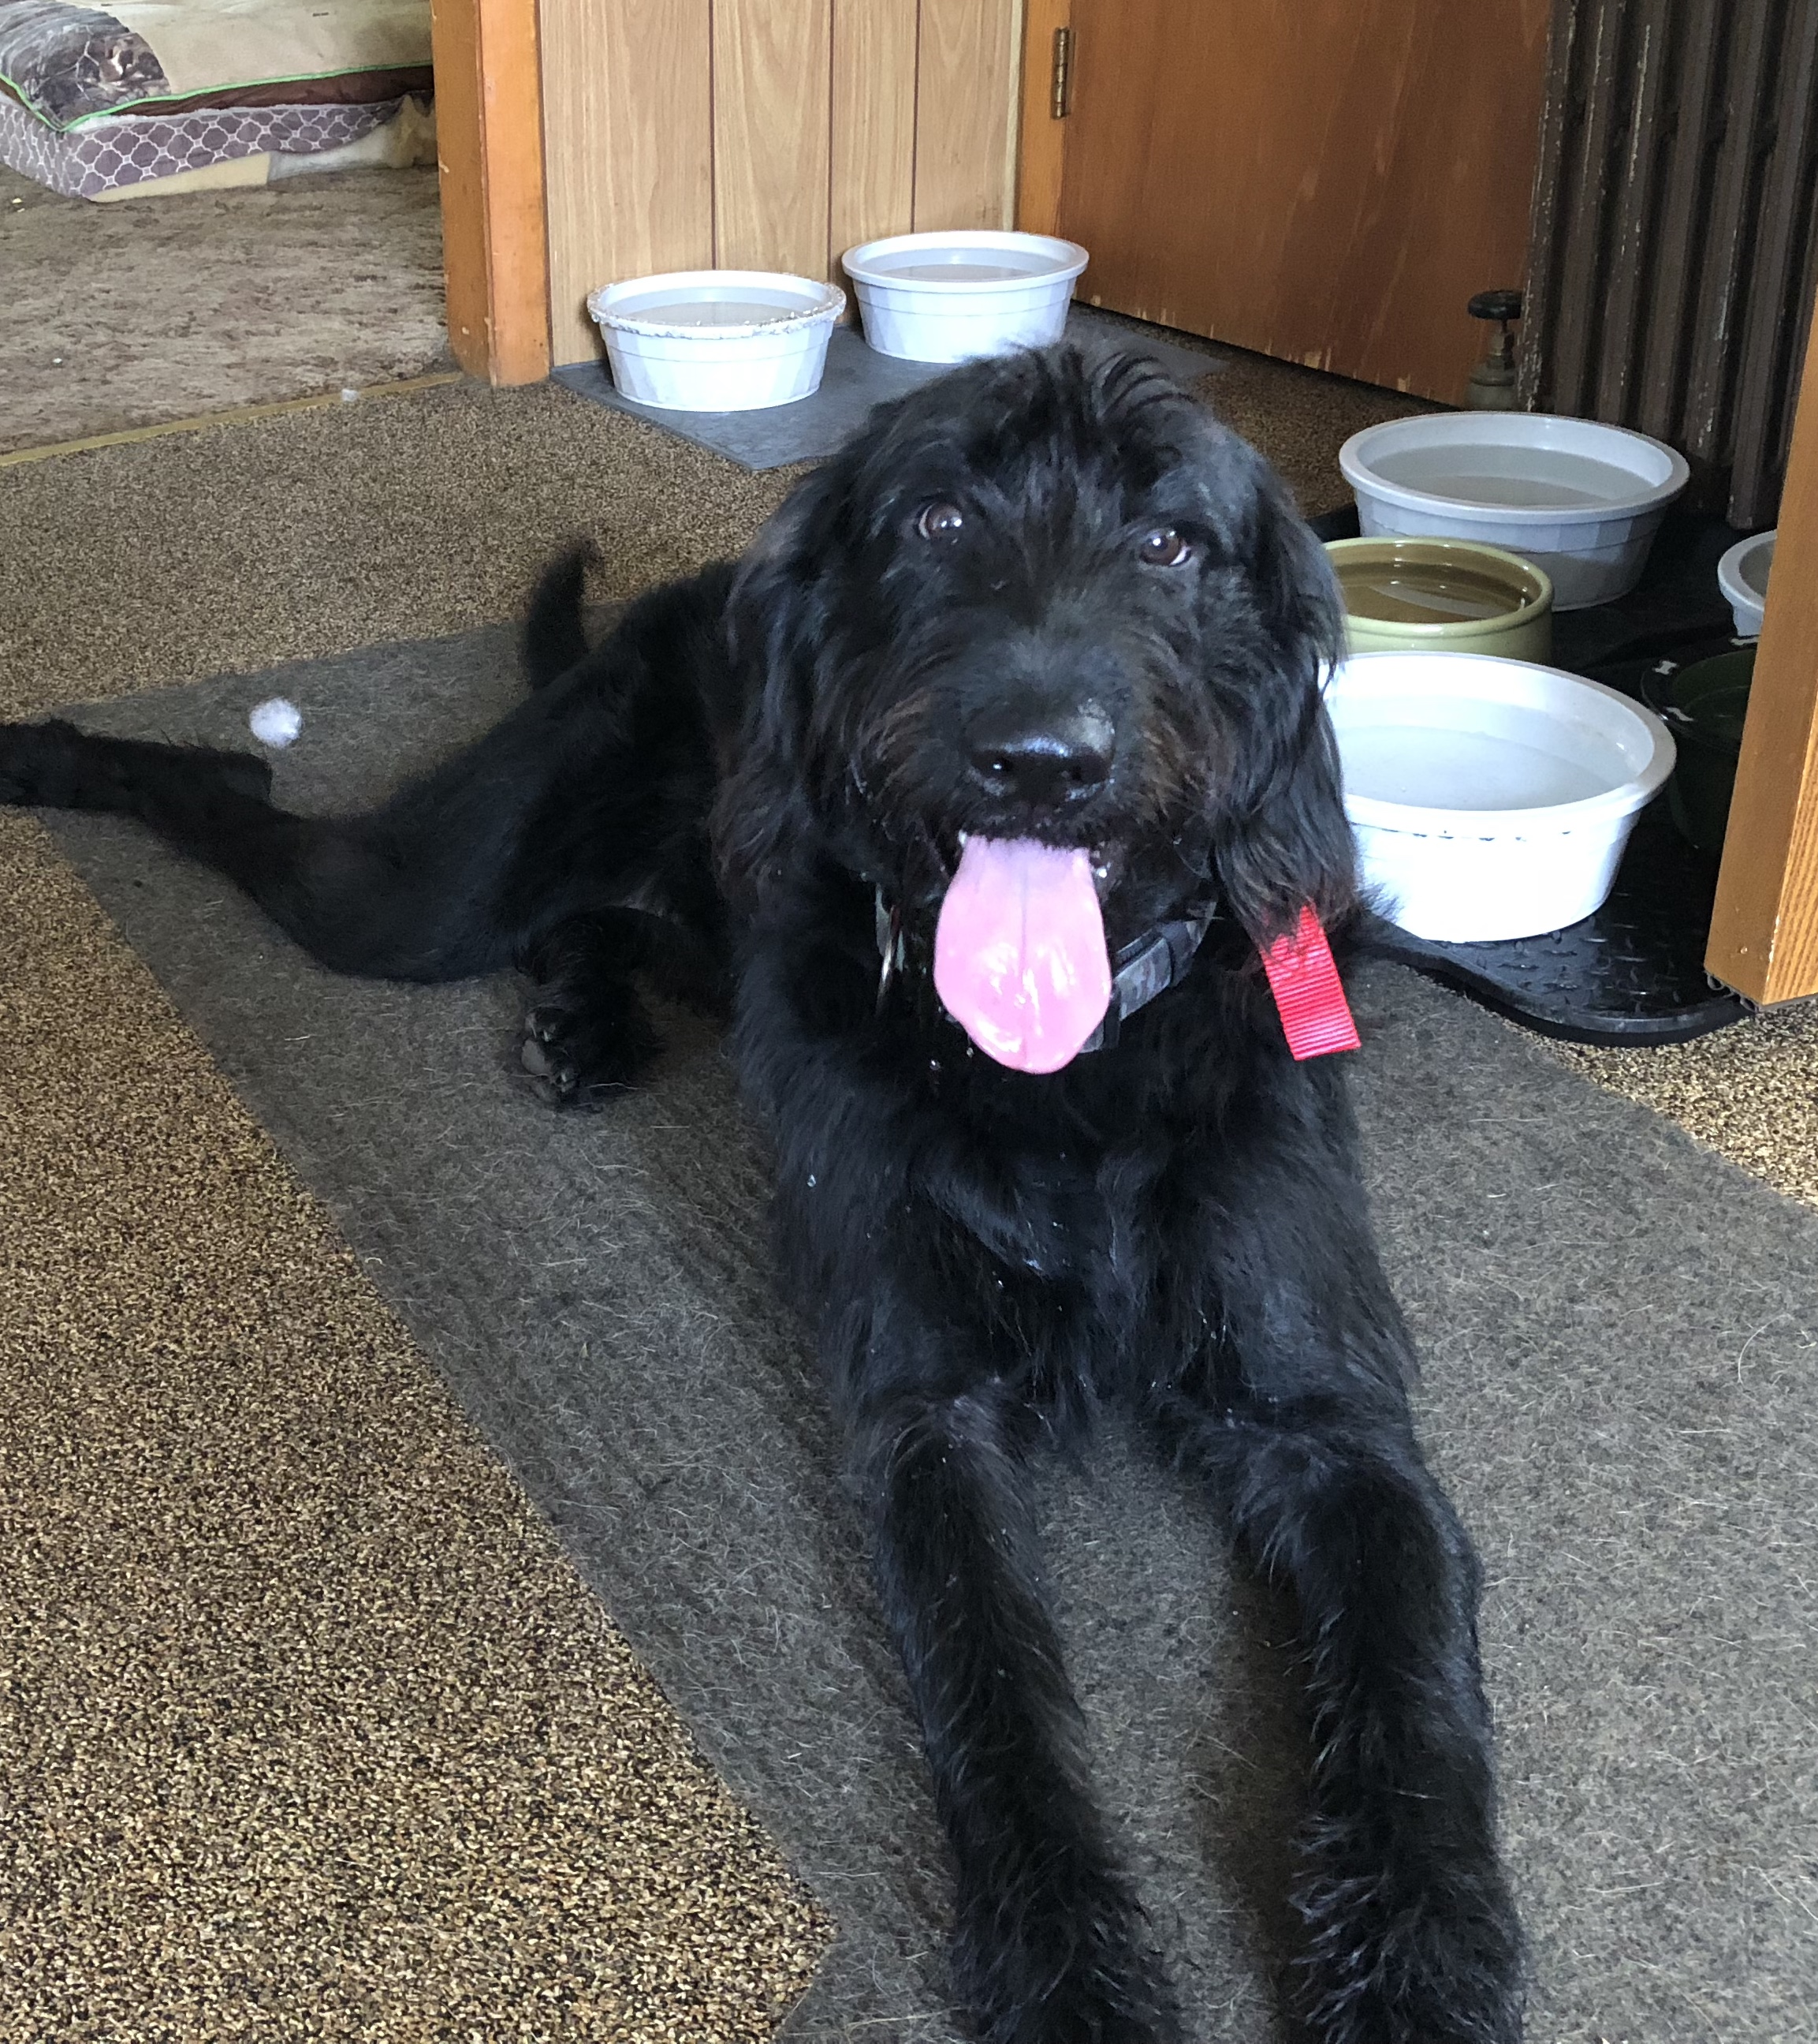  Our first surrender! Ranger!  He is 12 months old  Standard Labradoodle  Goofy, lovable, playful and so good with all the dogs he has come in contact with!  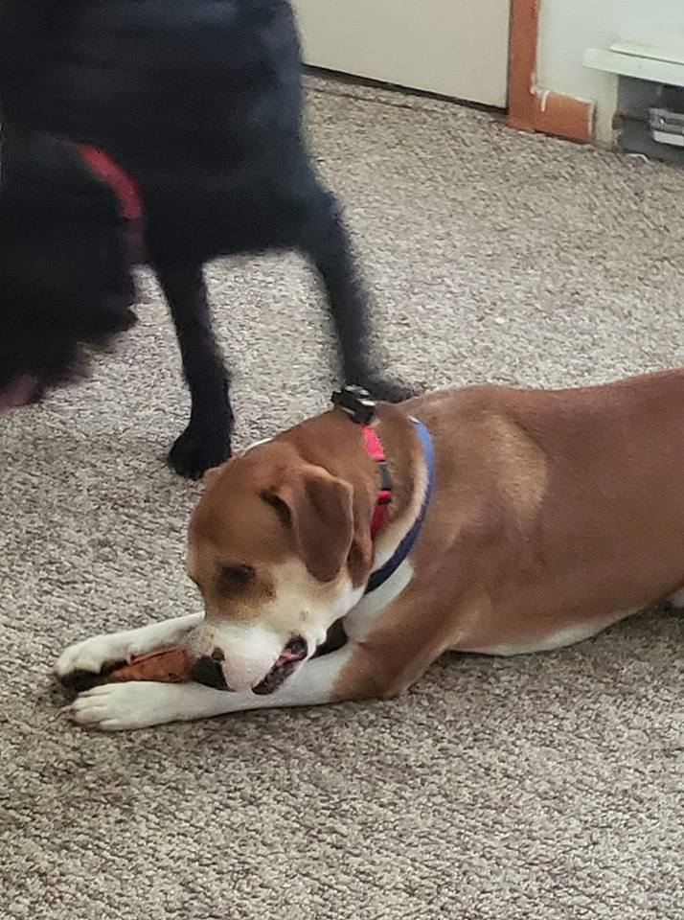  Our second surrender! Chase!  He is 3.5 years old  Mastiff/hound mix  Lovable, chill, and very good with Ranger, we are still introducing him to other dogs!!  Both dogs will need to be Neutered so hopefully we can have that done soon. Ranger did receive all his shots September 7 and the owner that surrendered Chase took him to get all vaccines, so he only needs his Lyme booster.  I am also trying to find a home for 10 cats for a very nice woman that has to move and not able to take her cats with her. If you or anyone you know might be interested, please message me through Facebook or our website.  This is Ladybug she also knowns her name very well and she will come running Ladybug knows the words come here no and down she loves to crawl in between 2 people and hog all the loving she can get ,likes to be covered ,likes fans,windows and fresh air.She likes to hang with you when you are on the computer she will lay her head down on your hand while you are typing I do believe she is 11 years old she was a stray she just got her rabies shot on 8/30/2018 She is also spayed. You can cut her nails but it takes 2 one to hold her and the other one to clip.Ladybugs likes Friskies dry and can wet she loves Temptatations cat treats She does not really like to be held Ladybugs nickname is Bugsy. Bugsy is a great fur baby.Oh you can also walk her on a cat leash she love it  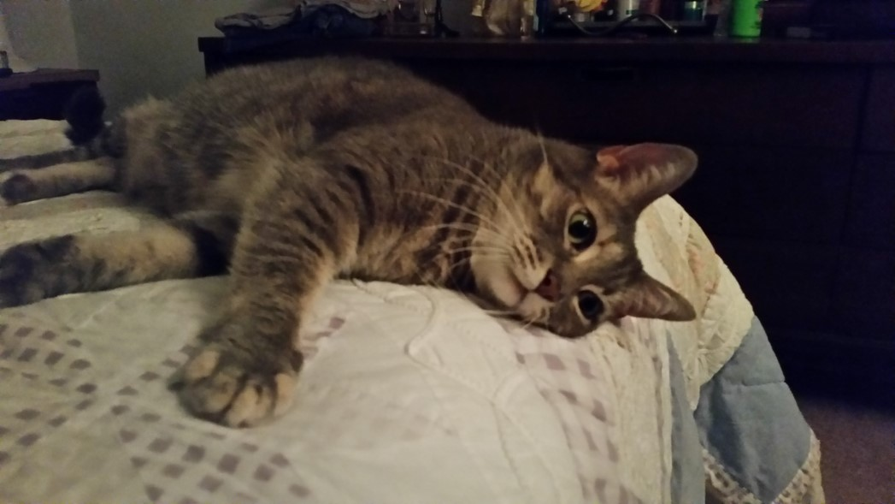  This Beggergirl also spayed female 10 years old She is a loner not a cuddler she like to do her own thing she does not like to be looked in the eyes I think it gets her nevous Beggergirl is allergic to fleas so she needs her REVOLUTION flea medication every month or she will lose her hair and get hard sores all over her body She does like to be pet but sometimes she like to lay next to your head when its time for bed  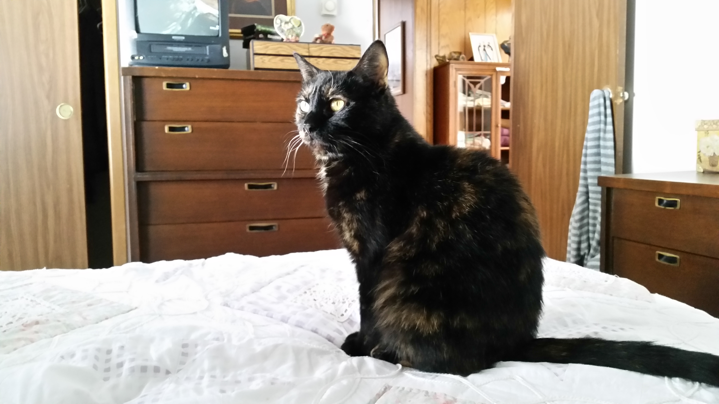  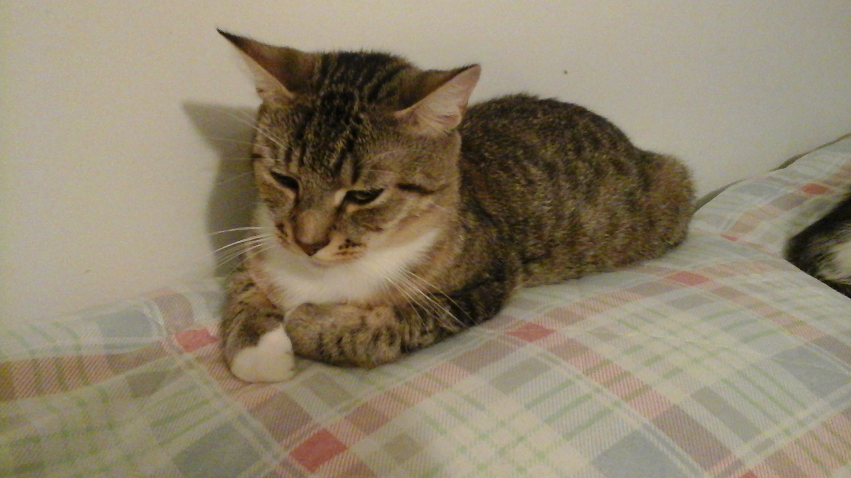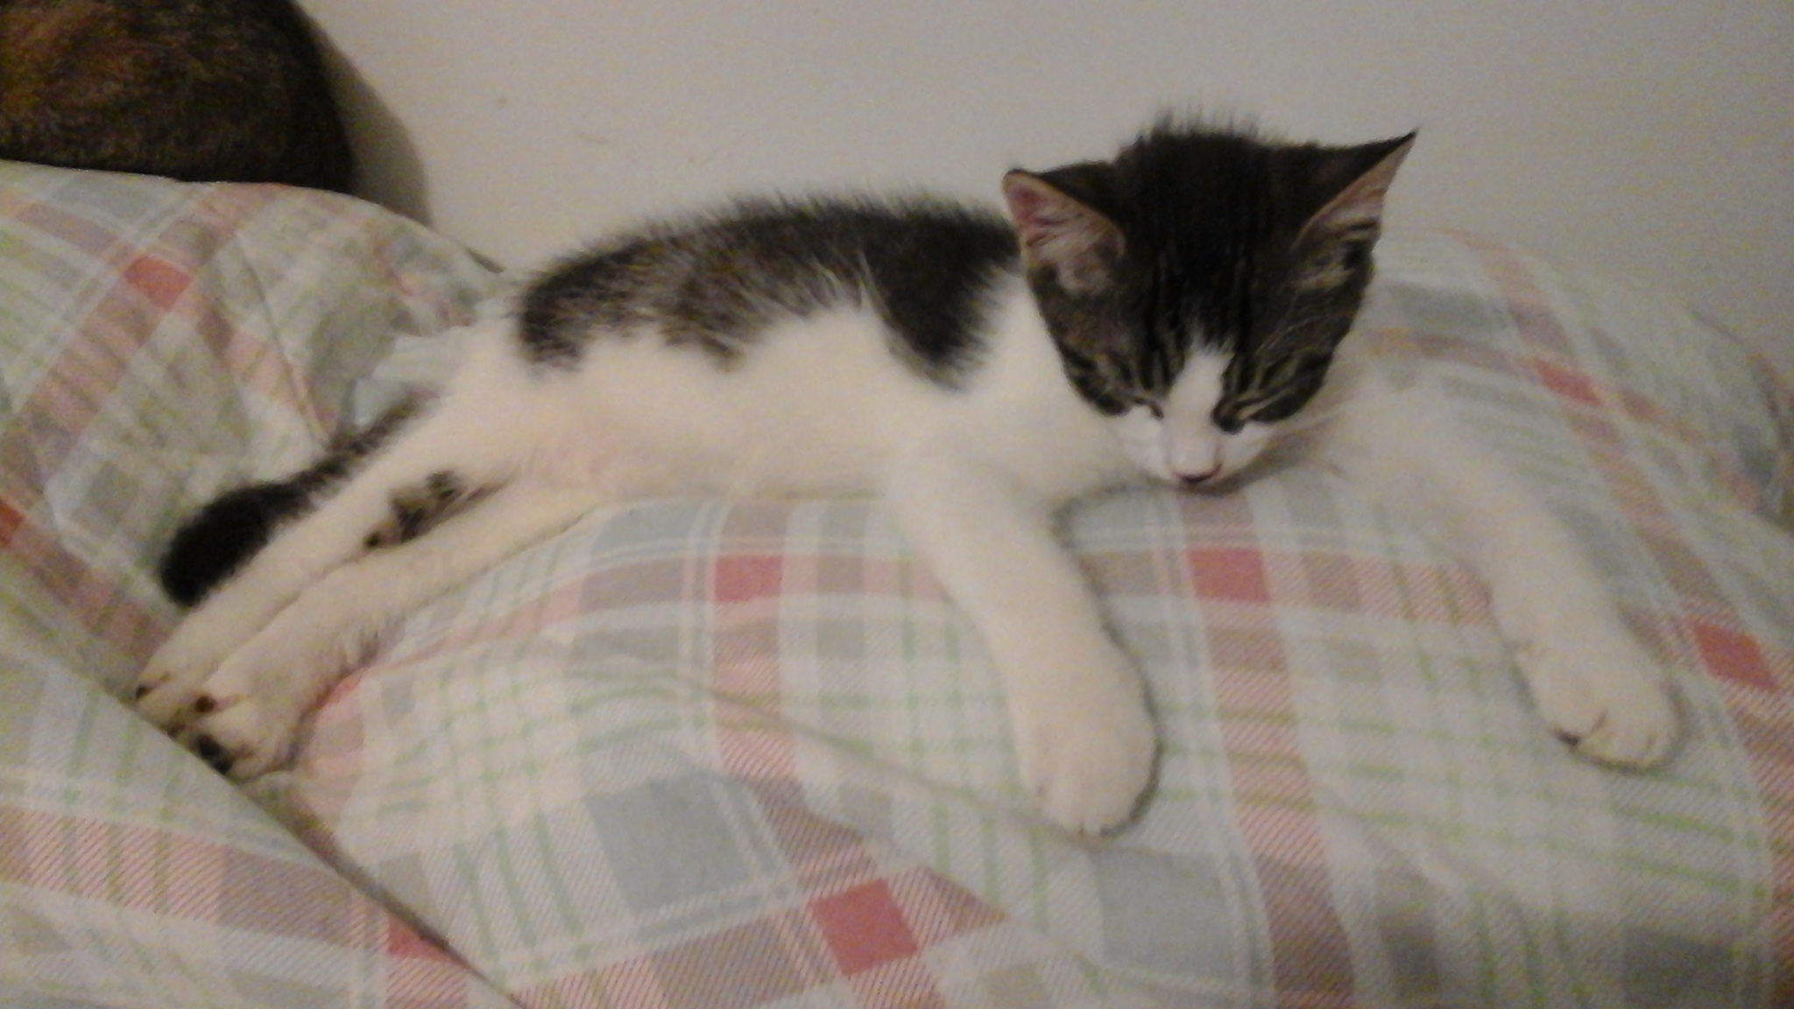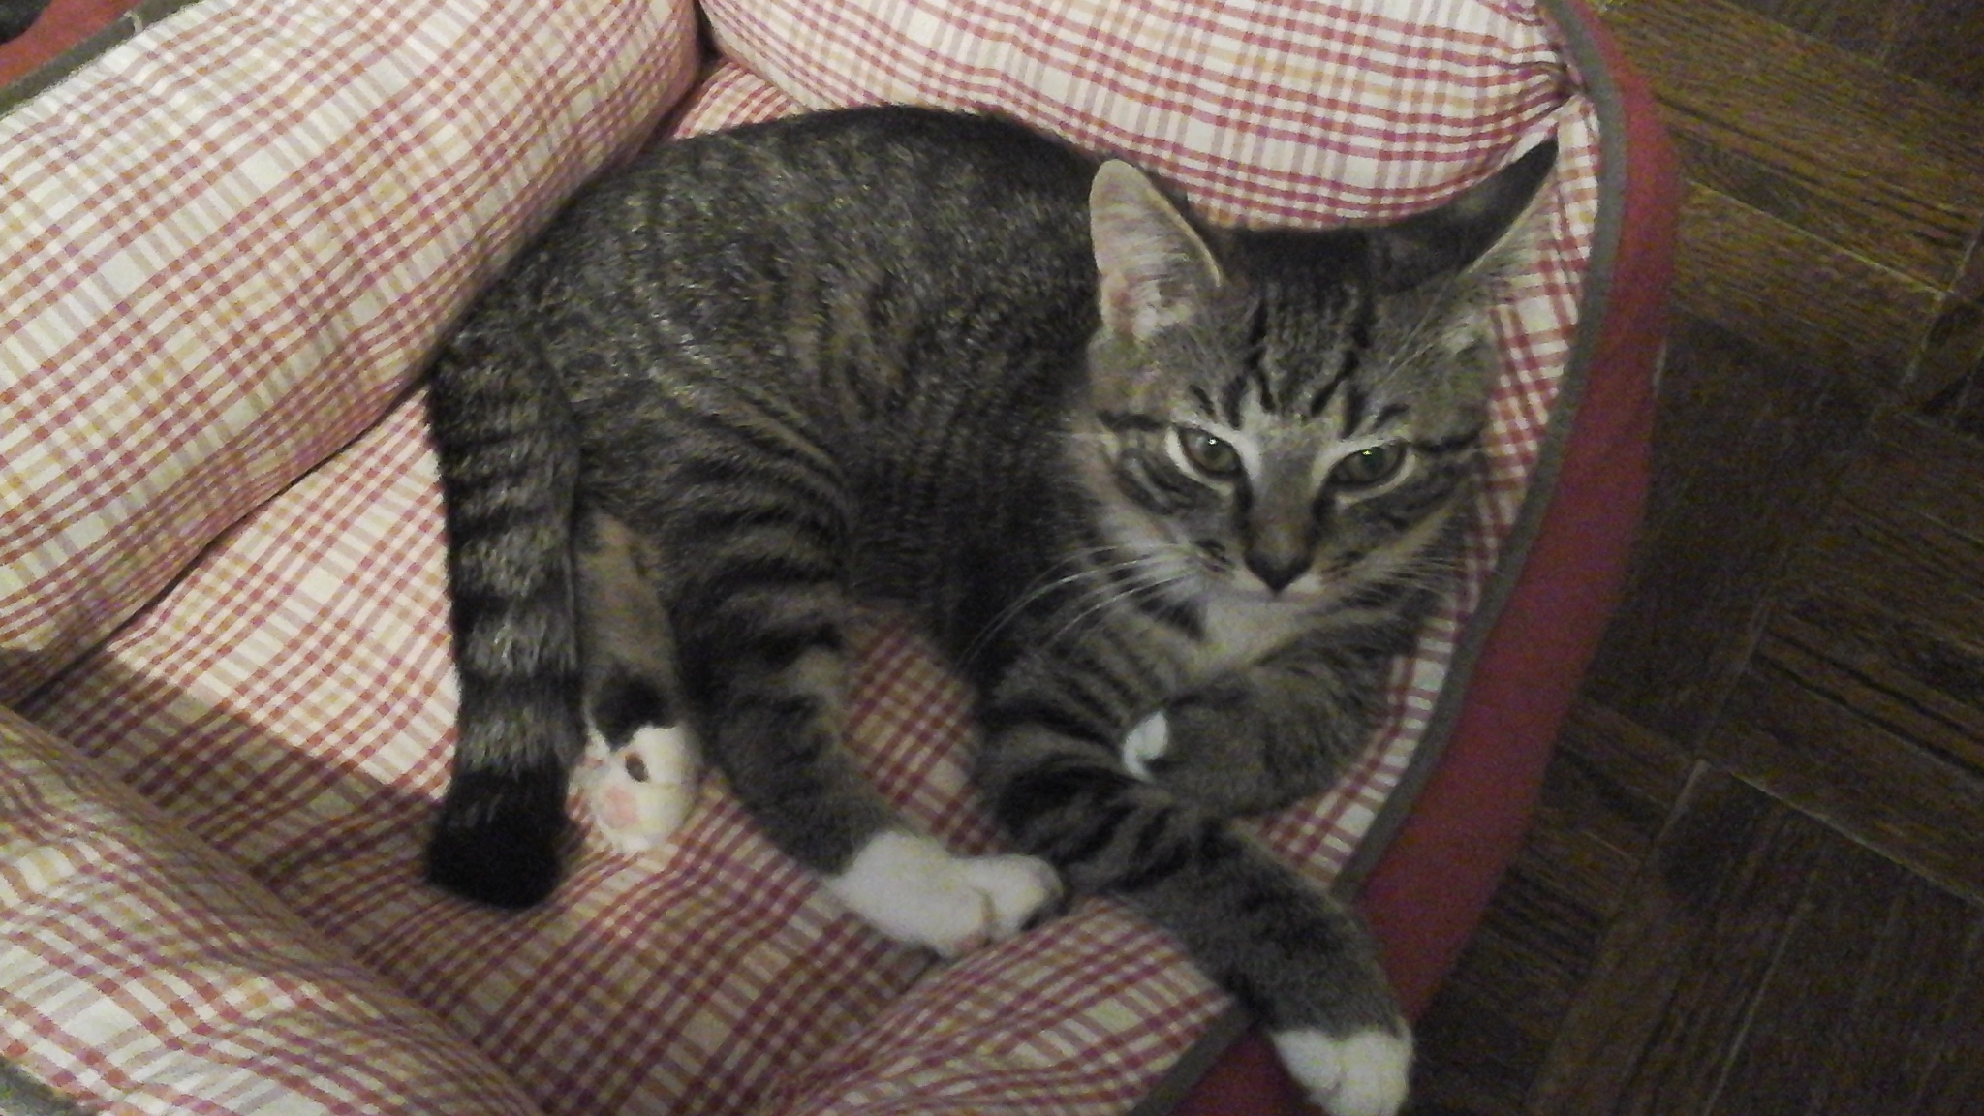  The first one is the mother 1 year and a half then Dexter white and black he is not neutered 13 weeks old last one is Suzy she is 13 weeks old and is not spayed  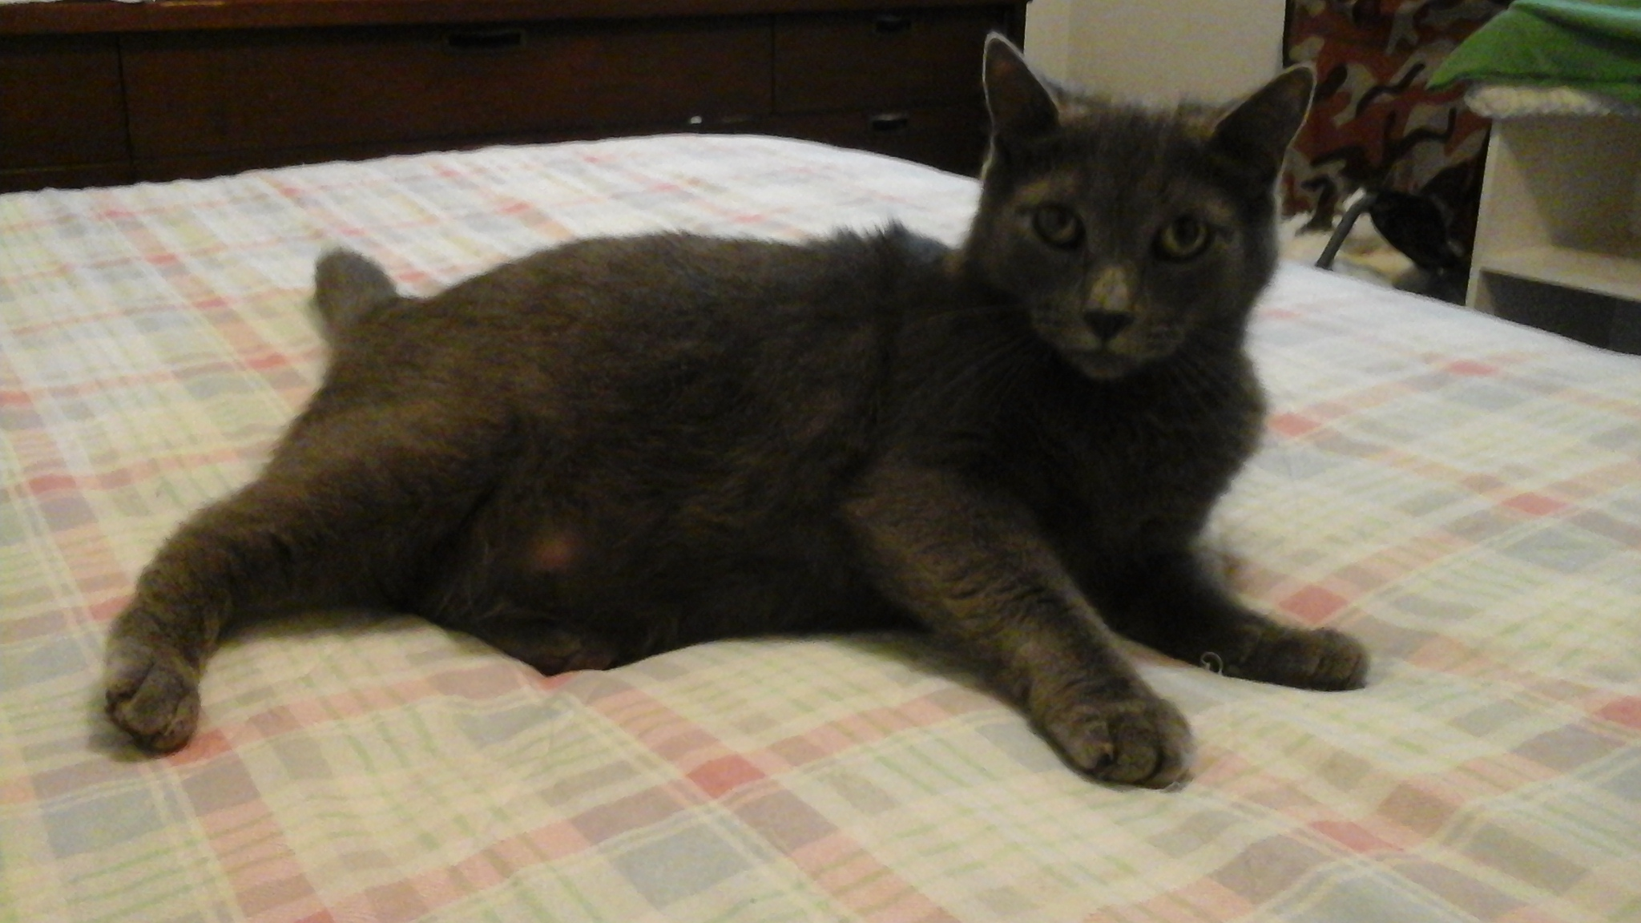  Charlie, not too sure but I think he is 7 or 8 years old he is neutered  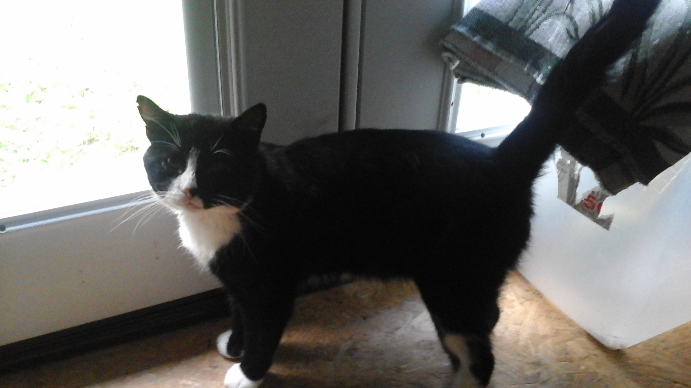  He’s is not neutered he’s a stray I have been taking care of him since he was a baby he’s 5and a half years old he comes and goes but he sleeps in my house it will take awhile for him to get used to someone else just like the rest of my cats he is very loving when he gets used to you  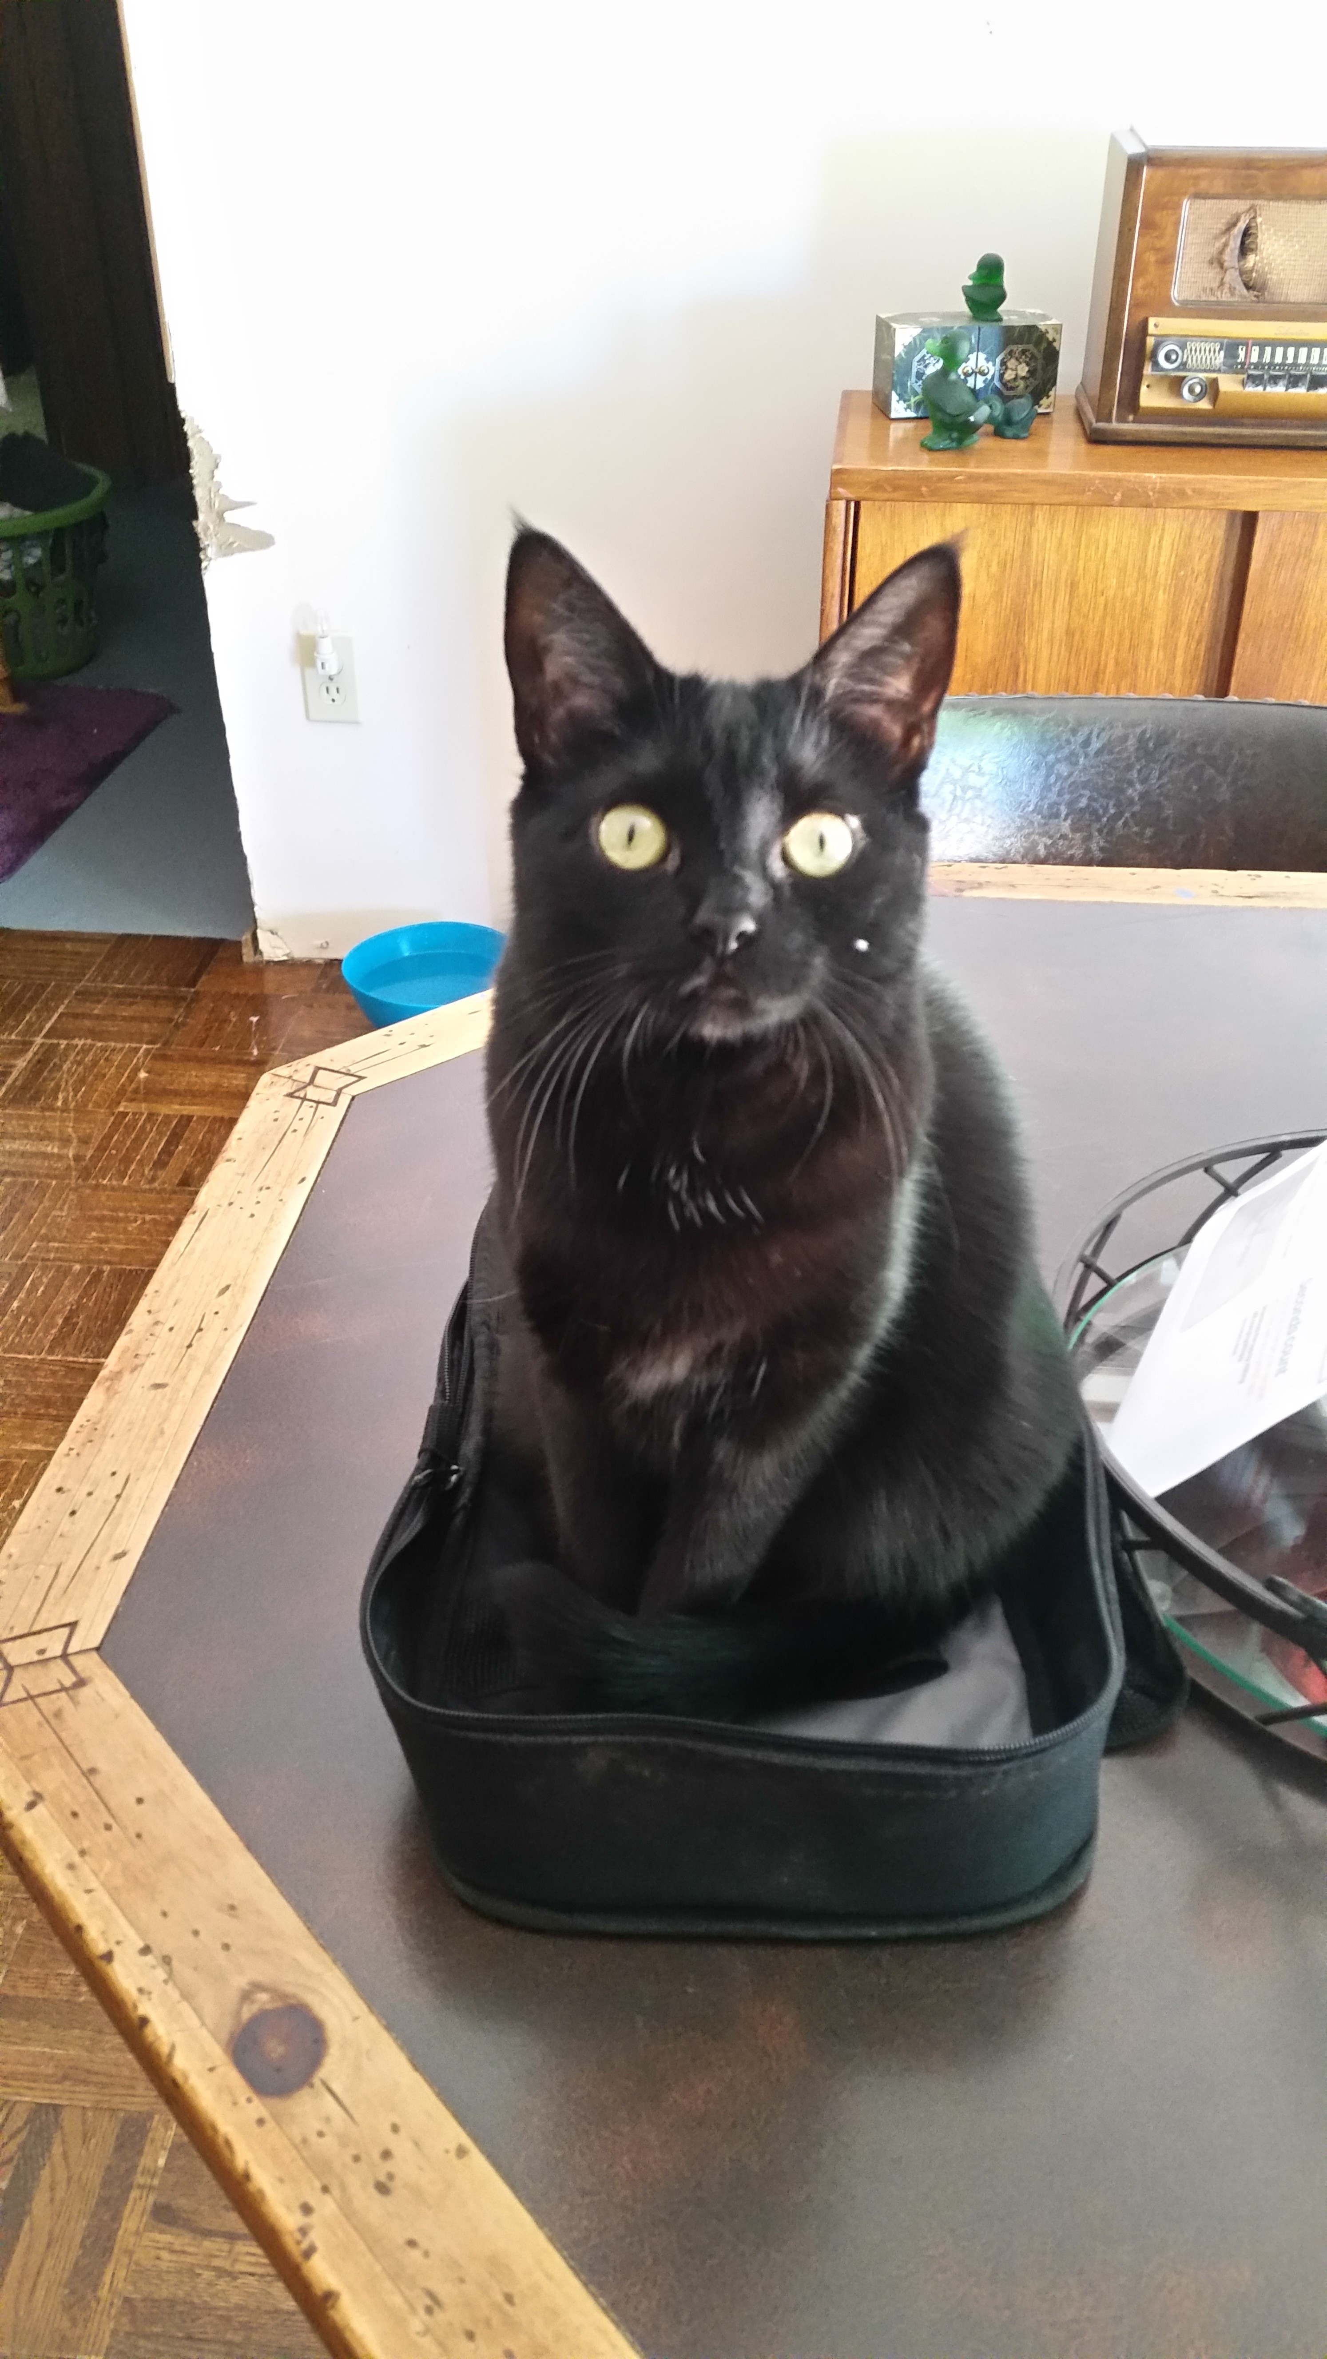  Gabby is a Black spayed female She knows her name loves treats she will eat any kind of cat food and dry She loves to cuddle up around your neck when it’s time for bed she will stay there all night until you get up she loves to gives kisses Now with Gabby she is a gobbler with her food if you give her too much she will throw up so you have to feed her a couple times a day Gabby has a big Appetite  Notes about the cats are straight from the owner – if there is not much information and you have a question about one of the cats, please do not hesitate to ask and I will find out for you.  Stay tuned for next months Newsletter! Visit our website 4hopeanimalsanctuary.com for more information or visit our Facebook page 4

