- Animal News  September 21, 2018  Busy work!  Find out all the things we have completed, in the words, what we have planned and how we will achieve them all. In this newsletter you will find information about the rescues we have already taken in, our properties, and how you can help. | 4 Hope Animal Sanctuary Newsletter  Our First!  This Newsletter will give everyone the insight into our plans, our work, and how we are accomplishing everything.  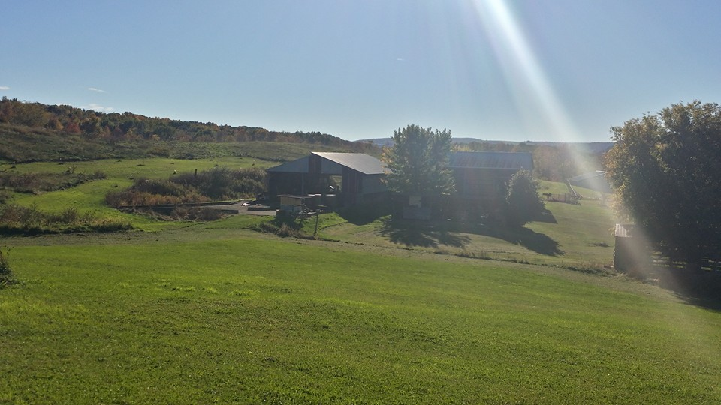  Caption Here  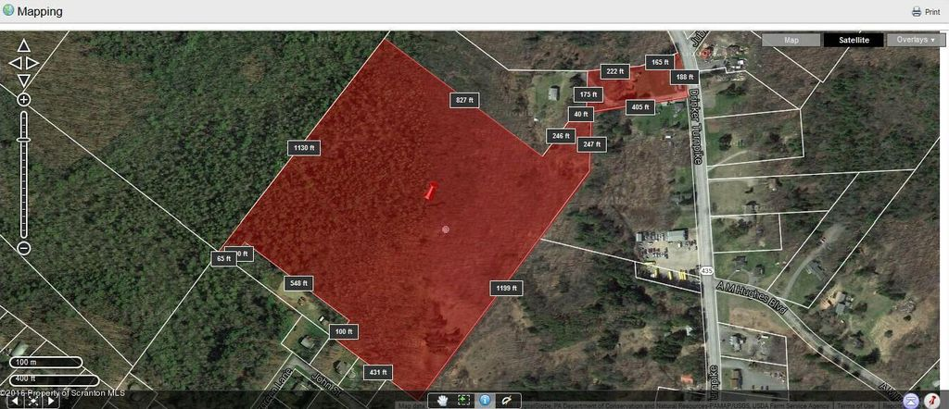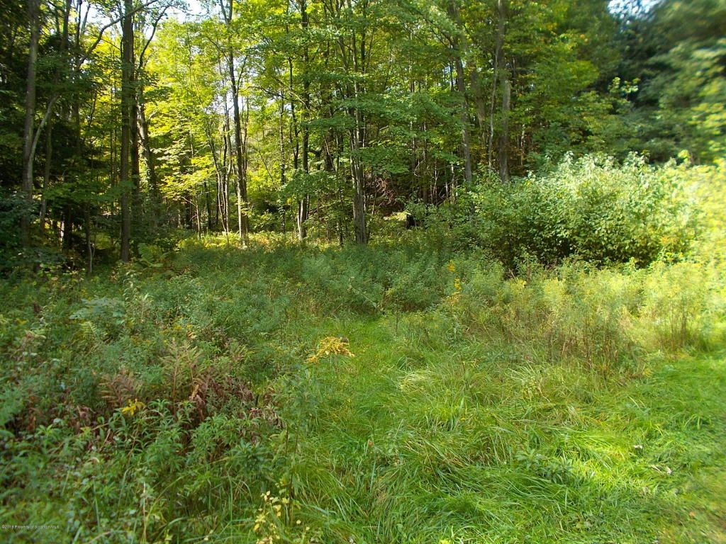  Caption Here  The first picture is from the hill looking from the side of our Dansville, NY property with two very large barns that come together to form an L shape. There are several other small buildings on the property that can be used to make a nice sized kennel with runs for dogs that are aggressive and need to be trained before placing them in the bigger area with the other dogs. The second picture is an outline of our 27.4 acres in Covington Township, PA with the third picture of the open field in the center of the land – it is mostly woods and will need to be excavated in order to build the sanctuary at this location. Our plan right now? Enclose and insulate both sides of the barn with the biggest area for dogs and the other for cats – large windows for cats to sit in and dogs to look out, but the dogs will have access to areas around their side of the barn out to the largest part of the 6.7 acres and will not have access to the cat area.
- Contact Us  4 Hope Animal Sanctuary  4 Hope Drive  Covington Township, PA 18424  570-848-7276  4hopeanimalsanctuary@gmail.com  4hopeanimalsanctuary.com  1116 Lemen Road  Dansville, NY 14437 | What have we accomplished so far?  We have filed with the state of Pennsylvania to get our nonprofit organization registered. With the assistance of Legalzoom.com we have our 501c3 application all set and ready to go, however, a newsletter and brochure should accompany it, so here is our first newsletter! More will come every month after this to keep everyone informed of our plans and accomplishments.  We have opened a business bank account, received our customized checks, return labels, and business cards. We have created our website, 4hopeanimalsanctuary.com through godaddy.com and even though we are still updating it and working on it daily, we still have plenty to do to make it look perfect. We have created a Facebook page and working to promote the page to get others to like the page so we can get the word out.  We are continuously working on some fundraising ideas! There are so many! For now, we have planet fundraiser application – the online portion can provide us with small donations if you go through the app to order from places like Walmart, Macy’s, Barnes and Noble to name a few. Download the app today and take a look and pick 4 Hope Animal Sanctuary for the nonprofit to provide a percentage to – nothing comes out of your money – the store you make a purchase from provides the donation.  I am creating a Schwann’s fundraising page and will make a blast on Facebook but will also share the page on our website so everyone that would like to participate can.  I have created a Shop with Scrip account – you can purchase gift cards and a percentage of the purchase goes to the sanctuary. I will also post information on Facebook about this and our website. Christmas is coming, and this is a great site to purchase those gift cards you give as gifts and donate to a good cause. I do have to provide a code and then you must set up an account and provide bank information – have the bank information verified before making a purchase so start early if you would like to do this.  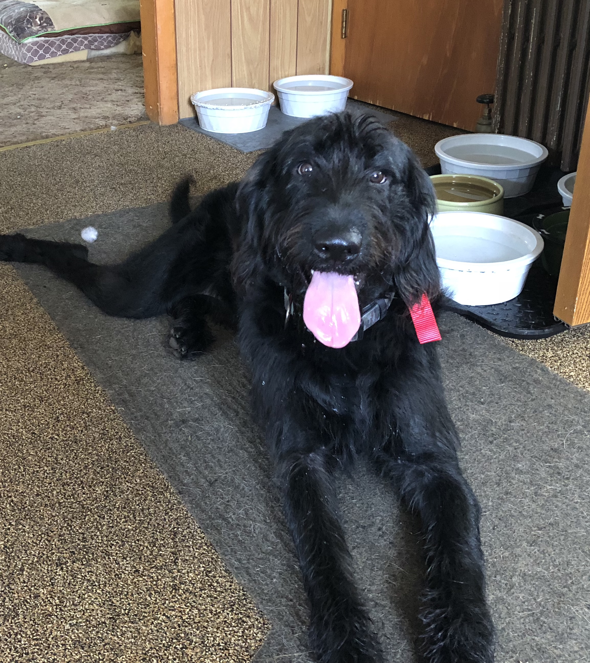  Our first surrender! Ranger!  He is 12 months old  Standard Labradoodle  Goofy, lovable, playful and so good with all the dogs he has come in contact with!  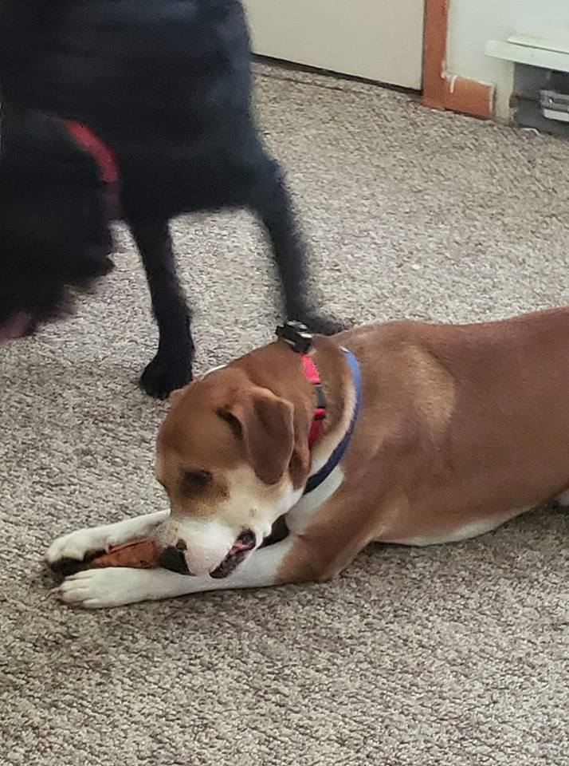  Our second surrender! Chase!  He is 3.5 years old  Mastiff/hound mix  Lovable, chill, and very good with Ranger, we are still introducing him to other dogs!!  Both dogs will need to be Neutered so hopefully we can have that done soon. Ranger did receive all his shots September 7 and the owner that surrendered Chase took him to get all vaccines, so he only needs his Lyme booster.  Stay tuned for next months Newsletter! Visit our website 4hopeanimalsanctuary.com for more information or visit our Facebook page 4

