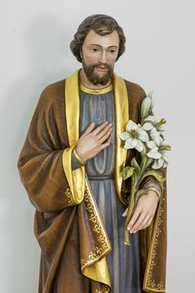
PRAYER SAINT
TO JOSEPH
MARCH 21, 2021
Pope Francis proclaims a “Year of St. Joseph”
With the Apostolic Letter “Patris corde” (With a Father’s Heart”), Pope Francis recalls the 150th anniversary of the declaration of Saint Joseph as a Patron of the Universal Church. To mark the occasion, the Holy Father has proclaimed a “Year of St. Joseph” which we will celebrate from March of 2020 to March 25, 2021, the “Annunciation of Our Lord” in our Archdiocese of Detroit.
The Holy Father wrote Patris corde against the backdrop of the Covid-19 pandemic, which he says, helped us to see more clearly the importance of “ordinary” people who through far from the limelight, exercised patience and offered hope every day. In this, they resemble Saint Joseph, “the man who goes unnoticed, a daily, discreet and hidden presence,” who nonetheless played“ an incomparable role in the history of salvation.” The Church is granting a plenary indulgence to those who ask for the year of St. Joseph.

INTRODUCTION:
We gather to celebrate and proclaim St. Joseph. His life reveals a man of many talents and virtues. Of regal lineage, Joseph experienced the common realities of his home in Nazareth. Compassionate and caring, Joseph was by trade a carpenter, and knew the creative joy of providing for his wife and child. He was a just man who lived the Jewish law and knew how to cherish a deep respect for just how the law applied to life. He was resourceful in exile, faithful to life’s duties and undoubtedly passed into eternity in the comforting care of his wife Mary and his loving Son, Jesus. May we be inspired and motivated by St. Joseph’s life and closeness to his beloved family Jesus and Mary.
THE STORY OF JOSEPH
We know St. Joseph was a carpenter, a working man. He was a beloved spouse of Mary and foster father of Jesus. For the skeptical Nazarenes, they would hear this question about his son, Jesus, “Is this not the carpenter’s son?” (Matthew 13:55). He was not a wealthy man when he took Jesus to the Temple to be circumcised and Mary to be purified. He offered the sacrifice of two turtledoves or a pair of pigeons, allowed only for those who could not afford a lamb (Luke 2:24).

Despite his humble work and means, Joseph came from royal lineage. Luke and Matthew disagree about the details of Joseph’s genealogy but they both agreed he was a descendent of David, the greatest king of Israel (Matthew 1:1-16 and Luke 3:23-38). Indeed the angel who first visited Joseph tells him about Jesus and greets him as “son of David,” a royal title used also for Jesus.
We know that Joseph was a compassionate, caring man. When he discovered Mary was pregnant after they had been betrothed, he knew the child was not his but was unaware that she was carrying the Son of God. He knew women accused of adultery could be stoned to death, so he resolved to send her away quietly so as not to expose her to shame or cruelty. When the Angel Gabriel came to Joseph in a dream, he said to him, “Joseph, son of David,
do not be afraid to take Mary home as your wife, because what is conceived of her is from the Holy Spirit. She will give birth to a son, and you are to give him the name Jesus, because he will save his people from their sins,” Joseph did as the angel told him and took Mary as his wife. (Matthew 1:19-25).
When the angel came again to tell Joseph that his family was in danger, he immediately left without hesitation everything he owned, all his family and friends, and fled to a strange country with his young wife and baby. He waited in Egypt until the angel told him it was safe to go and settle down in Nazareth. (Matthew 2:13-23)
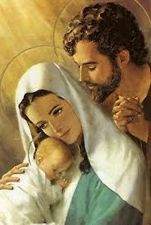
We know Joseph loved Jesus and Mary. His main concern was for the safety of this son of God entrusted to him. Not only did he leave his home to protect Jesus, but upon his return settled in the obscure town of Nazareth out of fear for the life of his family. Later on when Jesus was 12, he stayed in the Temple. We are told Joseph (along with Mary) searched with great anxiety for three days looking for him (Luke 2:48). There was great concern. We surely know that Joseph treated Jesus as his very own son. It was stated over and over by the people of Nazareth about Jesus, “Is this not the son of Joseph? (Luke 4:22)
We know that Joseph honored and worshipped God. He followed God’s commands in the way he handled many of life’s situations with Mary. One time was by going to Jerusalem to have Jesus circumcised and Mary purified after Jesus’ birth. Joseph took his family dutifully to Jerusalem every year for Passover. It was a strenuous journey back and forth with care.
Since Joseph does not appear in Jesus’ public life, at his death, or resurrection, many historians believe Joseph most likely died before Jesus entered into his public ministry.
According to the Catholic Encyclopedia, the Apocryphal Date for Joseph’s birth is 90 BC in Bethlehem and the Apocryphal Date of is death is July 20, AD 18 in Nazareth. We cannot

know this for sure.
Joseph is the Patron Saint of the dying. It seems most likely that Jesus and Mary accompanied him on his last journey to God. A gift we would all like to have and intercede for through Joseph at the time of our death.
St. Joseph is also the Patron Saint of the Universal Church, of families, fathers, expectant mothers, travelers, immigrants, house sellers and buyers, craftsmen, engineers and the working class in general. St. Joseph is the Patron of many countries Canada, China, Korea, Mexico, Austria, Belgium, Croatia, Peru, Vietnam, Syria, Sicily, many cities and dioceses and he is our special patron too.
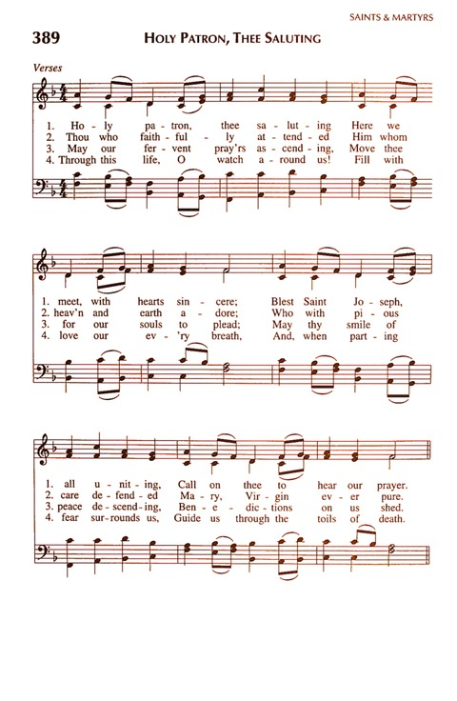
OPENING SONG:

Antiphon and Psalm121
ALL: In the hills of Nazareth, in silent and hidden ways, Joseph, spouse of Mary and Foster
Father of Jesus, fulfilled God’s plan, and grew strong in faith.

- I lift up my eyes to the hills
From whence comes my help.
My help comes from you, O God,
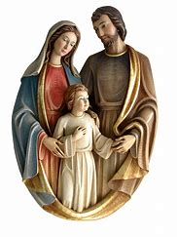
Who made heaven and earth.

2. You will not let my foot stumble,
You who preserve me, will not sleep.
Behold you who keep Israel
Will neither slumber nor sleep.

- You, O God, are our keeper.
You are our shade.
The sun shall not smite us by day,
nor the moon by night.

- You will guard us from all evil;
You will preserve our lives.
You will protect our goings and comings.
Glory to the Father and to the Son and to the Holy Spirit,
As it was in the beginning is now and will be forever. Amen

All: In the hills of Nazareth, in silent and hidden ways, Joseph, Spouse of Mary, and Foster
Father of Jesus, fulfilled God’s plan, and grew stronger in faith.

A READING FROM THE HOLY GOSPEL ACCORDING TO MATTHEW
(1:16:18-21 24 a)

Jacob was the father of Joseph, the husband of Mary. Of her was born Jesus who is called the Christ.
Now this is how the birth of Jesus Christ came about. When his mother Mary was betrothed to Joseph, but before they lived together, she was found with child through the Holy Spirit. Joseph her husband since he was righteous man, yet unwilling to expose her
to shame, decided to divorce her quietly. Such was his intention when behold, the angel
of the Lord appeared to him in a dream and said, “Joseph, son of David, do not be afraid
to take Mary your wife into your home. For it is through the Holy Spirit that this child
has been conceived in her. She will bear a son and you are to name him Jesus, because
he will save his people from their sins.” When Joseph awoke, he did as the angel of the
Lord had commanded him and took his wife into his home. THE GOSPEL OF THE LORD.

QUIET REFLECTION:

God made Joseph the trustee not only of the Blessed Virgin Mary, whose angelic purity
made her so acceptable in his eyes, but still more of his own Son, the sole object of his
delight and the unique hope of our salvation. God made St. Joseph the trustee of three
earthly sacred treasures. The first was the holy virginity of Mary, he had to preserve
inviolate under the sacred veil of marriage, the second, was the person of Jesus Christ,
whom the heavenly Father placed in his hands so he might serve as the earthly father
of the holy child and third, the secret of the mystery of the Incarnation of his Son. Wow!
God the Father shared his sacred secrets with Joseph and trusted him to keep them. How
Ominous!

INTERCESSIONS

LEADER: O God, St. Joseph was a faithful follower and dedicated to God through his care
of Jesus and Mary. He listened to the voice of God and lived his life’s call with
honor, wisdom, respect, solitude, and holiness. Let us intercede to St. Joseph for
what we need.

Leader: St. Joseph, you were called by God to protect and care for Mary and Jesus… ALL:
St. Joseph inspire and guide us.
Leader: St. Joseph, you were honest and a man of integrity and peace… ALL:
St. Joseph, inspire and guide us.
Leader: St. Joseph, you were faithful to your dream and followed the Angel’s call for Jesus
and Mary’s safety … ALL: St. Joseph inspire us and guide us.
St. Joseph, you trusted God’s will and word for your life… ALL: St. Joseph,
inspire and guide us.
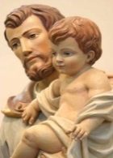
Leader: What else shall we pray for through the intercession of St. Joseph?

OUR FATHER…
LITANY OF ST. JOSEPH
RESPONSE - All: St. Joseph inspire and guide us.

St. Joseph, just one, you are a model of caring, a presence of strength,
a courageous follower and person of integrity; Response…
All: Help us to walk in your ways of holiness.

St. Joseph, you were a man of honesty and integrity; Response…
All: Help us to walk in your ways of holiness.

St. Joseph, you were faithful to the mystery of your dreams and followed God’s call; Response
All: Help us to walk in your ways of holiness.
St. Joseph, you respected the common good, empower us to be bearers of gentleness to all;
Response… All: Help us to walk in your ways of holiness.

St. Joseph, you trusted in God’s will and word for you life; Response… All: Help us to
walk in your ways of holiness.

St. Joseph, our Patron Saint, guide us in the ways of Jesus and Mary to be faithful ministers
of God’s living word and a loving presence to all those we meet; Response: Help us to walk in the ways of your holiness.

LEADER: St. Joseph had many virtues that are a blessing to us, What virtue of St. Joseph will you ask God for today and why? Now, each person, mentions a virtue. Share…

LEADER: Closing Prayer:

Oh, St. Joseph, whose protection is so great, so strong, and so prompt before the throne of God. I place in you all my interests and desires. Do assist me by your powerful intercession, and obtain for me from your divine Son all the spiritual blessings in his most Holy name. So that, having engaged her below your heavenly power, I may offer my thanksgiving and homage to you, the most loving of fathers. Amen.

PRAYER TO END THE FRATERNITY MEETING:

BLESSING:

May God bless you and keep you. Amen
May God’s face shine upon you and be gracious to you. Amen.
May God look upon us with kindness and give us peace. Amen.
May God bless you in the name of the Father and of the Son and the Holy Spirit. Amen.

