PHCT Director's Bid Form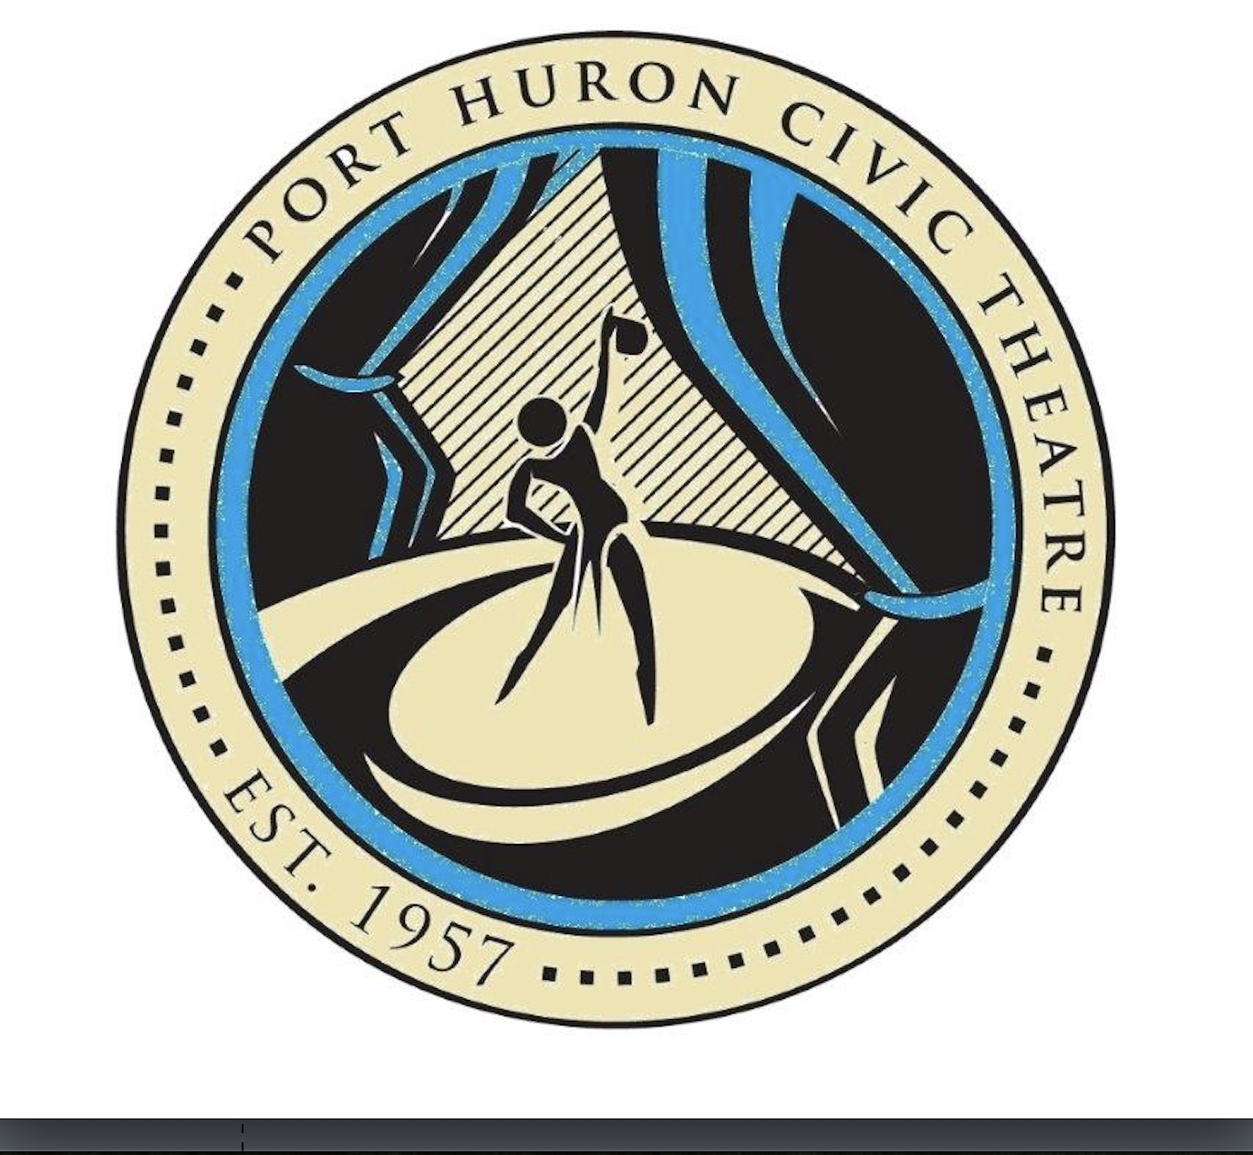 2019-2020 Season

All directors interested in directing a show for Port Huron Civic Theatre are asked to fill out all the information requested on this bid form.

Copy, attach and send by email to:  **phcivictheatre1@gmail.com**

Which show are you interested in directing?

___ Elf, The Musical, Dec. 13-15, 2019

___ Willy Wonka & The Chocolate Factory, March, 5-8, 2020

___ Joseph & The Amazing Technicolor Dreamcoat May 1-3, 2020

___ Cry Baby, August 14-16, 2020

Your name: _________________________________________

Phone Number: _____________________________________

Email address: ______________________________________

Recent directorial experience, please include where each production took place and when, each in a separate line.

Other recent theatrical experience:

Please provide 3 references. Include name & contact information.

Directorial Reference 1:

Directorial Reference 2:

Directorial Reference 3:

Production team you have available; ie, choreographer, musical director, vocal director, etc.

Preferred cast size for the desired production

Do you have a plan for sets and props? If so, please briefly detail them.

What days and times do you plan to schedule rehearsals?

Why would you like to partner with Port Huron Civic Theatre for this production?