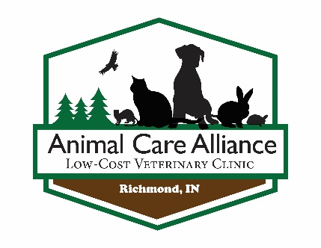

EMERGENCY RESCUE CARE:
1. ~NEVER~ feed an orphaned or injured animal without consulting with an animal care professional!
Many times people, who have the animals best interest at heart, unknowingly cause more hurt than help.
*Feeding a cold orphaned animal can be deadly to the animal!

2. Always warm an orphaned or injured animal immediately!
One of the leading causes of death for an orphaned or injured animal is hypothermia.
*Heat, like they would get from close proximity to the mother, is the primary care need for orphaned creatures. Many have core body temperatures higher than a normal human body temperature. (Kittens are 101.5 F.)

3. CALL FOR HELP!
There are professionals available to help you, call them!
Additionally, you can contact a staff member of Animal Care Alliance via our Facebook page.
Giving the wrong type of nutritional or medical care to an orphaned or injured animal may cause more harm.
*Giving the wrong care, despite many opinions otherwise, IS NOT better than no care.

