NAME:_____________________________________________PREFERRED NAME:________________________________ EMAIL:______________________________________________________________________________________________
MOBILE PHONE:______________________________________________________________________________________
DATE OF BIRTH:________________________________OCCUPATION:______________________________________
HOW DID YOU HEAR ABOUT US? ______________________________________________________________________
HOW WOULD YOU LIKE TO RECEIVE APPOINTMENT CONFIRMATIONS? EMAILS TEXTS BOTH
WOULD YOU LIKE TO RECEIVE EMAILS REGARDING MONTHLY SPECIALS? YES NO

EMERGENCY CONTACT:_______________________________________________________________________________
PHONE:___________________________________RELATIONSHIP:____________________________________________
PREFERRED THERAPIST/GENDER:______________________________________________________________________

ARE YOU CURRENTLY PREGNANT? ______________DOCTOR ______________________________________________
MEDICAL CONDITIONS/SURGERY/MEDICATIONS/ALLERGIES:_____________________________________________
____________________________________________________________________________________________________
____________________________________________________________________________________________________
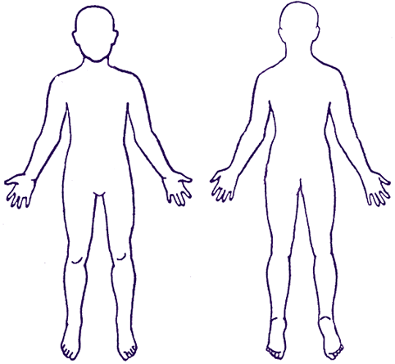
PLEASE CIRCLE ON THE DIAGRAM ANY AREAS WHERE YOU ARE FEELING PAIN, TENSION, DISCOMFORT, OR PRIOR SURGERY.
OTHER COMMENTS: ________________________________________________________________________________________________________________________
I have completed this intake and consent form to the best of my knowledge. By signing below, I hereby certify that the information provided is correct. I understand that massage therapy and bodywork is a health aid and does not substitute for medical care. I will inform the center and the therapist of any special needs, medical conditions, or changes in my health. Any and all information exchanged during treatment is confidential and is only used to provide the best treatment possible. If I am having or develop any complications during my service, I will promptly discuss this with my therapist. I hereby voluntarily release Renew Wellness Center, Central Florida Massage Clinics and the independent contractor for service from any liability or complications that may occur. By signing below, I agree that I have read the information above and have decided to receive services at my own risk.

CLIENT SIGNATURE______________________________________DATE__________________________________

