KOSINSKI FARMS
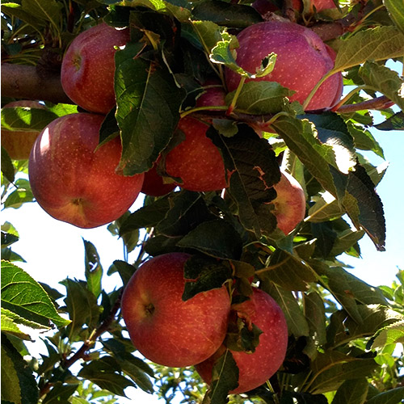
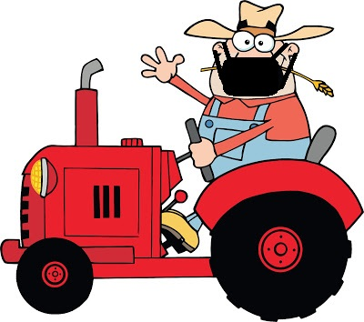
336/420 Russellville Road
Westfield, MA 01085
LIABILITY WAIVER +
Acknowledgement of Guidelines
NAME: ______________________________________ AGE: ____________
ADDRESS:___________________________________________________________________
CITY/STATE: ________________________________________________________ ZIP:
HOME PHONE: _________________________________________
ACKNOWLEDGEMENT OF RISK
I, _____________________________________, acknowledge that I understand that this is a working farm, with the attending inherent risks, and hereby indemnify and hold harmless, Kosinski Farms / Kosinskis Farm Stand, and its employees or owners from any liability arising from accident, injury, theft, or damages to myself and my party. All visitors under the age of 18 must be accompanied by an adult over the age of 21 and be listed as guests below along with all other visitors in the participant’s party. This agreement shall cover this visit to the farm’s property on ____________________, 2021.
In addition I, ____________________ have been advise of the guidelines set forth by this farm as defined by the MDAR and understand that I and my party will be asked to leave the event without reimbursement of event cost upon non-compliance of the guidelines.
Date: _________ Signed: _________________________________________
Participant
Names of everyone in participant’s party
Adults – 18 years + older | Children – under the age of 18

