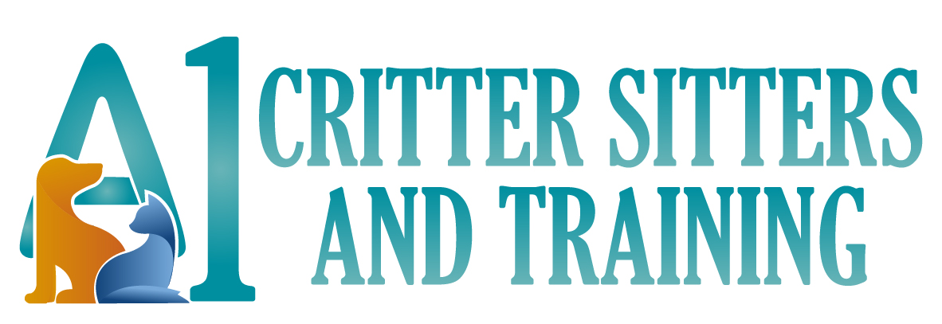

Resource Guarding Questionnaire

Please complete the New Client Intake Form in addition to this form. This questionnaire will help me better understand your dog, your situation, and develop a behavior modification program that will improve your dog’s behavior.

Overview
Before you acquired your dog, did he/she have a history of resource guarding or any kind of aggressive tendencies? __________________________________________________________________________
Age of your dog when behavior began: ________________________________
Why does this behavior concern you enough to contact a dog trainer? __________________________________________________________________________________________________________________________________________________________________________

Has your dog ever attended any kind of dog day care? If so, which one? _____________________________________________________________________________________
Has your dog ever seen another trainer for this behavior? If so, who? _____________________________________________________________________________________

Are any members of your household concerned about this behavior? _____________________________________________________________________________________
Are any members of your household expecting to bring home a new baby or new dog anytime in the next 12 months? _____________________________________________________________________________________

Attempted Solutions
What have you tried to change your dog’s behavior? _______________________________________________________________________________________________________________________________________________________________________________________________________________________________________________________________

Behavior Assessment
Check off which behaviors your dog has displayed while guarding food or an object from a person or another animal:
- Stiffness throughout his body while hovering over the object in his possession
- Stillness while staring at you, your hand, or the object in his possession
- Trying to gulp down the food or toy in his possession
- Low rumbling growl
- Moving the object away from you
- Exposing teeth and/or snarling
- Snapping at you or another dog
- Touched your skin with his/her teeth
- Bite with light bruising
- Bite with tearing of the skin
- Bite with puncture
- Multiple bites
Has your dog ever bitten another dog while resource guarding? ⬜ Yes ⬜ No
Has your dog ever bitten a person while resource guarding? ⬜ Yes ⬜ No
At what distance does your dog typically start guarding something? _____________________________________________________________________________________
What actions typically worsen your dog’s guarding behavior? __________________________________________________________________________________________________________________________________________________________________________

Type of Resource Guarding
What kinds of food does your dog guard? _____________________________________________________________________________________
What kinds of toys does your dog guard? _____________________________________________________________________________________
What kinds of clothing does your dog guard? _____________________________________________________________________________________
What kinds of places or furniture does your dog guard? _____________________________________________________________________________________
Other situations or objects your dog guards: _____________________________________________________________________________________

