The Kelly


Children's Home
NEWSLETTER
October 2022 I www.thekellychildrenshome.org I 300 E.10th Street, Washington NC 27889

Join Us at The Kelly Children's Home Second Annual Charity Gala!
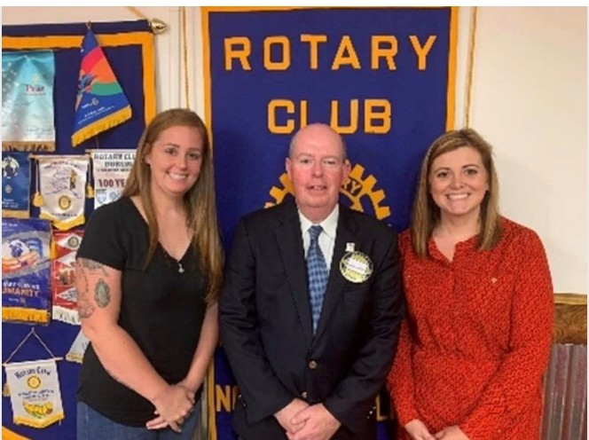

loin our lorqest event of the LJe□r.brinqinq toqether our dedieoted supporters from Woshinqton, NC and be4ond for□niqht of entertainment and connection. You will enjoLJ
□ three-course seated dinner, live music bLJ our loeol favorite, The Eli Croiq Bond, excitinq live and silent auctions. a 50/50 eosh raffle, and more! The event is Soturd□LJ, December

A Special Thanks to
Washington's Noon Rotary!
Ldst month. the Wdshinqton Noon Rotdn-J Club invited us to spedk dbout The KellLJ Children's Home. Ourinq this meetinq, founder Alexis KellLJ [pictured riqht of Club President 0[ Loope]. dnd office mdndqer, Ashlee WhitleLJ [pictured fdr left] spoke dbout the journeLJ thdt brouqht The KellLJSto this mission. Alexis dlso shdred stdtistics reqdrdinq homeless teens dnd teens in
3rd. at The Woshinqton Yacht b Countr4 Club

Our theme this 4eor is Alice in Wonderland! Come in 4our best cocktail, semi- or form□l
□ttire, or feel free to dress the theme! We hope LJOU will join us for this celebratorLJ niqht to recoqnize the importance of supportinq our children in need and how 4ou ore mokinq
□ difference in our communit4!

We ore seekinq donations for our silent and live auctions and event sponsors! lf LJOU or 4our orqonizotion are interested in donotinq or sponsorinq, please contact oshlee©Jthekell4childrenshome.orq Remember. all donations ore tax-deductible!
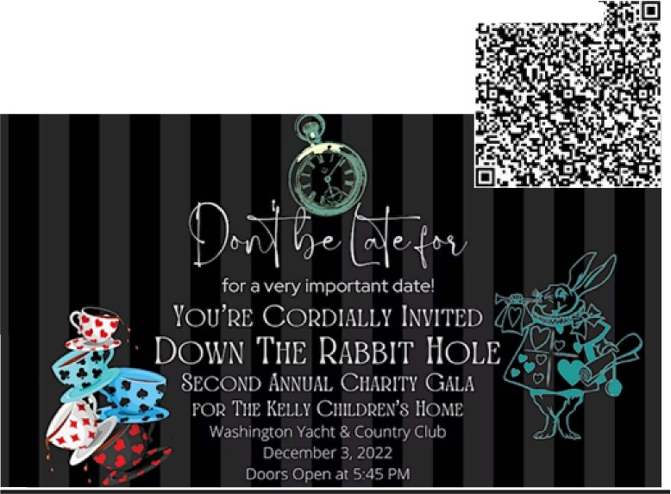
r::il I ' ... • '

foster rnre, dn upddte on their renovdtion proqress. dnd the deldLJStheLJ dre fdcinq in reledsinq qrdnt fundinq Despite the deldLJS. The KellLJ Children's Home dlso shdred how theLJ continue providinq support dnd rnre
to displdced children lornllLJ. The meetinq room dt Kinq Chicken WdS d full house, dnd so mdnLJ comrTIJnitLJ members were excited to hedr of the proqress 8 ledrn of WdlJStheLJ could qet involved A biq thdnks to Kinq Chicken ford delicious lunch! The RotdrLJ meets dt noon everLJ MonddLJ dt Kinq Chicken lf LJOU dre interested in JOininq RotdrLJ, LJOU rnn ledrn more dt wdshinqtonnoonrotdrL..Jorq
To purchase tickets, seon the QR code or visit our website! We look forward to seeinq 4ou at this spectacular eveninq!
1:11 , • -• •,a:..:

Missed our last newsletter?
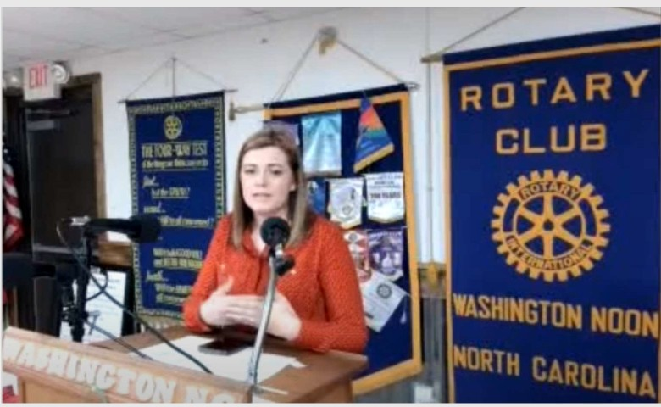

Check it out at wwww.thekellychildrenshome.org/in-the-news

