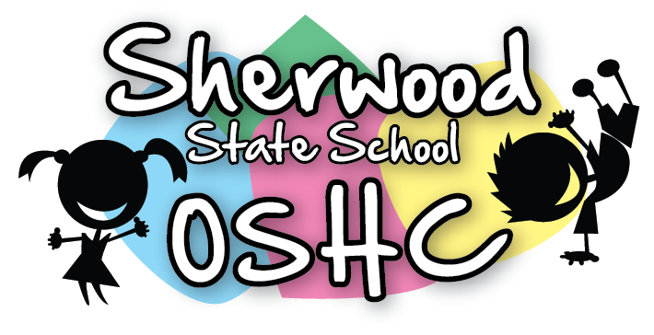
Afternoon Menu

Monday | Tuesday | Wednesday | Thursday | Friday
29/4/19 | 30/4/19 | 1/5/19 | 2/5/19 | 3/5/19
- Honey & vegemite Sandwiches  - Mixed Crackers with carrot sticks & Tzatziki dip  (Suggested by P.S) | - Wraps with Tuna, Lettuce, Tomatoes & Cheese  - Multi grain vita-weat  (Suggested by C.M & P.S) | - Make your own sandwich with Ham, tomatoes, coleslaw & Cheese (Shredded)  - Sesame corn Thins | - Chicken & Cheese sandwiches  - Yoghurt & Museli  (Suggested by C.B) | - Cream Cheese & Honey sandwiches  - Delites with cucumber sticks & Sour cream
Vegetarian (V)/Gluten free (G)/ Dairy free(D)
(G) Gluten free bread  (D) No Tzatziki Dip | (G) Gluten free Wraps  (V) Beans –No Tuna | (G) Gluten free bread  (V) vegetarian Sausages  (D) Only Ham, No cheese Sandwiches | (G) Gluten free bread  (V) Honey Sandwiches  (D) Popcorn | (G) Gluten free bread  (D) No Sour Cream
A selection of seasonal fruit and vegetables offered everyday – See Seasonal Fruit and Vegetable List for more details

Please Note: Always check the packaging for the dairy, soy, gelatine, gluten, nuts or sesame seeds before serving food and be aware of the children with food allergies

