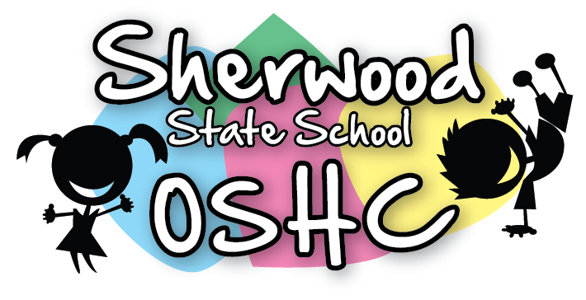
Afternoon Menu

Monday | Tuesday | Wednesday | Thursday | Friday
6/5/19 | 7/5/19 | 8/5/19 | 9/5/19 | 10/5/19
LABOUR DAY | - Honey & vegemite sandwiches  - Nachos with Salsa & Cheese(shredded  (Suggested by S.W) | - Bean Salsa with cheese & Bread  - Vanilla yoghurt & Fruits  (Suggested by M.M) | - Make your own sandwich with Ham, tomatoes,4 leaf salad & Cheese (Shredded)  - Seaweed Crackers  (Suggested by E.H) | - Butter & Honey sandwiches  - Salada with carrot & Cucumber sticks & Cheese
Vegetarian (V)/Gluten free (G)/ Dairy free(D)
 | (G) Gluten free bread | (G) Gluten free bread  (D) Popcorn | (G) Gluten free bread  (V) Vegetarian Sausages  (D) Only Ham,  No cheese Sandwiches | (G) Gluten free bread  (D) Honey Sandwich
A selection of seasonal fruit and vegetables offered everyday – See Seasonal Fruit and Vegetable List for more details

Please Note: Always check the packaging for the dairy, soy, gelatine, gluten, nuts or sesame seeds before serving food and be aware of the children with food allergies

