**Breakfast Menu**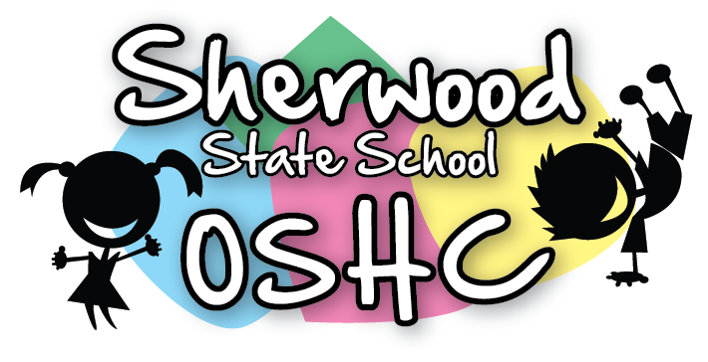

|  |  |
| --- | --- |
| Breakfast Items Offered Everyday (unless out of stock) | |
| Cereal | Toast |
| * Weetabix * Rice Bubbles * Corn flakes | * Wholemeal Toast/Gluten Free Toast * Spreads – Margarine, Vegemite & Honey |

|  |  |  |  |  |
| --- | --- | --- | --- | --- |
| Additional/Special Items This Week | | | | |
| Monday  20/5/19 | Tuesday  21/5/19 | Wednesday  22/5/19 | Thursday  23/5/19 | Friday  24/5/19 |
| Cheese Toastie  Image result for cheese toastie picture  (suggested by M.M) | Pancakes  C50BF4D8 | Bacon on Toast  Image result for bacon on toast picture  (Suggested by M.M & S.W) | Fruit salad  Image result for fruit salad picture | Banana shake  Image result for banana shake picture  (Suggested by A.L-V) |

**Please Note: Always check the packaging for the dairy, soy, gelatine, gluten, nuts or sesame seeds before serving food and be aware of the children with food allergies.**