**Breakfast Menu**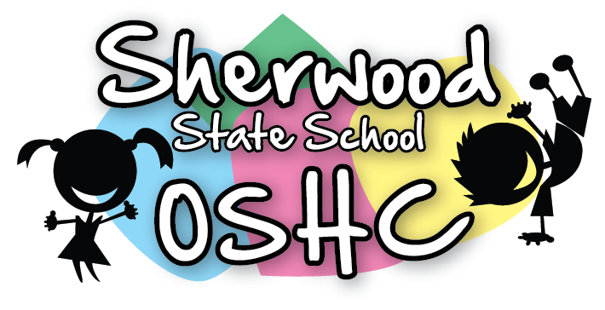

|  |  |
| --- | --- |
| Breakfast Items Offered Everyday (unless out of stock) | |
| Cereal | Toast |
| * Weetabix * Rice Bubbles * Corn flakes | * Wholemeal Toast/Gluten Free Toast * Spreads – Margarine, Vegemite & Honey |

|  |  |  |  |  |
| --- | --- | --- | --- | --- |
| Additional/Special Items This Week | | | | |
| Monday  3/6/19 | Tuesday  4/6/19 | Wednesday  5/6/19 | Thursday  6/6/19 | Friday  7/6/19 |
| Pancakes  C:\Users\raina\AppData\Local\Microsoft\Windows\Temporary Internet Files\Content.MSO\C50BF4D8.tmp | Raisin Toast  C:\Users\raina\AppData\Local\Microsoft\Windows\Temporary Internet Files\Content.MSO\272A0CC.tmp | Bacon & Toast  (Image result for bacon on toast picture | Banana on toast with honey  C:\Users\raina\AppData\Local\Microsoft\Windows\Temporary Internet Files\Content.MSO\583BA8A6.tmp | Ham & Cheese Toastie  C:\Users\raina\AppData\Local\Microsoft\Windows\Temporary Internet Files\Content.MSO\7E6763A4.tmp  (Suggested by ) |

**Please Note: Always check the packaging for the dairy, soy, gelatine, gluten, nuts or sesame seeds before serving food and be aware of the children with food allergies.**