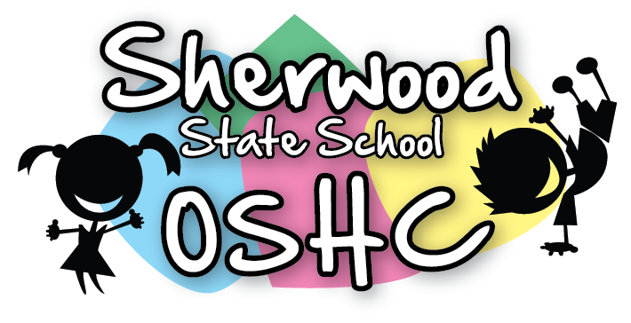
Breakfast Menu

Breakfast Items Offered Everyday (unless out of stock)
Cereal | Toast
- Weetabix  - Rice Bubbles  - Corn flakes | - Wholemeal Toast/Gluten Free Toast  - Spreads – Margarine, Vegemite & Honey

Additional/Special Items This Week
Monday  6/5/19 | Tuesday  7/5/19 | Wednesday  8/5/19 | Thursday  9/5/19 | Friday  10/5/19
LABOUR DAY | English Muffin with spreads | Pancakes  (Suggested by M.M) | Bacon on Toast  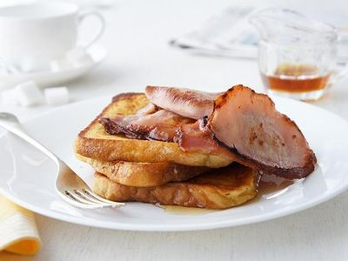  (Suggested by M.M) | Banana on Toast  (Suggested by C.M)

Please Note: Always check the packaging for the dairy, soy, gelatine, gluten, nuts or sesame seeds before serving food and be aware of the children with food allergies.

