**Breakfast Menu**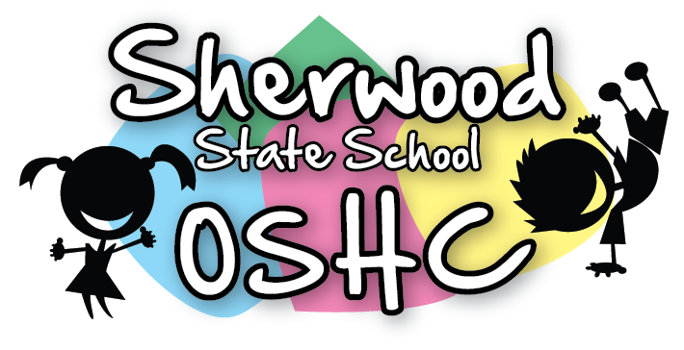

|  |  |
| --- | --- |
| Breakfast Items Offered Everyday (unless out of stock) | |
| Cereal | Toast |
| * Weetabix * Rice Bubbles * Corn flakes | * Wholemeal Toast/Gluten Free Toast * Spreads – Margarine, Vegemite & Honey |

|  |  |  |  |  |
| --- | --- | --- | --- | --- |
| Additional/Special Items This Week | | | | |
| Monday  22/4/19 | Tuesday  23/4/19 | Wednesday  24/4/19 | Thursday  25/4/19 | Friday  26/4/19 |
| Public Holiday  (Easter) | Fruit Salad  Image result for fruit salad picture  (Suggested by M.M) | Mixed Berry Shake  AC270771 | Public Holiday  (ANZAC Day) | Bacon & Toast  Image result for bacon on toast picture  (Suggested by A-L.V & E.K) |

**Please Note: Always check the packaging for the dairy, soy, gelatine, gluten, nuts or sesame seeds before serving food and be aware of the children with food allergies.**