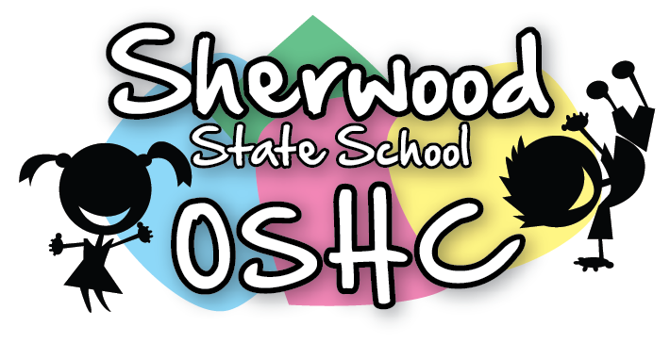
Breakfast Menu

Breakfast Items Offered Everyday (unless out of stock)
Cereal | Toast
- Wheatbix  - Rice Bubbles  - Corn flakes | - Wholemeal Toast/Gluten Free Toast  - Spreads – Margarine, Vegemite, Jam & Honey

Additional/Special Items This Week
Monday  29/04/18 | Tuesday  30/04/18 | Wednesday  1/05/18 | Thursday  2/05/18 | Friday  3/05/18
Crumpets  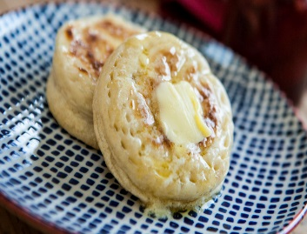 | Ham & Cheese Toastie | Bacon & Toast  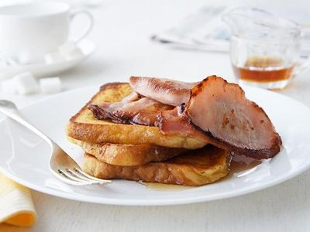 | Banana Shake  (Suggested by E.A) | Spaghetti On Toast

Please Note: Always check the packaging for the dairy, soy, gelatine, gluten, nuts or sesame seeds before serving food and be aware of the children with food allergies.

