Before School Care

 | Monday  13/05/19 | Tuesday  14/05/19 | Wednesday 15/05/19 | Thursday  16/05/19 | Friday  17/05/19
OSHC Hall | 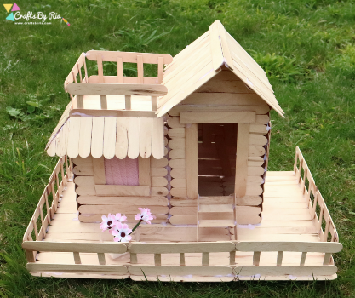  Paddle Pop Houses | 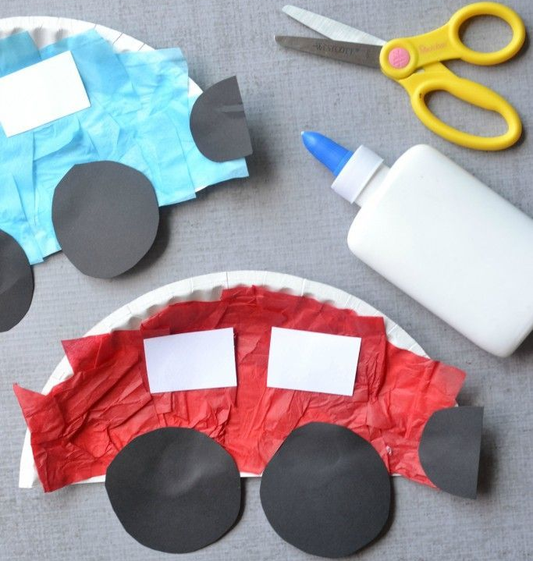  Paper Plate Cars | 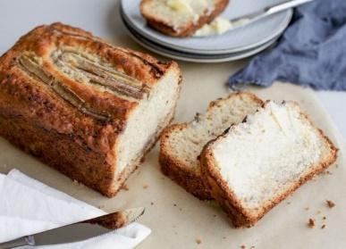  Making Banana Bread | 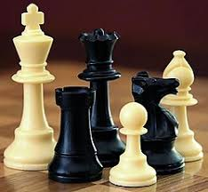  Chess Club | 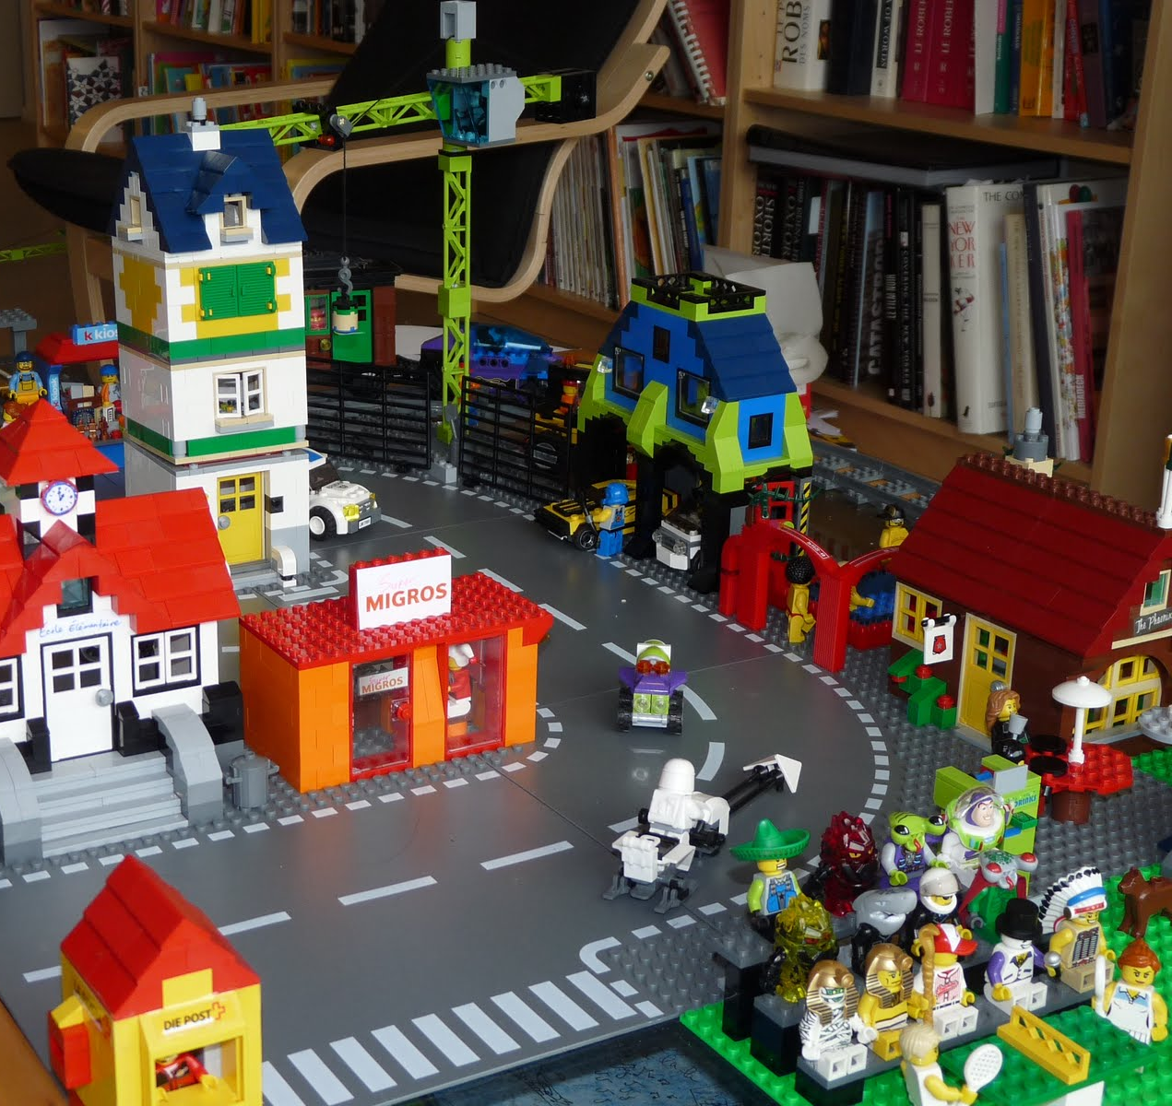  Lego & Block Cities
Downstairs | Handball Competition | 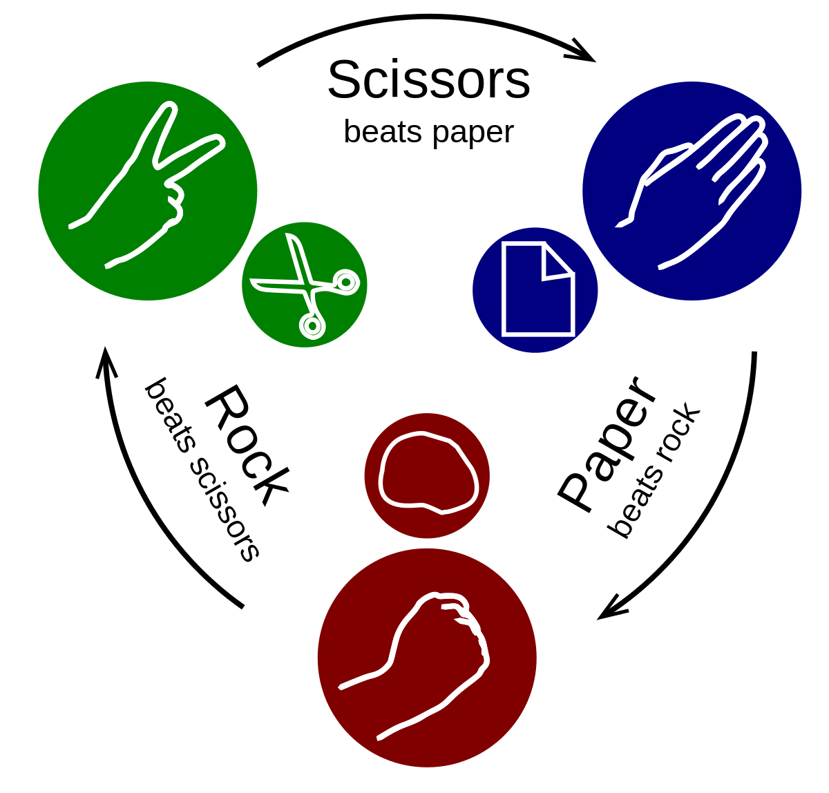  Rock, Paper, Scissors Evolution | 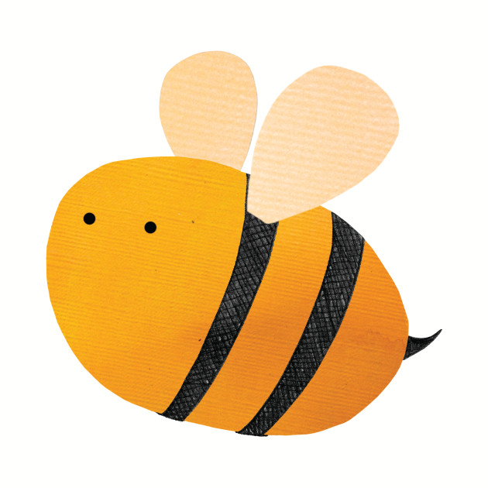  Buzz Off! | Dodgeball | 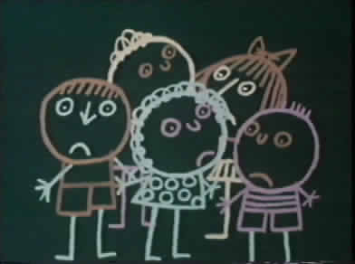  Chalk Drawing

After School Care - Inside

 | Monday  13/05/19 | Tuesday  14/05/19 | Wednesday 15/05/19 | Thursday  16/05/19 | Friday  17/05/19
OSHC Hall | 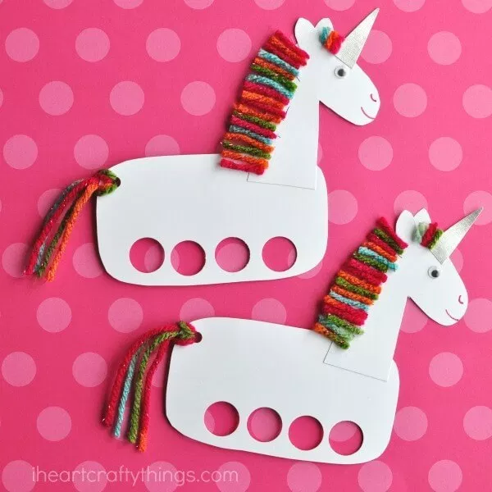  Unicorn Hand Puppets  (Suggested by M.R) | 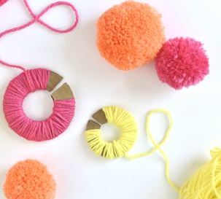  Making Pom Pom’s | 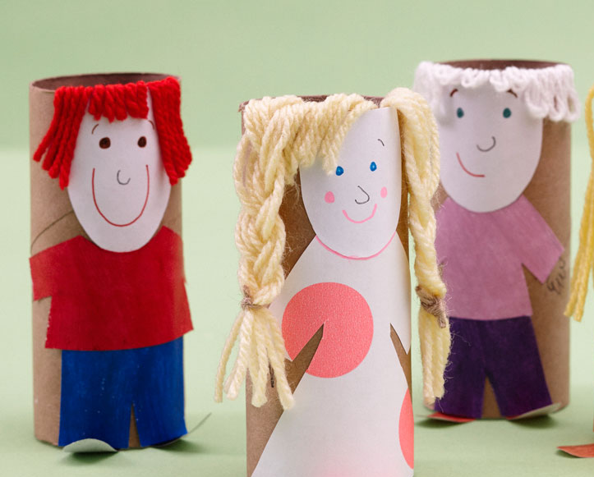  International Families Day:  Paper Roll Families | Pipecleaner  Dinosaurs  (Suggested by O.W) | Dance Party  (Suggested by H.M)
Quiet Room:  Seniors & Homework | Board Games & Homework | Realistic Drawing & Homework | Hama Beads & Homework | Poster Making & Homework | Program Review & Homework
Veranda | DIY Jigsaw Puzzle  (Suggested by E.S and S.N) | Bug Painting (Suggested by M.M) | 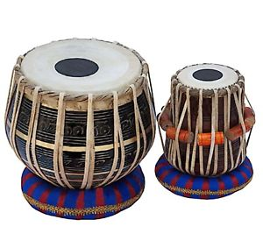  International Musical Instruments | Making Banana Bread -  Senior Activity | Making Banana Bread -  Junior Activity

After School Care - Outside

 | Monday  13/05/19 | Tuesday  14/05/19 | Wednesday 15/05/19 | Thursday  16/05/19 | Friday  17/05/19
Oval | 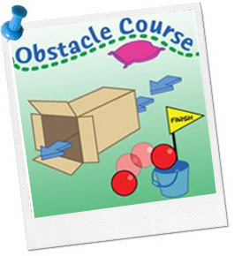  Obstacle Course | 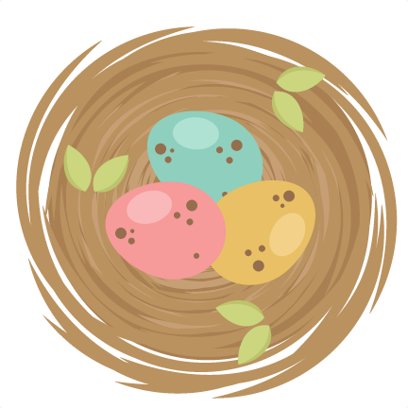  Rob The Nest | Field Hockey | Octopus Tag | Soccer
Undercover Area | 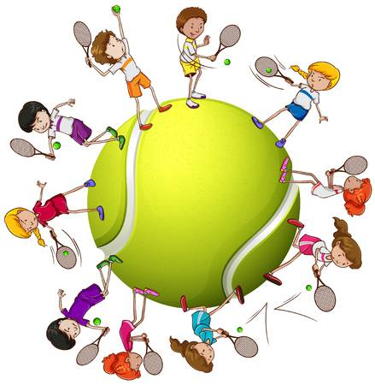  Tennis Practice | 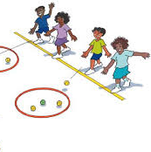  Weme | Skipping | Hopscotch | 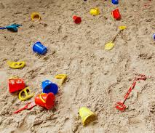  Sandpit

