Before School Care

 | Monday  10/06/19 | Tuesday  11/06/19 | Wednesday  12/06/19 | Thursday  13/06/19 | Friday  14/06/19
OSHC Hall | 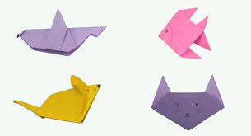  Origami Animals | 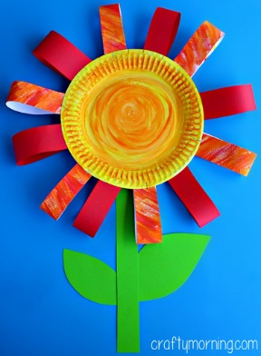  Paper Plate Flowers | 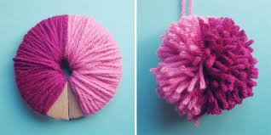  Making Wool Pom Poms | Making Rainbow Fruit Skewers | Pipe Cleaner Friendship Bead Bracelets (National Buddy Day)
Downstairs | 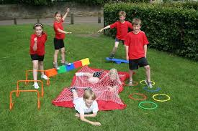  Obstacle Course | 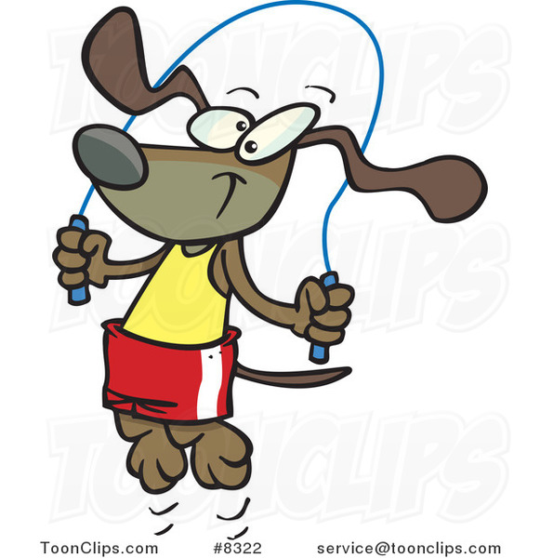  Skipping Practice | 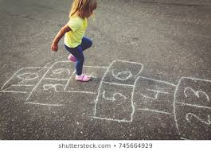  Hopscotch | 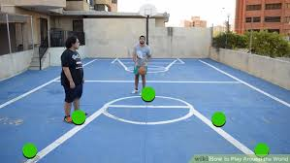  Basketball All Around the World | 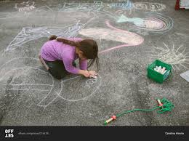  Chalk drawing of their buddy (National Buddy Day)

After School Care - Inside
 | Monday  10/06/19 | Tuesday  11/06/19 | Wednesday 12/06/19 | Thursday  13/06/19 | Friday  14/06/19
OSHC Hall | 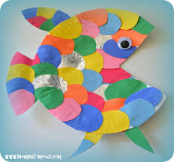  Paper Plate Fish | 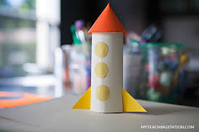  Paper Roll Rockets | 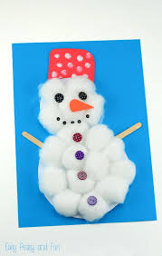  Winter Cotton Ball Snowman | 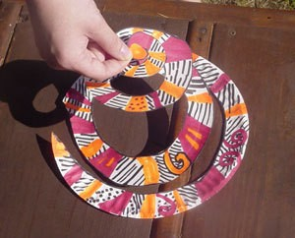  Making an Indigenous Inspired Wind Twirler | Blue Cotton Ball Bathtub Craft (International Bath Day)
Quiet Room:  Seniors & HW | Sketching & Homework | Reading & Homework | Coloring & Homework | Free Hand Drawing & Homework | Card Games & Homework
Veranda | 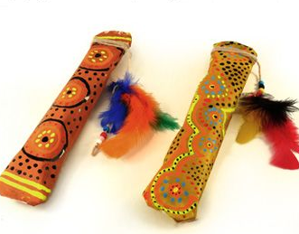  Indigenous Paper Rainstick | 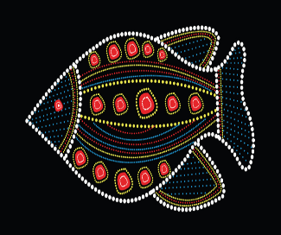  Black Paper Animal Dot Painting | Junior Cooking -  Making Cheese and Vegemite Scrolls | Senior Cooking -  Making Cheese and Vegemite Scrolls | 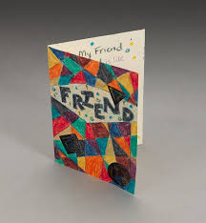  Making Friendship  Cards
After School Care - Outside
 | Monday  10/06/19 | Tuesday  11/06/19 | Wednesday 12/06/19 | Thursday  13/06/19 | Friday  14/06/19
Oval | 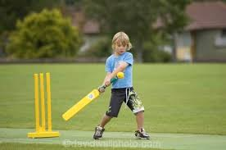  Cricket (supporting Men’s Health Week) | 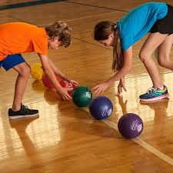  Reverse Dodgeball | 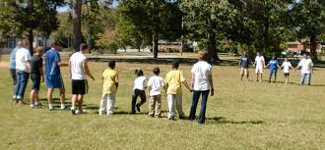  Red Rover | Silent Ball | 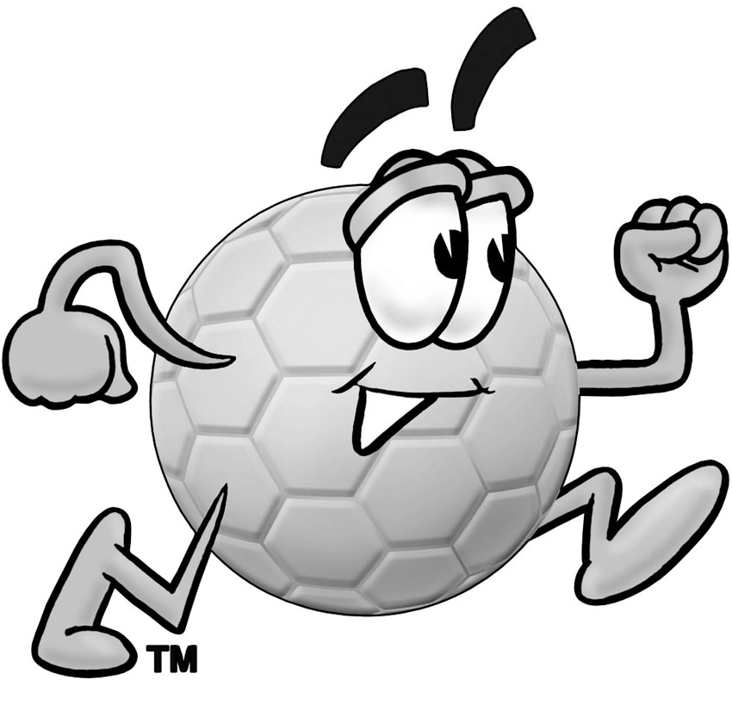  Soccer
Undercover Area | 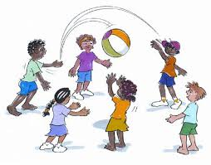  Indigenous Game “Kai” | Handball game | 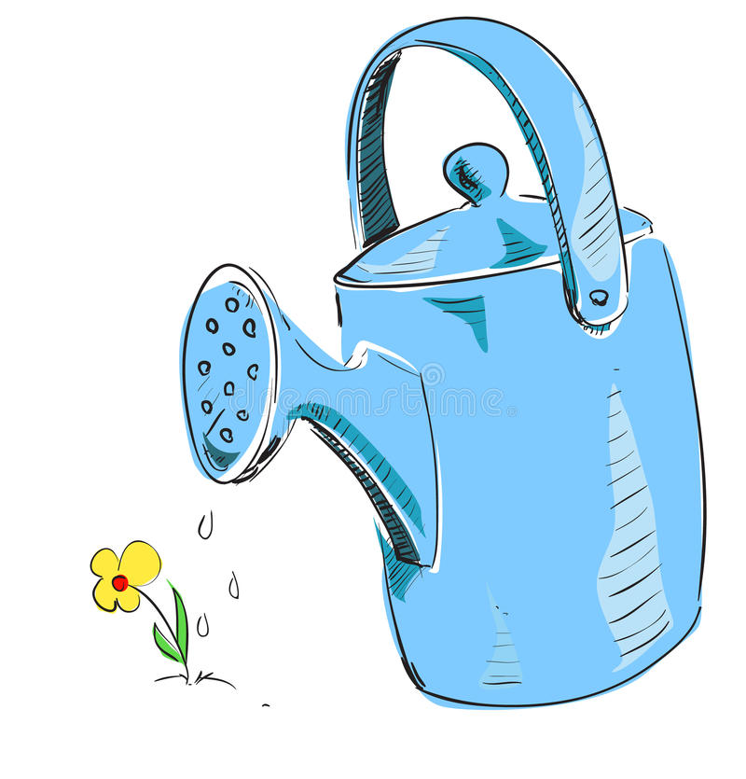  Gardening | Chalk drawing of their buddy (National Buddy Day) | 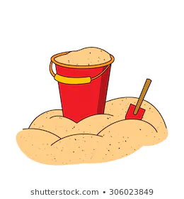  Sandpit

