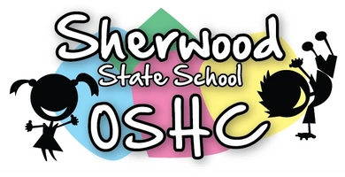 Before School Care
 | Monday  01/07/19 | Tuesday  02/07/19 | Wednesday  03/07/19 | Thursday  04/07/19 | Friday  05/07/19
OSHC Hall | Hand Exercise Ball(suggested by C.B) | 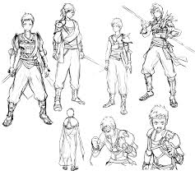  Inventing Video Game Characters  (suggested S.W) | Collage – Designing winter clothes  (suggested by I.S) | “In Celebration Of NAIDOC Week”  Painting NAIDOC awareness posters | 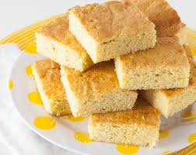  Junior Cooking  Honey Bread
Downstairs | Pop-Up Tag  (suggested by P.S) | 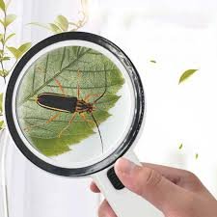  Identifying insects and wildlife in surroundings  (suggested by N.M) | 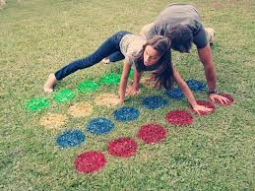  Lawn Twister | 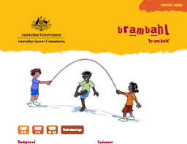  Indigenous Game  “Brambahl | Gardening

After School Care - Inside
 | Monday  01/07/19 | Tuesday  02/07/19 | Wednesday 03/07/19 | Thursday  04/07/19 | Friday  05/07/19
OSHC Hall | 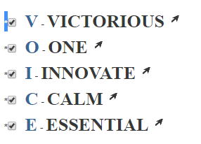  Making acronyms for NAIDOC THEME WORDS:  VOICE- TREAT Y- TRUTH | Make Pipe Cleaner Dinosaur’s | 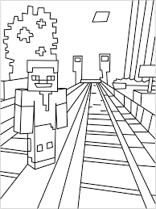  Drawing plans for a Mind Craft city  (sugg ested by H.T) | Making Chatter Box’s  (suggested by P.S) | Lego Building competition  (suggested by H.M)
Quiet Room:  Seniors & HW | Bracelet Making & Homework | Origami & Homework | Board Games & Homework | NAIDOC awareness cards & Homework | Hama beads & Homework
Veranda | Making Playdough  (suggested by N.W) | 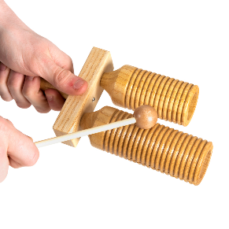  Musical Instruments | Reading Circle | Senior Cooking  Honey bread | 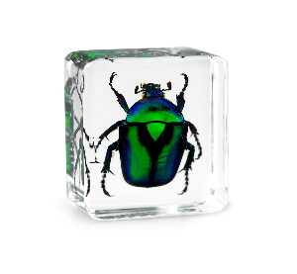  Examining Insects
After School Care - Outside

 | Monday  01/07/19 | Tuesday  02/07/19 | Wednesday  03/07/19 | Thursday  04/07/19 | Friday  05/07/19
Oval | Fly – Jumping game | Senior Cricket  (suggested  by C.B & J.L) | Junior Cricket | Capture the Flag | Sandpit
Undercover Area | 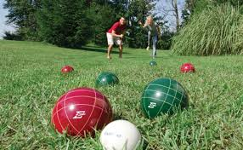  Bocce | 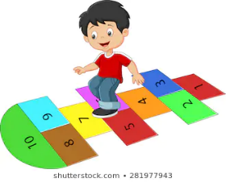  Hopscotch | Shooting hoops &  dribbling obstacles | Hand Ball | 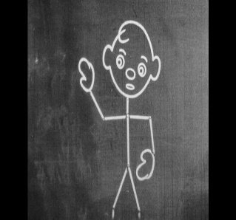  Chalk Drawing

