Weekly Activities

Monday | Tuesday | Wednesday | Thursday | Friday
01/04/19 | 02/04/19 | 03/04/19 | 04/04/19 | 05/04/19
BEFORE SCHOOL CARE
Inside: Painting Native Australian Animals  (Suggested by E.K)  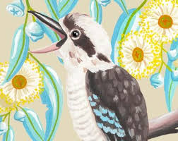 | Inside: Origami  (Suggested by L.G)  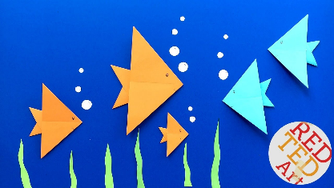 | Inside: Senior Cooking  Make Your Own  Cookie  (suggested by Dushyant)  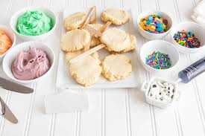 | Inside: Number to Number drawing  (Suggested by N.B)  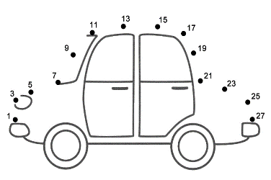 | Inside:  Joke Books  (suggested by S.W)  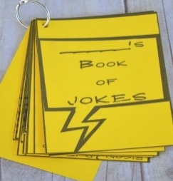
AFTER SCHOOL CARE
Inside:Heart Shaped Bee Craft  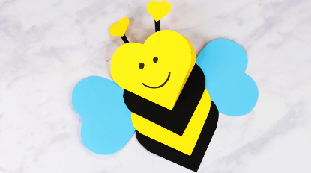  (Suggested by I.S.)  Outside:Cricket  (Suggested by J.L.) | Inside: Senior Cooking  (Make your own cookie)  Outside: Kolap (Indigenous Throwing game) | Inside: Super Hero Cuffs  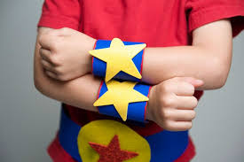  (suggested by M.M)  Outside: Red Rover  (Suggested by H.B) | 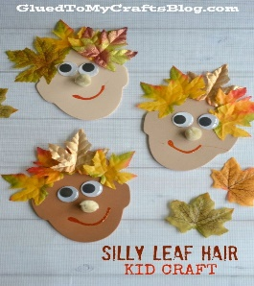  Inside: Autumn Leaf Hairstyles  Outside: Soccer Game  (Suggested by E.B) | Inside:Magic milk Science Experimen  Outside – Sandpit

