Weekly Activities

Monday | Tuesday | Wednesday | Thursday | Friday
29/04/19 | 30/04/19 | 01/05/19 | 02/05/19 | 03/05/19
BEFORE SCHOOL CARE
Inside: International Dance Day: Paddle Pop Ballerinas  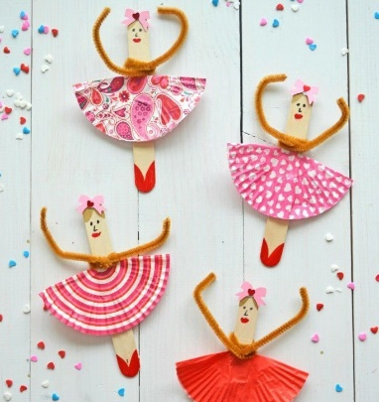 | 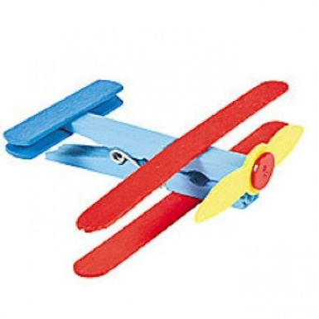  Inside: Peg Planes | Inside: Paper Bag Monster Puppets  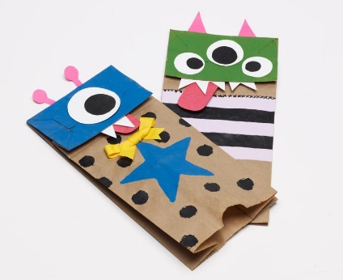 | 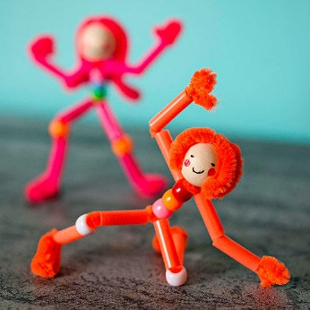  Inside: Pipe Cleaner People | Inside: Aboriginal Dot Painting Handprints  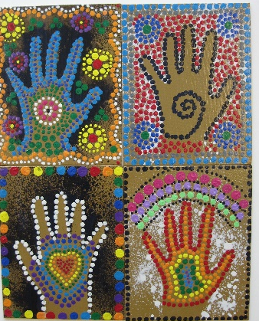
AFTER SCHOOL CARE
Inside: Aboriginal Rainsticks  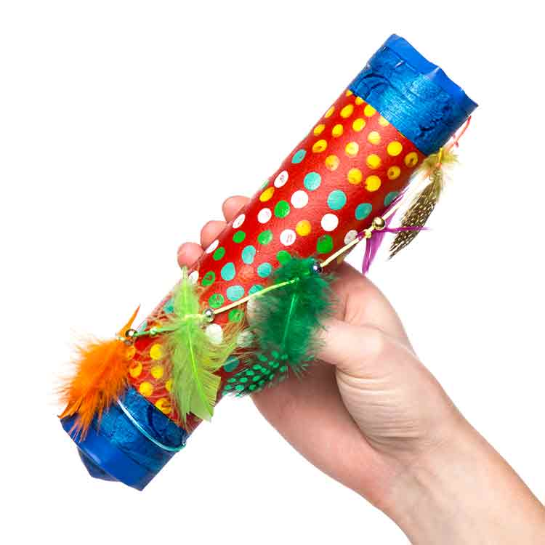  Outside: Cricket | Inside: Making Sushi -Snr (Suggested by St. S)  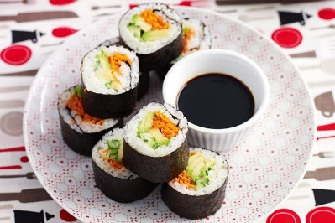  Outside: Munhanganing (Indigenous Tag game) | Inside: Shiny Clay Fish  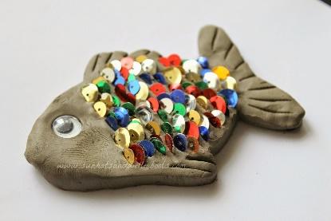  Outside:Handball Competition (Suggested by S.S) | Inside: Making Sushi – Jnr (Suggested by St. S)  Outside: Red Rover | Inside: Dance Party  Outside – Sandpit

