Before School Care
 | Monday  27/05/19 | Tuesday  28/05/19 | Wednesday 29/05/19 | Thursday  30/05/19 | Friday  31/05/19
OSHC Hall | 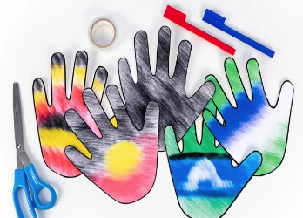  “SORRY DAY”  Indigenous Australian Craft  Flag Handprints | “MINDFUL MAY”  Colouring in | 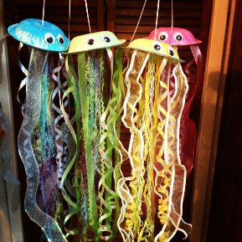  Paper Plate Jellyfish | 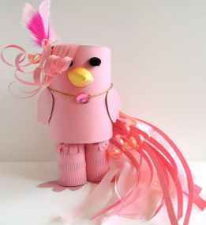  Imaginary Pet Craft  (Suggested by S.S) | 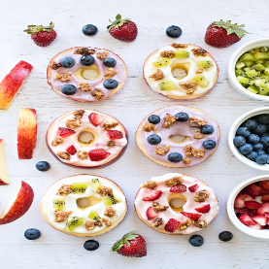  Making Fruit Donuts  (Suggested by H.G.)
Downstairs | Pop-Up Tag | Bull Rush | Ship to Shore | Cat and Mouse | Gardening

After School Care - Inside
 | Monday  27/05/19 | Tuesday  28/05/19 | Wednesday 29/05/19 | Thursday  30/05/19 | Friday  31/05/19
OSHC Hall | 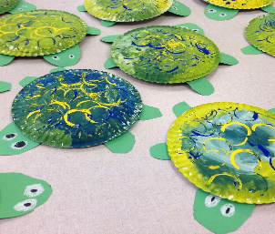  Wayamba The Turtle Craft  (Painted Shell Turtles) | 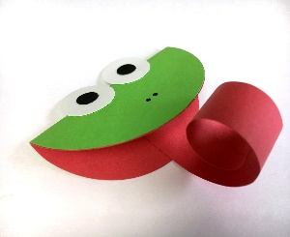  Tiddalick The Frog  (Frog Mouth Puppet) | 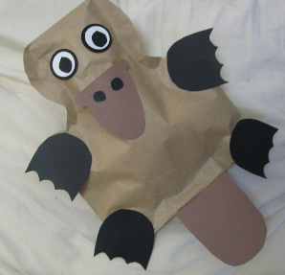  Biladurang the Platypus  (Paper Bag Platypi) | 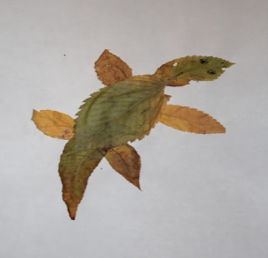  Girawu the Goanna  (Leaf Lizards) | 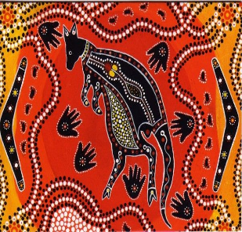  Mirram the Kangaroo  (Sand Art Australian Animals)
Quiet Room:  Seniors & HW | Bracelet Making & Homework | Poster Making & Homework | Card Games & Homework | Stamp Making & Homework | Kinetic Sand & Homework
Veranda | 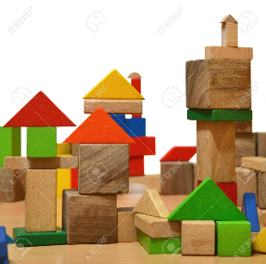  Wooden Block Cities | 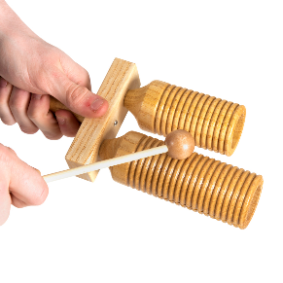  International Musical Instruments | Junior Activity - Making Fruit Donuts | Senior Activity - Making Fruit Donuts | 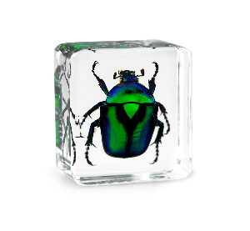  Examining Insects
After School Care - Outside

 | Monday  27/05/19 | Tuesday  28/05/19 | Wednesday 29/05/19 | Thursday  30/05/19 | Friday  31/05/19
Oval | 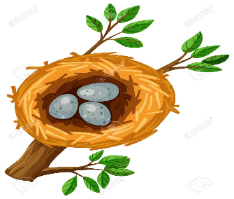  Rob The Nest  (Suggested by Sharada) | 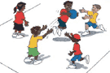  Indigenous Game - Gorri | Soccer Junior | Soccer Senior | Sandpit
Undercover Area | Skipping games | Hopscotch | Shooting hoops | Bullseye | 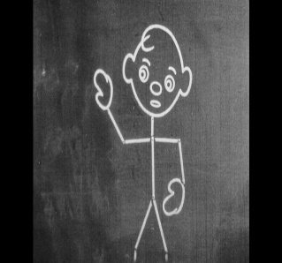  Chalk Drawing

