Before School Care

 | Monday  03/06/19 | Tuesday  04/06/19 | Wednesday  05/06/19 | Thursday  06/06/19 | Friday  07/06/19
OSHC Hall | Paper Plane Construction and Flight | 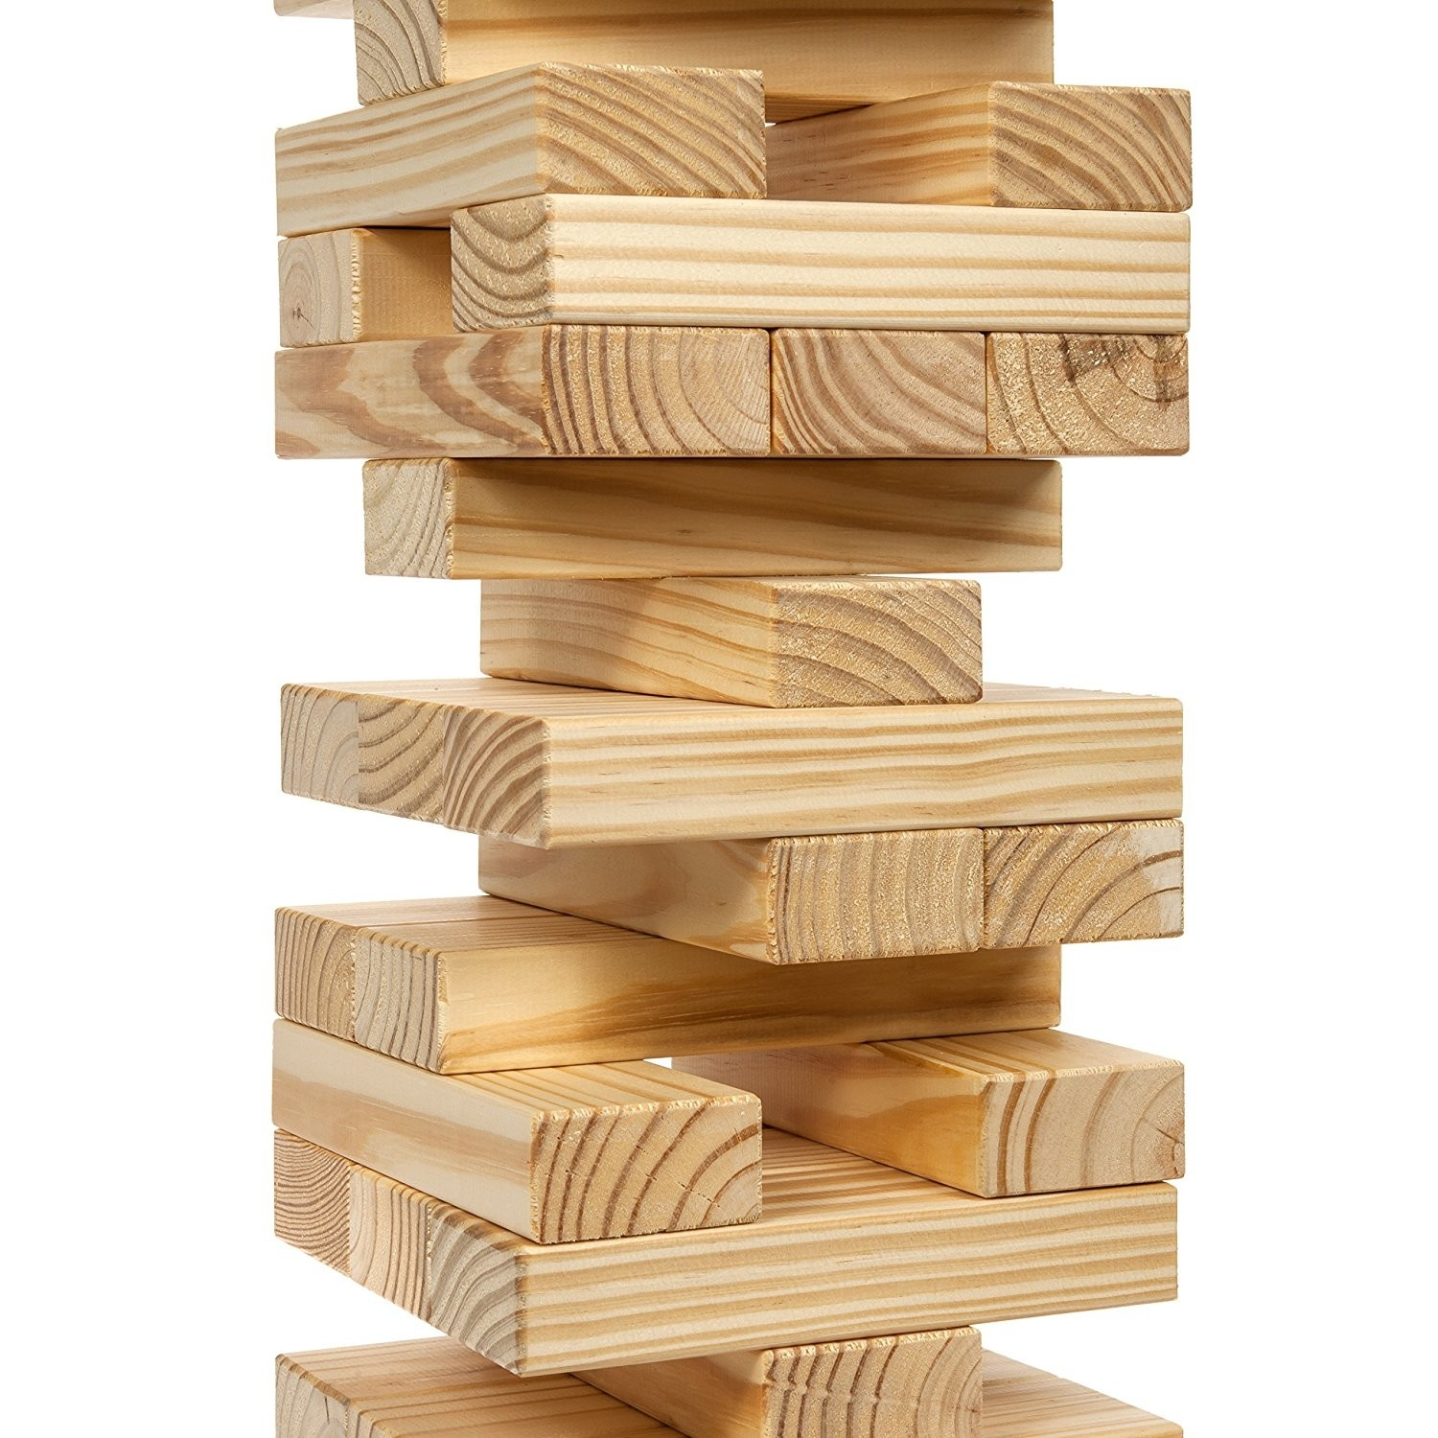  Tower Stacking Games | 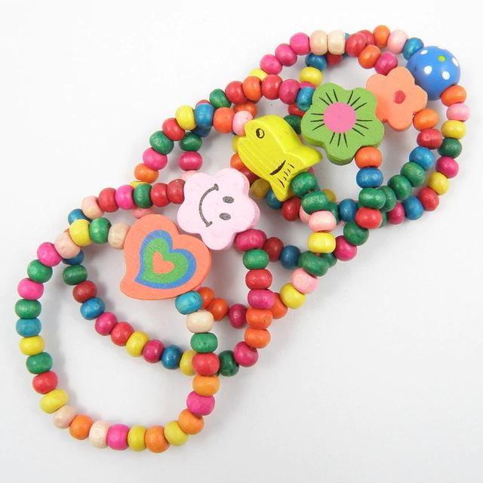  Bead Jewellery | 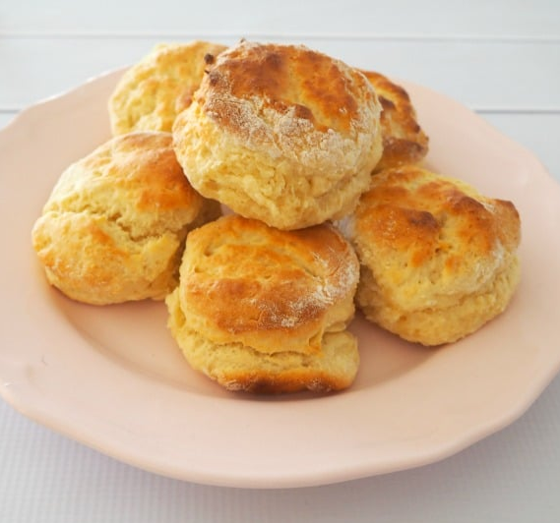  Making Lemonade Scones | Group Activity -  1000 Piece  Jigsaw Puzzle
Downstairs | Hula Hooping | Handball game  (suggested by S.S) | 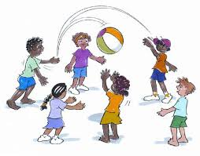  Indigenous Game “Kai” | Skipping Practice | French Cricket

After School Care - Inside
 | Monday  03/06/19 | Tuesday  04/06/19 | Wednesday 05/06/19 | Thursday  06/06/19 | Friday  07/06/19
OSHC Hall | 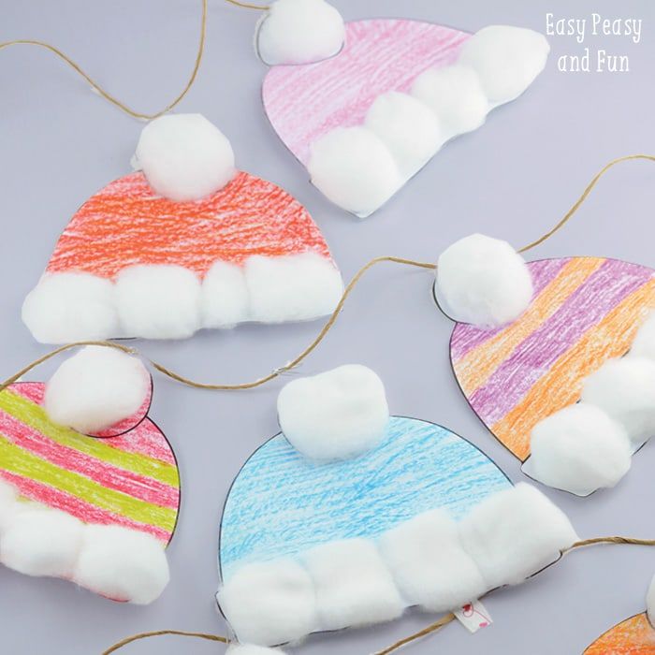  Cotton and Card  Wooly Winter Hats | 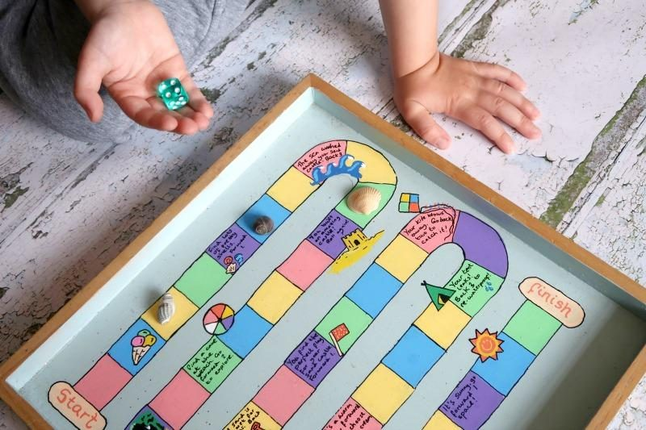  Design Your Own Board Game | Reconciliation Week: Colouring in Competition | 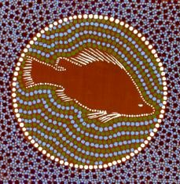  Thuggai the Yellowbelly - Leaf Fish Aquariums | In Celebration of  Eid al Fitr:  Mosaic Artworks
Quiet Room:  Seniors & HW | Sketching & Homework | Reading & Homework | Coloring & Homework | Free Hand Drawing & Homework | Hama Beads & Homework
Veranda | 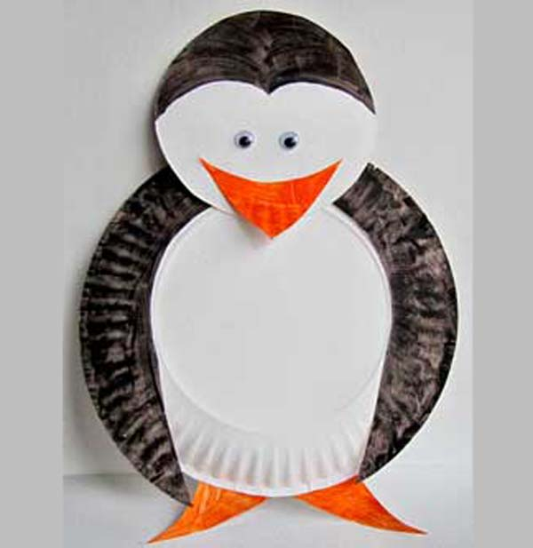  Paper Plate Penguins | Bubble Wand Making & Bubble Blowing | Junior Cooking -  Making Lemonade Scones | Senior Cooking -  Making Lemonade Scones | Painting Cut-Out Cards
After School Care - Outside
 | Monday  03/06/19 | Tuesday  04/06/19 | Wednesday 05/06/19 | Thursday  06/06/19 | Friday  07/06/19
Oval | Top & Bottom Tag | Speed Ball  (Junior) | 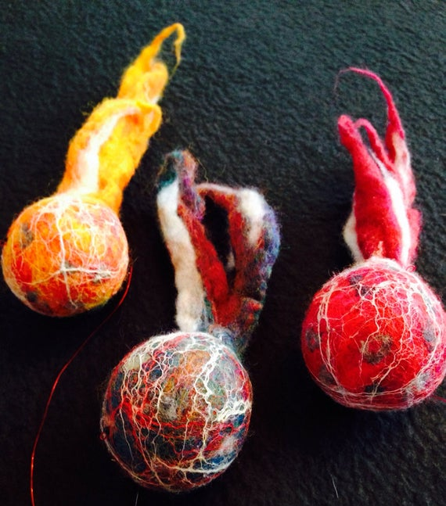  Kee’an | Speed Ball  (Senior) | 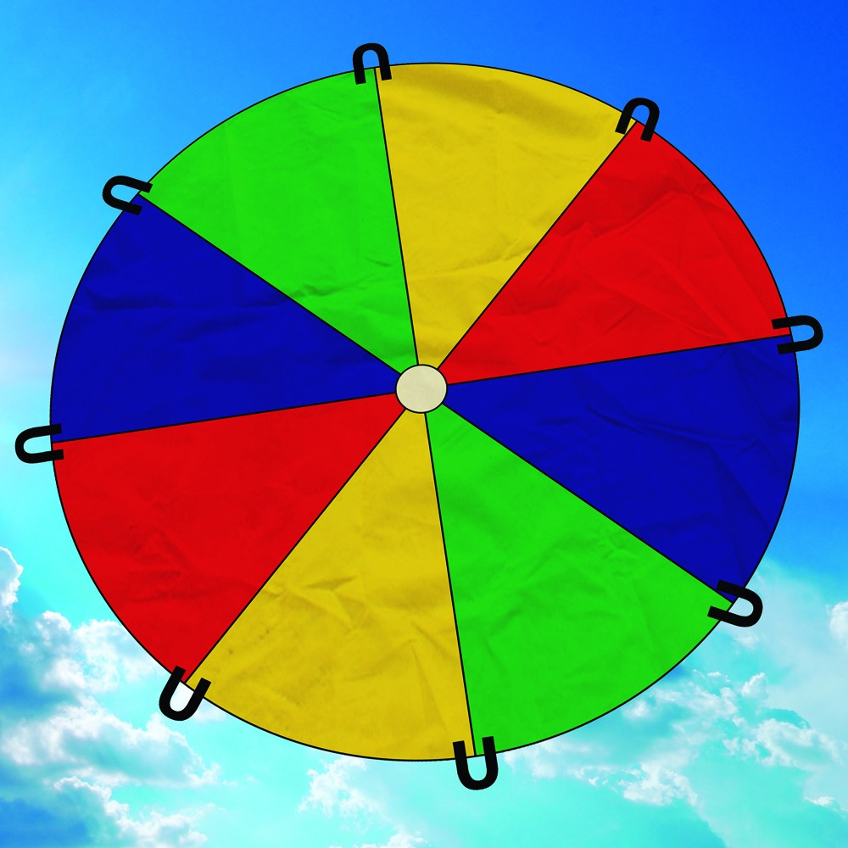  Parachute Games
Undercover Area | Netball Practice | 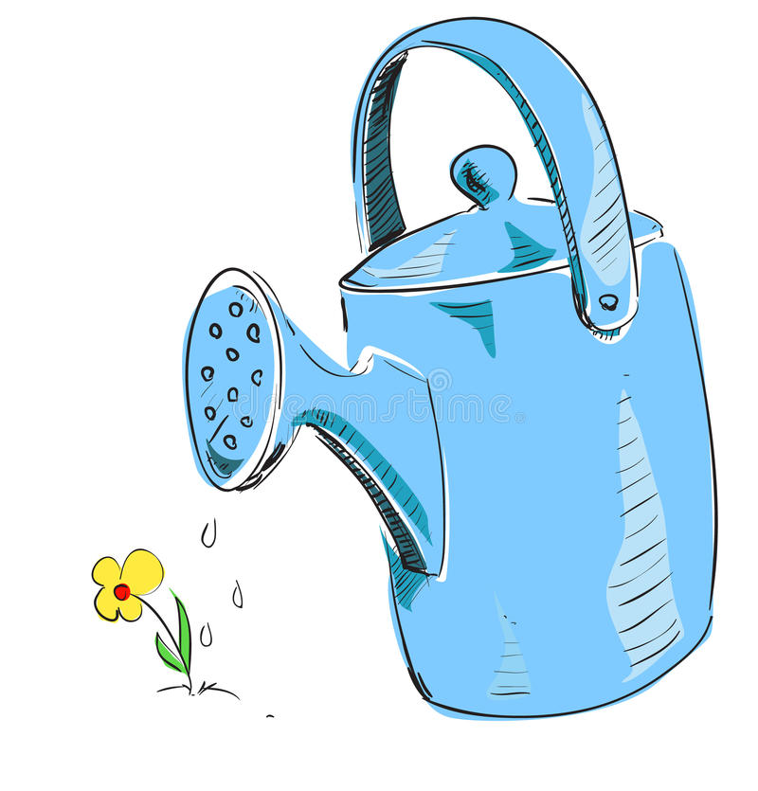  Gardening | Buzz Off! | Silent Ball | 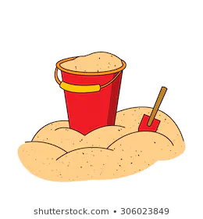  Sandpit

