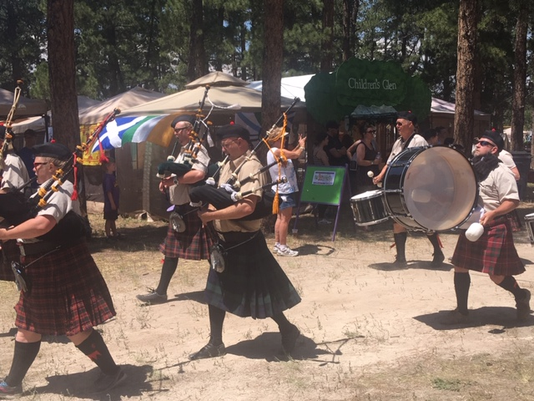 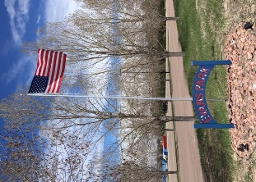

While we had begun operating the new splashpad and allowing kids to get some much needed wet and cool relief from the hot temps, the actual ribbon cutting ceremony was held on Saturday, August 3rd at 10am. The Board of Directors and staff as well as over a hundred community members celebrated the addition of this great new amenity to Evans Park for the community. The event included light refreshments, play on the District’s inflatables, face painting, and of course the “official” start-up of the splashpad for everyone to enjoy.

We are so fortunate to be able to introduce this new amenity to the community and we hope it brings lots of joy to residents for

years to come. Thanks for your continued support!

**Youth and Teen Self-Defense Clinics**

Elizabeth Park and Recreation District has partnered with Staying Fit and Lovin It to offer this valuable program for your child. Instructors have over 30 years combined experience teaching youth to recognize dangers in their environment and how to disable and evade an attacker. Open to youth ages 9-18. Next clinic is 8/24 from 9am-11am. Cost is $10. Check website for registration info.

**Introduction to Slacklining – Ages 10 - 101**

Created by Yosemite rock climbers as a fun activity to do between climbs, slacklining involves balancing on a piece of stretched webbing while walking, bouncing, or doing tricks. It is a fun activity that is great for developing balance and core strength and can be done about anywhere. This clinic will teach you how to set up a line and how to begin training to become a pro. Clinic held on 8/14 from 5pm-6pm. Cost is $10. Check website for more info and to register. Call the Park Office with any questions at 303.646.3599.

**End of Summer Youth Camps**

Still looking to get the kiddos out of the house before school starts for some summer fun? Our August mini-camps are here to save the day. Camps are being offered the week of Aug 12-16, with both morning and afternoon sessions offered on some days. Camp themes include *Outdoor Explorers, Field Day, Arts and Music, Be a Scientist,*and *Water Play Day.* Morning sessions are from 9am to Noon, and afternoon sessions are from 1pm to 4pm. Care is also available during the lunch hour if needed. Cost is $15 per session. All camps are held at either Casey Jones or Evans Park.

**Come Out and Play!**

***Splashpad Grand Opening***

**Aug - 2019**

*- Splashpad Grand Opening*

*- Message from the Director*

*- Program Updates – Come Out and Play!*

*- Upcoming Special Events*

*- Quote of the Month*

***in this issue >>>***

[www.elizabethpr.com](http://www.elizabethpr.com) [info@elizabethpr.com](mailto:info@elizabethpr.com) 303.646.3599 PO Box 434 – Elizabeth, CO 80107

***connections***

*EPR*

**Monthly Insight into the Elizabeth Park & Rec District**

Upcoming Special Events



Pints in the Pines

9/6 & 9/7 – Casey Jones Park

Friday, Sept 6 Saturday, Sept 7

5pm-9pm Craft Beers 12pm-10pm Craft Beers

Food Vendors Food Vendors

Live Music Live Music

Inflatables

9pm-12am Barn Dance (CJ Pavilion) Corn Hole Tournament

Contact the Chamber at 303.646.4287

for more info

End of Summer Bash

August 17th, 10am-2pm

Evans Park

Rebecca and the Programs Crew are planning a fun-filled party for community youth to wrap up the summer. Make plans now to bring your family to the park for yard games, play on the giant slip-n-slide, Elizabeth’s biggest water ballon battle, and more. Concession stand wil be open for snacks and slushees, but families are encouraged to bring a picnic lunch. No registration required just come on by.

Message from the Director

**Please Respect Youth Sport Officials**

**As we all surely heard or read about, there was a horrible incident where a brawl broke out at a youth baseball game in Lakewood this summer. Garnering national attention, it was an ugly and disturbing scene where adults mobbed a youth umpire and then physically attacked each other after disagreeing with a call. At least 20 individuals were observed participating in the melee at this game for 7 year olds and 12 have now been charged with crimes. As we work to improve the culture of our youth sport programs, this serves as a powerful example of how quickly things can go bad when parents and spectators fail to respect the officials, the other team, each other, and most importantly the children. The outcome of a baseball game for 7 year olds should never carry enough significance to cause an argument, let alone an all out brawl in the middle of the field while children run for safety. That goes beyond saying of course, yet here we are. As you attend your child’s games this fall, please remember that your words and actions really matter out there, and that the children are always watching and learning. In most all of my experiences with youth sports, the children are rarely the problem, it is always the adults. Please join us in setting the right example for your child and lets all have a great uplifting fall youth sports season!.**

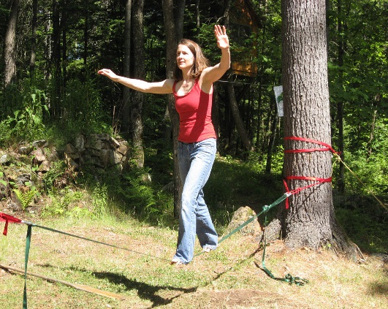

[This Photo](https://commons.wikimedia.org/wiki/File:Maggie_on_slackline.jpg) by Unknown Author is licensed under [CC BY-SA](https://creativecommons.org/licenses/by-sa/3.0/)

Slacklining

“It is a happy talent to know how to play”

- Ralph Waldo Emerson -

*Quote of the Month*